

Table of Contents

Project Executive Summary 1

Brief Business Description 1

Industry Research 2

The Competition 2

Current Operations 3

Problems and Solutions 3

Looking Ahead 3

Business Case 4

Issues 4

Requirements 4

Justification 4

Project Approach 6

Business Rules 6

Find out the Problems and Requirements 7

Strobe and SWOT Analysis 7

Business Goals 7

Create an Entity Relation Diagram 8

Data Dictionary 8

Project Solution 9

Current reports and sample records 9

Client Info & Event Details 9

Empty Booking Form 10

Sample Booking Forms 11

Song and Packages 14

Testing Processes 15

Creation of Database 15

Insert Dummy Records 15

Delete and Update Testing 15

Project Improvements 16

Project Maintenance Issues 17

Lessons Learned 18

Project Summary 19

Data Dictionary 20

Booking_Status 20

Client 20

Client_Location 20

Client_Type 21

County 21

Employee 21

Employee_Status 22

Employee_Title 22

Employee_Training_Request 22

Employee_Training_Status 22

Employee_Type 23

Event 23

Event_Date 23

Event_Expenses 24

Event_Location 24

Event_Status 24

Event_Type 24

Locations 25

Payment_Method 25

Payroll 25

Phone_Numbers 26

Postal_Codes 26

Service_Requested 26

Songs 26

Timesheet 27

Timesheet_Status 27

User_Info 27

User_Login 27

Vacation_Request 28

Vacation_Status 28

Entity Relation Diagram (Primary Keys and Relationships) 29

Relationships 29

Primary Keys and attributes 30

Normalized Data Models 32

Create Table Scripts 33

Alter Table Scripts 45

Data’s Loaded into Tables 49

Song Records.csv file 49

Locations.cvs file 52

Clients.csv file 56

Phone_Numbers.csv file 63

Postal_Codes.csv file 66

Counties.csv file 70

Client_Location.csv file 73

Client_Type_List.csv file 77

Booking_Status.csv file 80

Payment_Method.csv file 84

Event.csv file 87

Event_Type.csv file 91

Event_Status.csv file 94

Event_Expenses.csv file 98

Employee.csv file 101

Employee_Type.csv file 108

User_Login.csv file 112

Event_Date.csv file 116

Payroll.csv file 120

Timesheet_Status.csv file 123

Timesheet.csv file 127

Employee_Status.csv file 130

Employee_Title.csv file 134

Employee_Training_Request.csv file 137

Employee_Training_Status.csv file 141

User_Info.csv file 144

Event_Location.csv file 148

Vacation_Request.csv file 151

Vacation_Request_Status.csv file 155

Service_Requested.csv 158

SQL Insert, Update, Delete Scripts 163

Insert Scripts 163

Update Scripts 174

Delete Scripts 185

Join Query Reports 196

GUI Forms/Screens 246

Login Menu 246

Main Menu 247

Client Menu 248

Employee Menu 249

Event Menu 250

Music Menu 251

Timesheet Menu 252

Training Request Menu 253

User Menu 254

User Registration 255

Vacation Requests Menu 256

Updated Problems and Requirements List 257

Status Report 259

# Project Executive Summary

## Brief Business Description

The music industry is endless and forever growing continuously; as its popularity and variety expands, so do the companies who pursue this trade. Vester Harper, also known as Lady BG, is the founder of Lady BG Productions Karaoke Crew who initially started the company as a hobby. After brining karaoke equipment’s to family functions and being compensated for it, she aspired to start her own business in the music industry. After 16 years of hard work, she now owns the number one mobile karaoke business in Houston.

Our team, Houston Vertical Systems, has had the opportunity to aid in the company’s growth in 2018. Our goal is to dedicate our time and knowledge to creating a better database system for the company so that it can function efficiently and prosper even more. The team consists of 9 students from the University of Houston:

* Randy Nguyen – Project Manager
* Kristy Hoang – Program Analyst
* Jason Ngo – Functional Analyst
* Brandon Nguyen – Functional Analyst
* Muktar Abubakar – Database Designer
* Samuel Epke – Database Designer
* Celesta Monsivaiz – Client Representative
* Brady Acevedo – Client Representative

Houston Vertical System’s aim is to increase their efficiency by 50% within the next two years.

## Industry Research

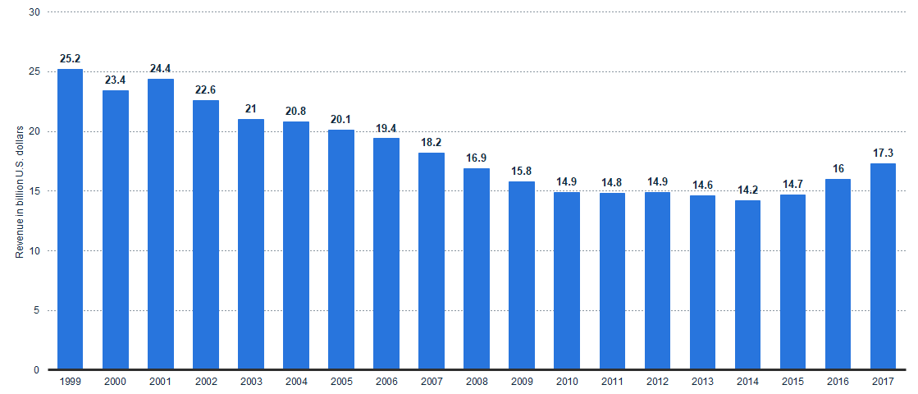

Statista, a site dedicated to statistical analysis, states that the music industry within the past two decades has generated 17.3 billion U.S. dollars in revenue. A large portion of that revenue can be attributed to digital music. While the use of digital music is predicted to decrease over the next decade, Lady BG Productions utilizes digital music differently than most with their mobile karaoke services and nightlife events.

## The Competition

Lady BG Productions has three rival companies in the karaoke and nightlife scene. These companies are:

1. Spotlight Entertainment
2. Glitter Karaoke
3. The Drapper DJs

Even though they are her competitors, each company differs in their services that can still prove to be a challenge for Lady BG. Lady BG plans to not only offer karaoke as a service, but also invest their time as a DJ in the nightlife. This can range from home party events, to night clubs, and even music events.

## Current Operations

Lady BG Productions is made up of 7 employees.

* Vester “Lady BG” Harper – CEO and Founder
* KJ Sharai Wiley – Lead KJ (Karaoke Jock) and Booking Coordinator
* Shenita “Nita Boo” Jones – Lead KJ
* Jarvis “Mookie” Williams – Assistant KJ
* Shay “Shay Butta” Harper – Assistant KJ
* Adrian “AJ” Johnson – Assistant KJ (In Training)
* Tracey “Tha Songbird” LeFluer – Lead KJ (In Training)

## Problems and Solutions

The focus of Houston Vertical Systems is to:

1. Migrate existing data into a database, thus decreasing the time of the booking process significantly.
2. Both Lady BG and Sharai have stated that the booking process can take up to three hours to complete. By creating a system that is automated, less time can be put into the booking process.
3. This can lead to an increase of saving opportunity. Using an estimate of a five-year period, the company can save $46,500 on employee work hours.
4. Catalog her songs list.
   1. With her songs recorded in the database, Lady BG would be able to filter songs based on censorship, event type, and genre.
   2. Possible reduction in the amount of time the KJ’s spend error checking for duplicate songs when creating playlist and CD’s
5. Increase efficiency by 50% within the next 2 years.

## Looking Ahead

Houston Vertical Systems has already made progress in creating a system for Lady BG Productions. By the end of May 2019, the prototype for the system will be completed and ready for productions so we can perform testing and maintenance.

# Business Case

## Issues

Lady BG Productions is experiencing problems with organizations of their clients, booked events, and music. Because of the large influx of request, their time is spent handling the booking process and keeping track of all their clients.

1. There is no way to track customer bookings or purchases efficiently.
2. Reports and booking process are generated manually on paper.
3. Unable to keep track of all available song listings. This is crucial for customers to decide on what type of music they would like at their events.
4. High Volumes of request consumes employee’s time.

## Requirements

With our prototype database, we are slowly able to touch base on each issue and found resolution for each one. As we progress in our testing phase, we will perform maintenance and updates to improve the database.

1. Create an interface that allows for a quicker booking process and client tracking.
2. Generate a query to display reports of end user’s request.
3. The database will hold records of all available songs to be sorted based on user’s demand.
4. Any updates or changes in client or event information will be easily accessible.

## Justification

With all options considered, Houston Vertical Systems has decided to create a customer graphical user interface that meets the needs of our client. The system will be an on-site SQL database that will effectively improve the booking process and tracking of all requests. We feel that this is the optimal route to take as this is the highest quality product we are able to provide with current resources.

This tailored system would contain features that will meet the necessities for Lady BG Production’s current and future operation. Using the SDLC approach, we will be able to thoroughly build the system with a guaranteed success and quality. Recording information will be automated as much as possible to minimize time consumption so that the employees can focus more on improving the services they will provide to clients.

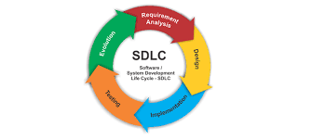

# Project Approach

Our team has determined that the most optimal approach towards this project is by learning the business rules of the company. By learning how they operate, we will be able to design a database and interface based on their habits and familiarity. One of the most problematic issues in integrating a new system, such as this, is changing the habits of the employees. We do not wish to disrupt an employee’s rhythm and process that they’ve develop to complete their tasks. Following this mindset, we want the employees to feel comfortable when they begin to incorporate this system into their daily routine.

## Business Rules

A business rule is similar to a process that the employees follow to complete their tasks. Each employee has their own method of completing the task, however we have recorded the general guidelines that an employee follows in their routine.

1. Employee must respond to inquiries and requests within the hour.
2. Customer must provide payment methods during bookings.
3. Customer must pay a $75 non-refundable fee to confirm booking.
4. Employees can be assigned to many events.
5. Customers can book more than one events at a time.
6. Employee must have the list of all requests from the customer.
7. Customers are encouraged to provide feedback to get discounts on any future event requests.
8. All provided information by customers are for private use only.
9. Customers must cancel 72 hours in advance before the event date to receive a refund of any amount paid other than the non-refundable booking fee.
10. All employees must abide by the federal copyright laws.
11. Personal devices of any types are not allowed at events. All employees must use the company provided equipment.
12. Unprofessional behaviors at events are not tolerated.

## Find out the Problems and Requirements

Identifying the problems within the company is the second part of approaching this project. The reason being is that once we find an issue within the company, we have to find a solution for it. By resolving the issue, we can work more towards improving the company and work flow efficiency.

## Strobe and SWOT Analysis

Performing a Strobe and SWOT allows us to learn more about the company. We get to learn about the strengths, weaknesses, opportunities and threats. This is essential to the company so that we know what to work towards to improve the company.

Learning about the strengths of the company will allow us to learn what we should play towards and work with. There is no need to focus time on sections of the company that is favorable for them. With less effort wasted on the strengths of the company, we can than think of ways to resolve the company’s weaknesses.

Understanding the weaknesses of the company will let us know why they need help and what should be improved upon. This is crucial so that the company can grow in the future and operate at 100%. The weaknesses of the company can even include their time management skills, manual reports, or even the way they keep track of information.

Afterwards, the opportunities the company has to grow will become apparent. This can become vital to the company as it will let them understand what they can work towards to expand even more. Their service area can grow, and reputation can increase which will lead to larger profits.

Lastly, the threats of the company. We believe in the emphasis of learning about the threats of the company because it will let them know why their competitors get more business.

## Business Goals

Before creating a database for the company, we have to learn about what the owner or managers of the company wants to be improve. Learning about the problems and requirements is not enough to start the project. We have to learn about what Lady BG wants differently for the company because our goal is to create a customize database and interface that meets the needs of the customer.

## Create an Entity Relation Diagram

Identifying the possible entities through our problems and requirements will let us establish the relationships between each one. This is the main foundation for our database so that we can create tables that will allow for proper flow of information. Using the problems and goals of Lady BG Productions, we can structure an ERD so that we can graphically illustrate the database relations. Each entity will have an attribute that describes it. The attributes for the entities can be used as a guideline as what information needs to be attached to it.

## Data Dictionary

With our ERD created, we use the attributes for each entity and create a data dictionary. The data dictionary is a collection of descriptions of the data objects or items in a data model for the benefit of the programmer or database designer. Each data dictionary will have field names for a specific table and each field names act as a column for the table. The data type of each fields will be defined and how much data can be inserted into it. Once the data type is defined, a column that is used to uniquely identify a row in the table should have the constraint of a primary key.

With the primary key constraint designated, we have to create a foreign key constraint that will allow us to associate a table with another table. This lets us reference the row of a table and the connection between them.

# Project Solution

With our business case defined and project approach listed, we can work towards the solution for our project. The project being is – the database and interface designed for the company. With its customized format, Lady BG will be able to shorten the booking process of new clients and events.

In addition to that, the information recorded will be kept tracked of properly so that data redundancy and data abnormalities are reduced. Anything of the sort will result in loss of time within the company which is one of the problems we planned to resolve.

Reports for the company can be generated automatically with queries within the interface and they do not have to be created manually or by hand. With reports being generated with ease, Lady BG can spend more time towards planning out how she will cater to events and even reach out to her past clients to advertise her company.

## Current reports and sample records

### Client Info & Event Details

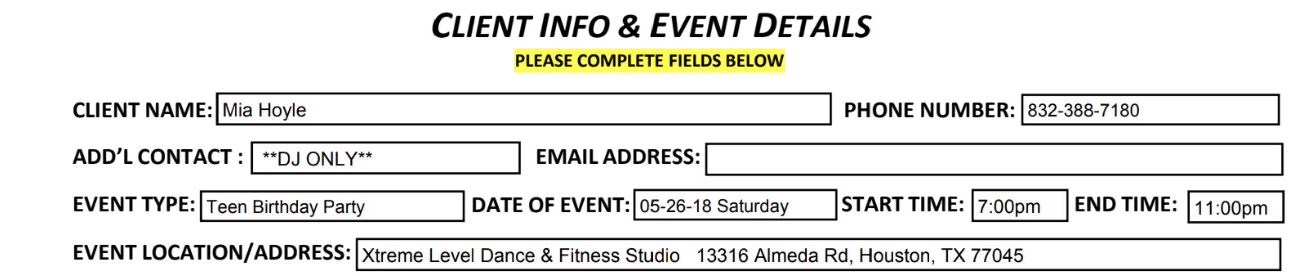

### Empty Booking Form

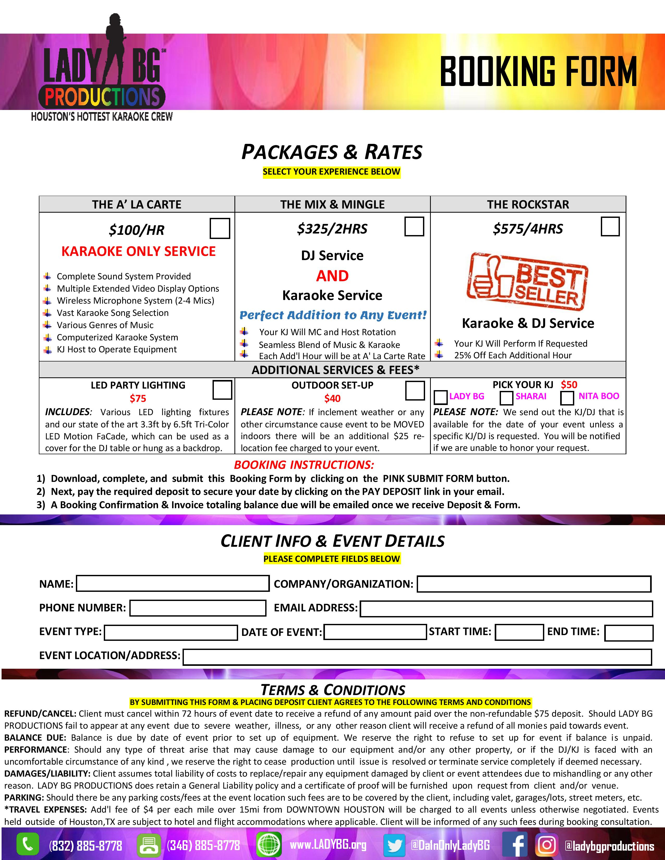

### Sample Booking Forms

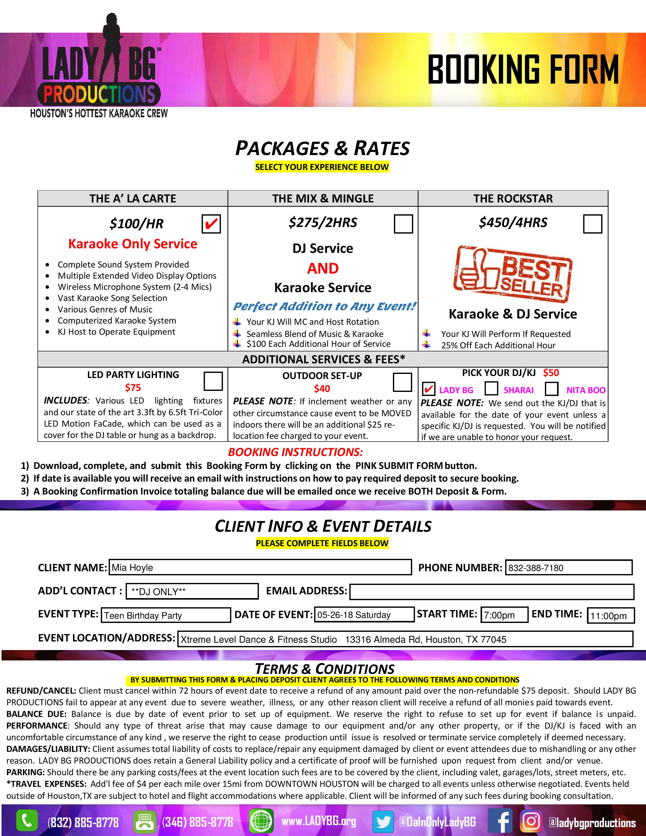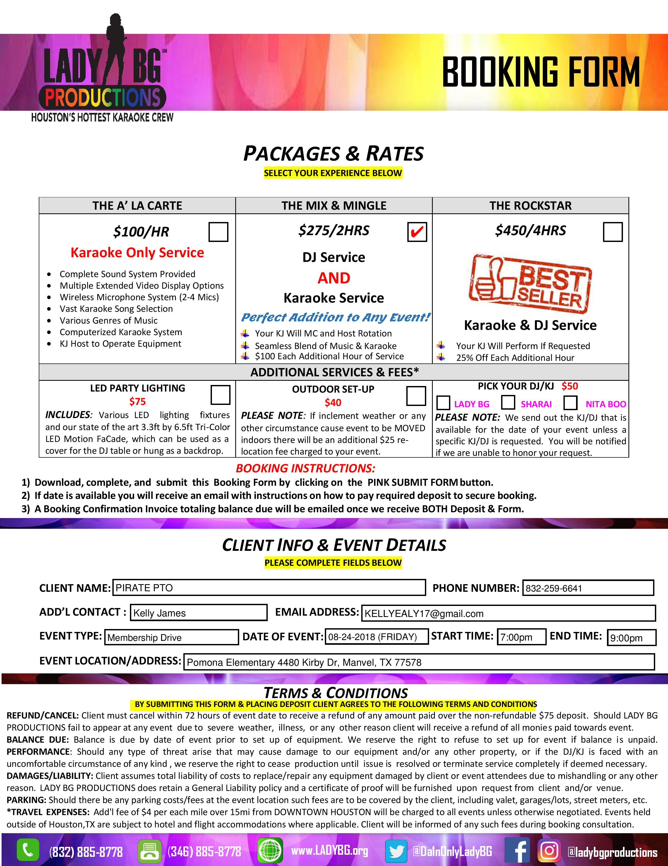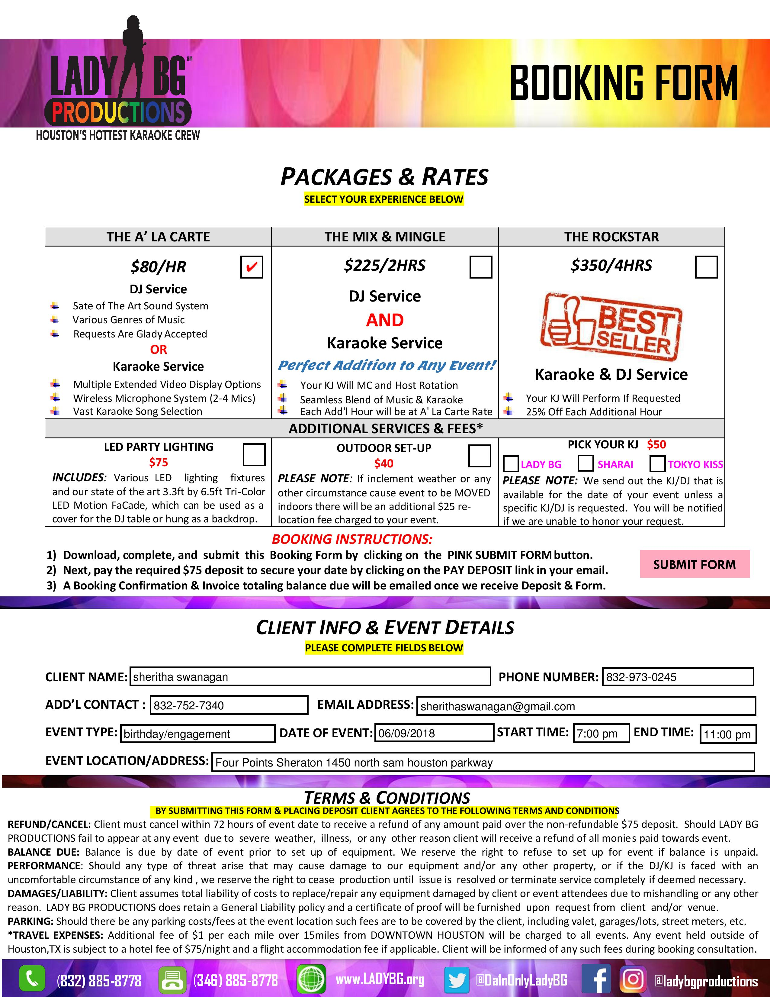

### Song and Packages

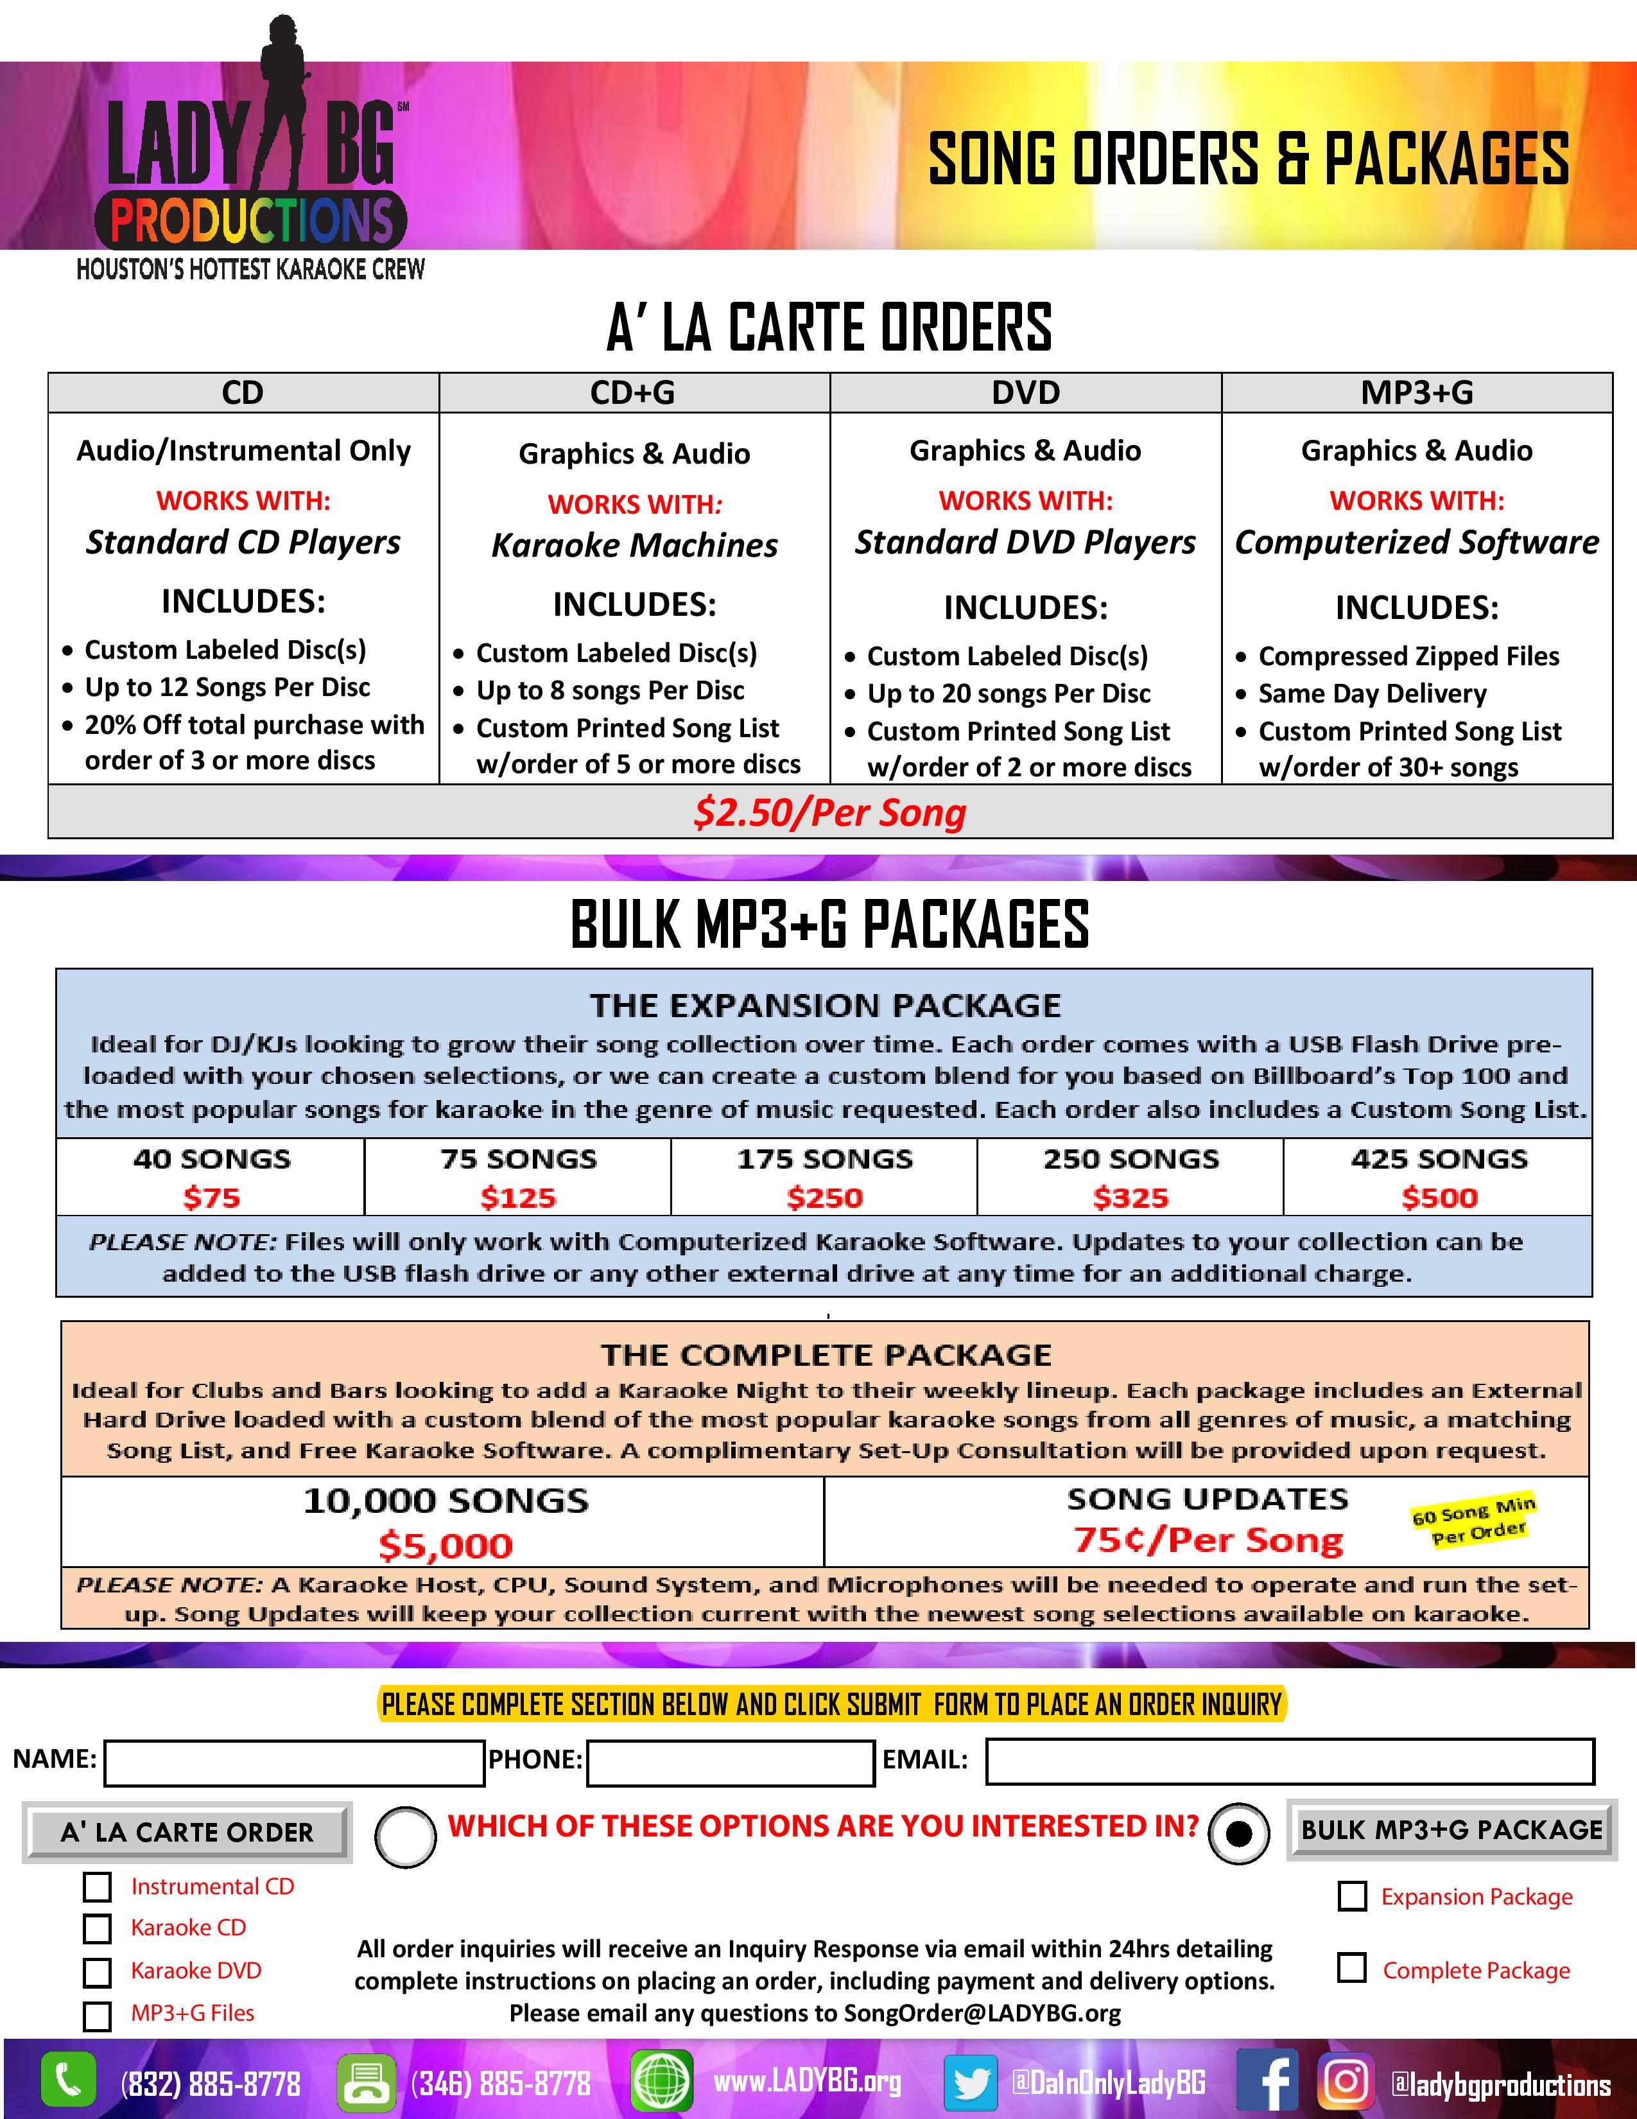

# Testing Processes

## Creation of Database

We began our project by creating 2 different databases to work with. The first initial database was created so that we can test out our various tables and their relationships. Certain tables have foreign keys that associates them to other tables. This caused us to run into certain issues as when we fill them out with data, previous tables need to have records inserted in them before they can be filled out.

## Insert Dummy Records

Lady BG has provided us a list of records that we can insert into the main database. However, before we can insert these records, we have to check whether or not the tables and their constraints are properly implemented. By using a bulk insert from a cvs file, we were able to test whether or not the columns and constraints within the tables were working properly. If the bulk insert ended in an error, that means the records were not the issue, but the table structure is.

## Delete and Update Testing

As a part of the project, we have to create an executable interface that Lady BG can use for her business. Within this interface, Lady BG will have the ability to have a table view listing of all available records within the database. Even if there are no records within the database, she will be able to insert records into it. Once records are inserted into the database through the interface, Lady BG will be able to delete and update necessary information. Using the dummy records, we tested out our delete and update buttons to check if the code was functioning properly.

# Project Improvements

As a prototype project still being tested, we overlooked some components and functionalities that we could have included within our project. Here are some of the few ideas we could have implemented to increase efficiency within the company.

* A query report that can be customized based on end user’s preference.
* An autofill feature in the event that a client is returning for business.
* A function that allows us to create a profile for a client so that we can add onto it.
* Automated email feature that sends out advertisement and discounts to past customers who requested a service.
* An online generated receipt to be eco-friendlier.
* Send out text messages to clients for discounted rates.

The customized query report is an excellent feature for Lady BG to use so that it’ll filter out information that Lady BG requires. Some of the reports that are generated through our queries are hard coded. This means that the set reports are the only thing Lady BG will be able to see. Sometimes, it is more beneficial to customize the reports to suit the needs so that Lady BG can look up information with ease.

A profile created for a client can be simple and allows the company to see the business transaction with each client. This helps the company decide whether or not if the client should receive a discount so that it could increase returned business.

An automated email feature would help Lady BG reach out to past clients and advertise their company with ease. As long as the flyer and email is preset, they waste no time as they reach out to their clients. This does not help reduce the booking process time, but it does not consume any necessary work time at all.

In the age we live right now, most customers or clients want to give back to the world. This means they want to reduce waste, recycle, and be greener. Making receipts paperless and sent electronically allows a company to take a step in that direction. Becoming a green company interests’ people and allow them to feel prouder to be associated with that company.

# Project Maintenance Issues

Some of the issues that we’ve ran into when creating this database and interface was the connection between our java compiler and the database. The method we chose to implement our interface was the use of javas Spring Boot Repositories and its flyway migration function. This allows the spring in java to look over our migration files to validate our table structures and relations. Flyway migration has caused us some issues where at times we would have to clean the cache and flush the system. By doing so, we can validate our migration files and ensure proper execution.

Another issue was that we have not created a back-up method for the database and interface. That is why we recommend to Lady BG to buy an additional hard drive or a bigger cloud storage space that will allow her to back up her records monthly. So far, when it comes to back-ups, there is no automated process and so they would have to be done manually by the IT or Lady BG.

In addition to having to do manual back-ups, the recovery point, in the event of a failure, can be found through the back-ups. We recommend that Lady BG back-up her data monthly so that not only will she have records for her own use, but also so she can avoid any future disasters that could impede her work operations.

# Lessons Learned

During this semester, we learned the limitations that come with a database. Some of the things that we painfully learned about this class was the time management skills we had to develop. Not everybody was doing their work on time and some had a lot on their plate. Not only that, we had to work on Lady BG’s time, and this could vary a lot as a business owner. It was hard to get a hold of her schedule while trying fit it into the times we were free.

We learned that the Foreign Keys were difficult to implement within a database because each table had an association with one another. When creating foreign keys for each table, there were issues we ran into when creating the constraint for each foreign key. We also learned that certain tables needed a connection between each other and because of this, we were not able to combine these table for a proper query report.

Flyway migration has proven itself to be difficult to work with. When creating our interface with java, we used flyway migration as a way to connect to our database and create our tables. The reason we chose this method because we learned this in CIS3368 that we are taking concurrently with this class. As we learned this in class, we tried to use this knowledge and integrate it with our project. We slowly learned that our configurations did not meet the requirements necessary, thus causing us issues within our database. One of the issues was that flyway shuffled our columns for each table after we had created them. This proved to be difficult as we tried to insert our records. We had to manually reorganize our columns to match how flyway rearranged our columns.

In conclusion, we learned that time management is a crucial skill to have as it encompasses our daily lives. As a result, we weren’t able to dedicate a majority of our time to the trouble shooting process for this project. We now know that, as we move forward in life, to pace ourselves and schedule out what is to be expected of us so that we can complete the tasks in an orderly and timely manner.

# Project Summary

We were hired to create a database for our employer – Lady BG. The goal of this project was to create an efficient system that would allow Lady BG to reduce her booking process and keep track of all her records. Due to her creating records and keeping track of it manually, we believed this to be the best solution for her.

We began the process by using our last semester Entity Relation Diagram and improved upon on with the knowledge we learned from Professor Sadeghi. This step was important due to the relationships each entity could have with each other, based on Lady BG’s business process.

The ERD’s that we created, allowed us to create tables within our SQL server and have them defined within our data dictionary. This is an important step because the data dictionary helps define our columns, data type, constraints, and field lengths.

After some more inquiries and research at Lady BG’s business, we were able to record “dummy” records for our database to test it out. Each table has been loaded with at least 100 records to test the threshold and capabilities our database has. During the insertion process, we tried out some SQL queries that joins 4 or more tables to generate reports that Lady BG can use for her business. Each report has a meaning and use to her company and will help let her see what is necessary for the company.

Lastly, while we were having the SQL server set up, we were constructing a Java based project that will act as an interface between the user and the SQL server. The Java we used was a Spring CRUD Repository base that will allow us to perform SQL commands with ease within our interface. Throughout this process, we managed to create the necessary screens possible to demonstrate our current prototype interface.

In conclusion, we currently have our initial database tables defined within our SQL server. Our normalized data models are created with our data dictionary fully documented. We managed to create SQL reports after our database tables were fully loaded and tested. The GUI, graphic user interface, has been connected to our database and functioning properly.

# Data Dictionary

## Booking_Status

Checks the booking status of client’s request for an event.

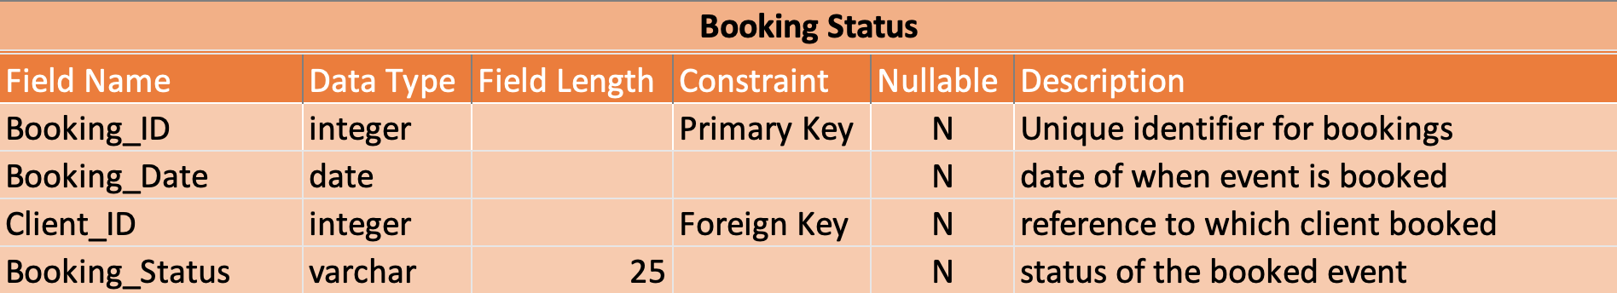

Client

List of clients and their recorded information and ID’s to uniquely identify each client.

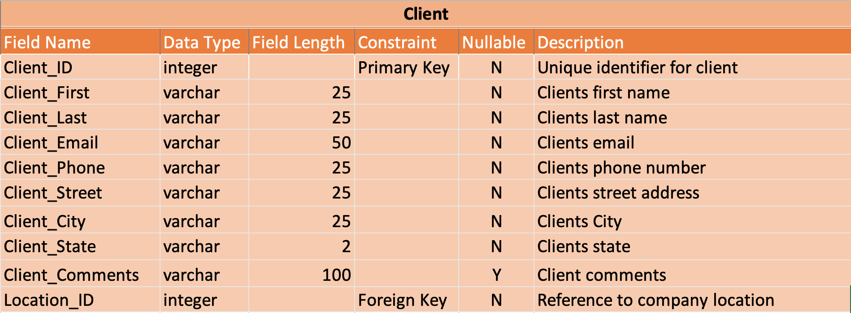

## Client_Location

List of the client’s address so that it is possible to mail out discounts for continued business.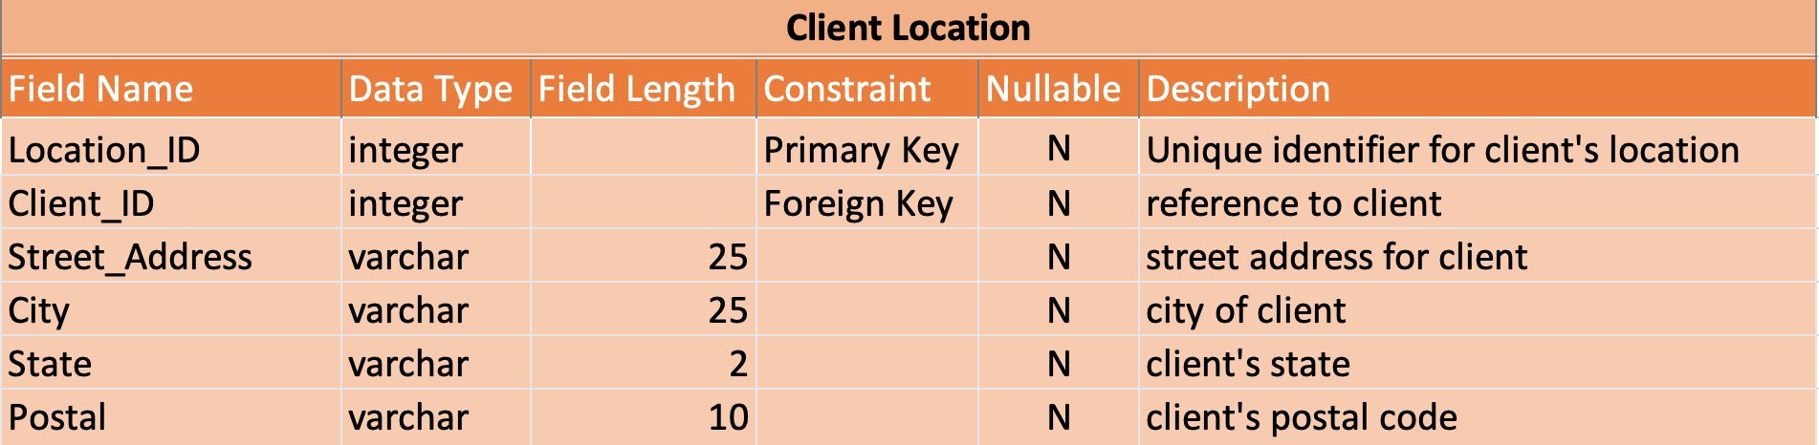

## Client_Type

List of type of client’s to determine whether or not they are new or a returning client.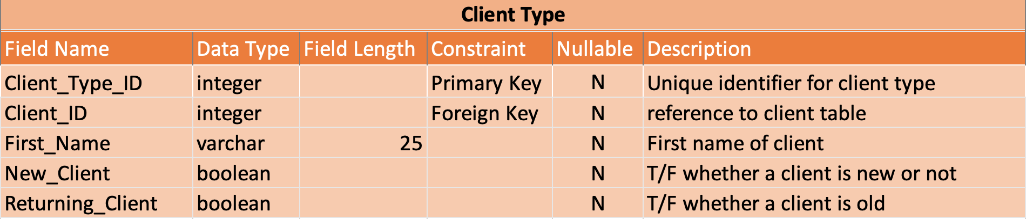

## County

List of all counties our client’s stem from. That way, we can determine which areas they are well known in.

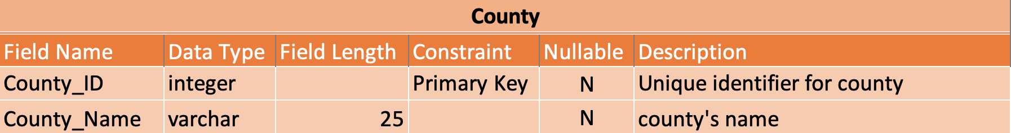

## Employee

List of all employees and their information needed for employment. Each employee has an ID that uniquely identifies them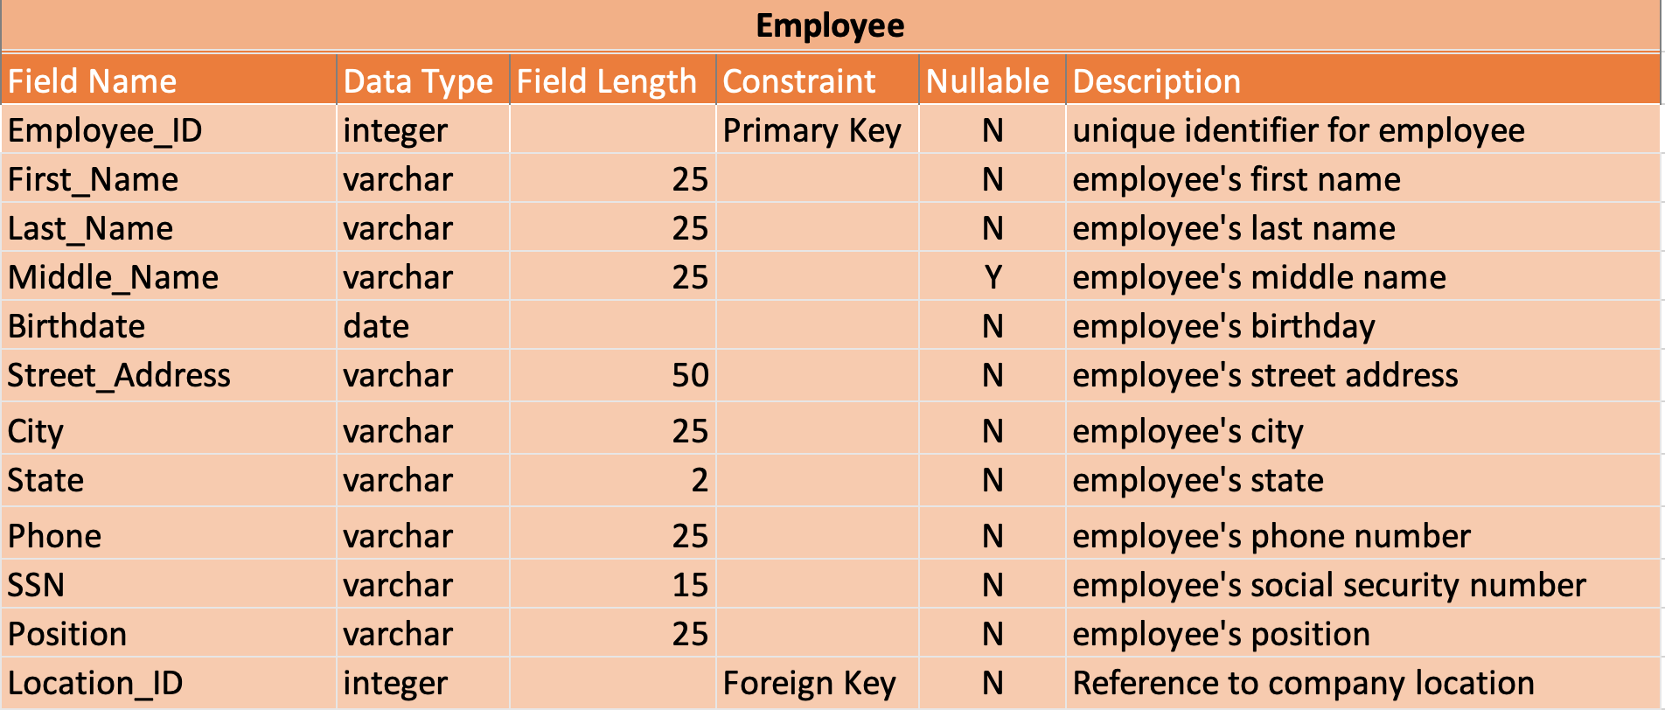

## Employee_Status

Status of any new employees to see if they are rejected or accepted as a worker.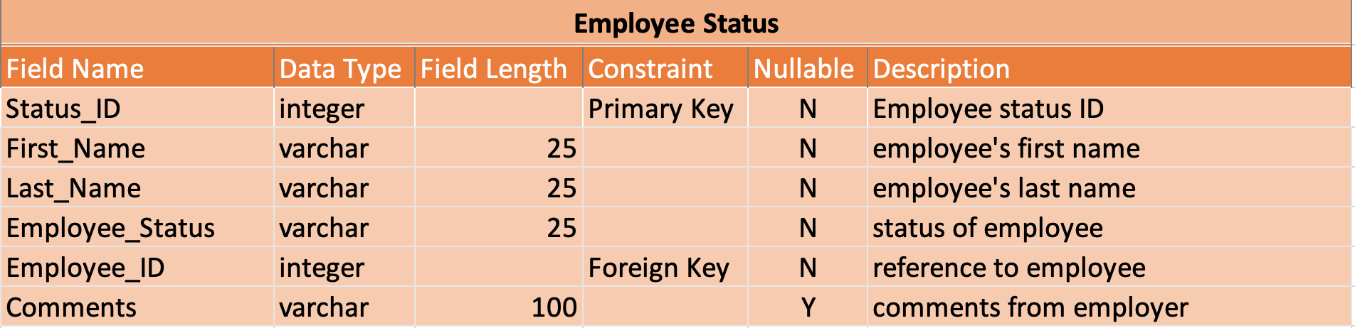

## Employee_Title

Title of an employee to determine their position within the company.

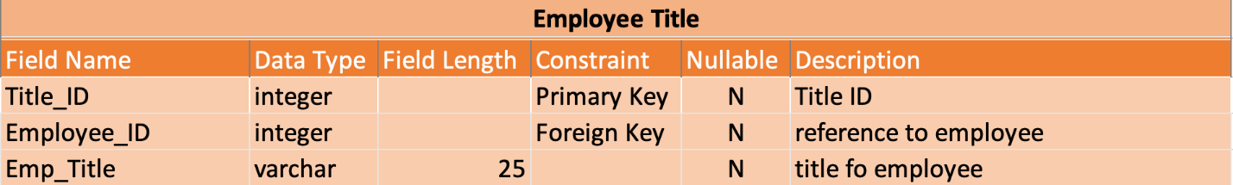

## Employee_Training_Request

Listing of all employee’s training request so that they may learn new skills.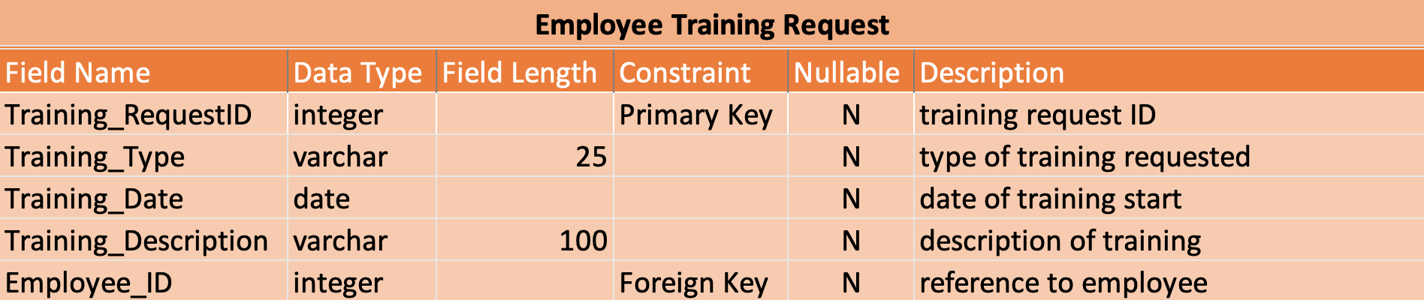

## Employee_Training_Status

Status of all employee training request. Determines if they are accepted for training.

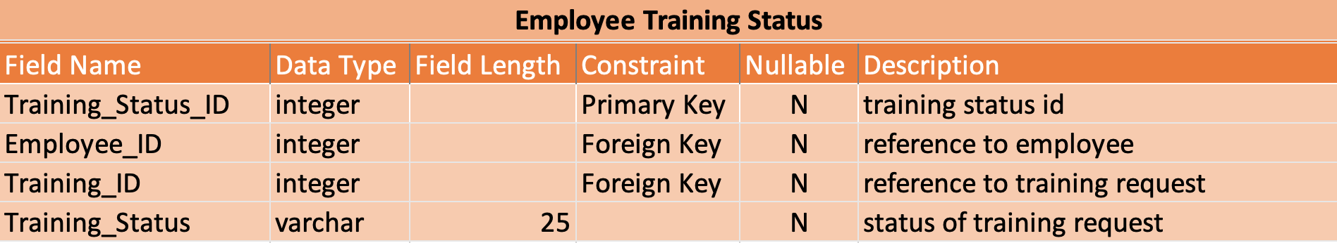

## Employee_Type

List of all types of employee on whether or not they are returning or new to the company.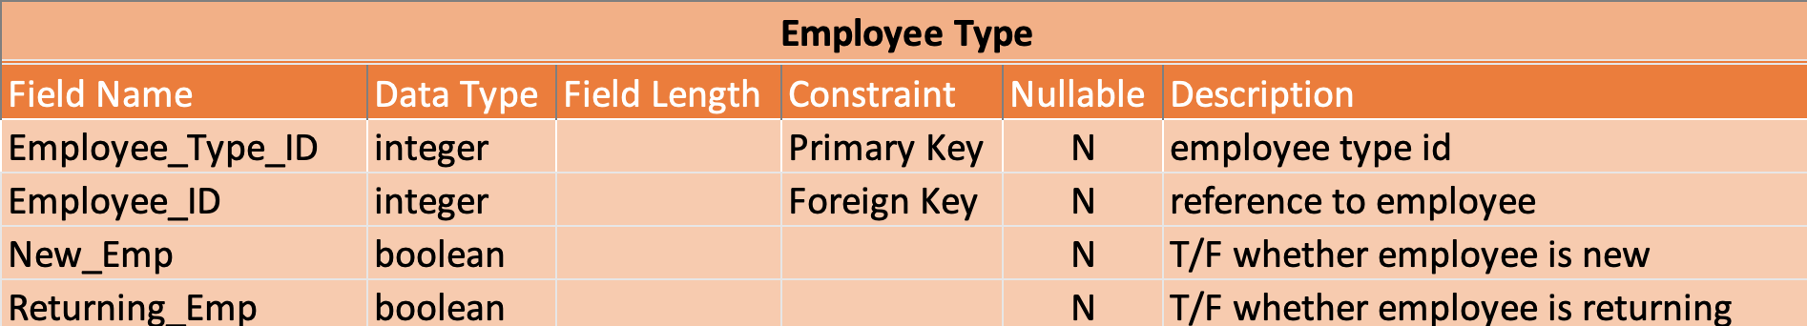

## Event

List of events that client’s request. Each event has an ID that uniquely identifies it and all events have a client ID that associates them to which client requests this event.

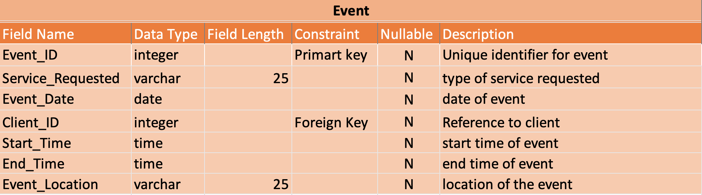

## Event_Date

A listing of all event dates that includes when it starts and ends.

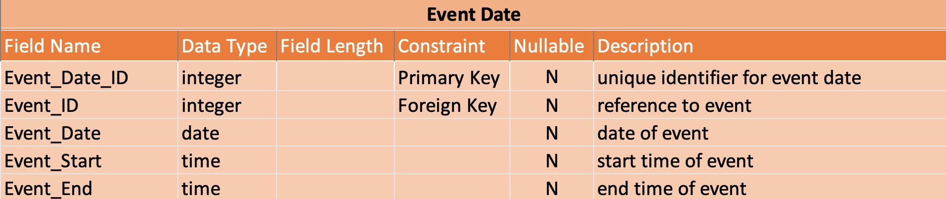

## Event_Expenses

A listing of all expenses incurred for an event or for any other expenses for the company.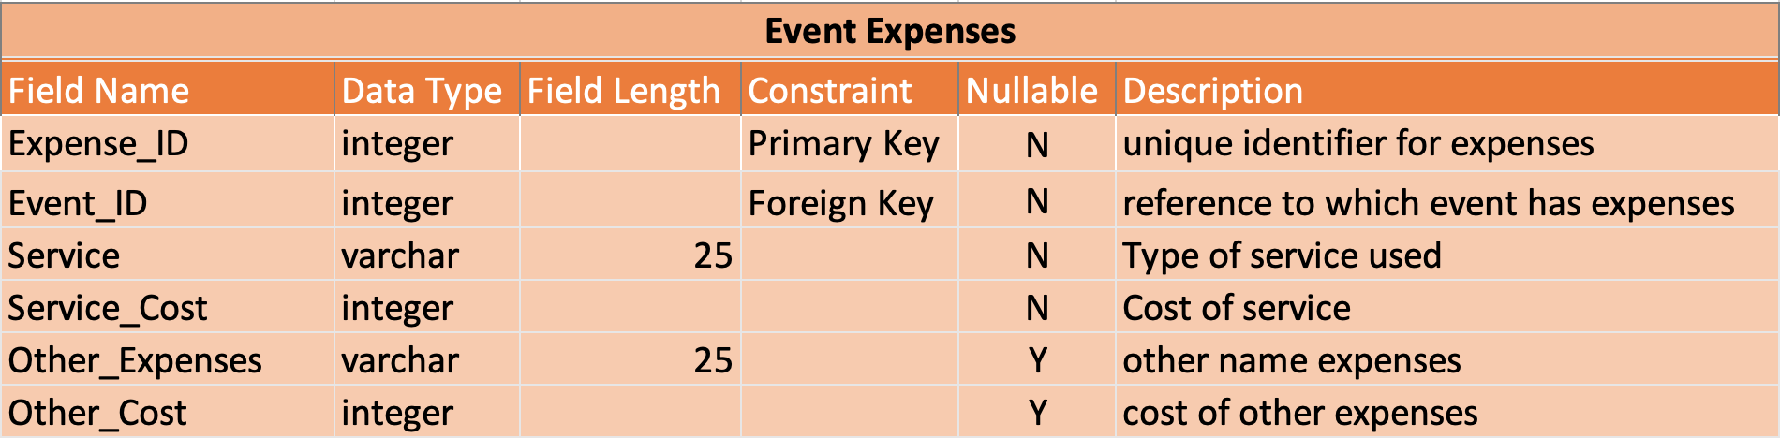

## Event_Location

Records all event location.

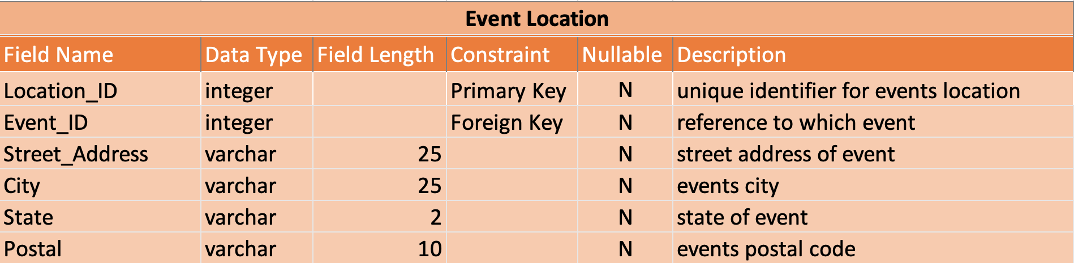

## Event_Status

Status of all events on whether or not they are approved. The status can also change depending on the client’s demand if they want to cancel it.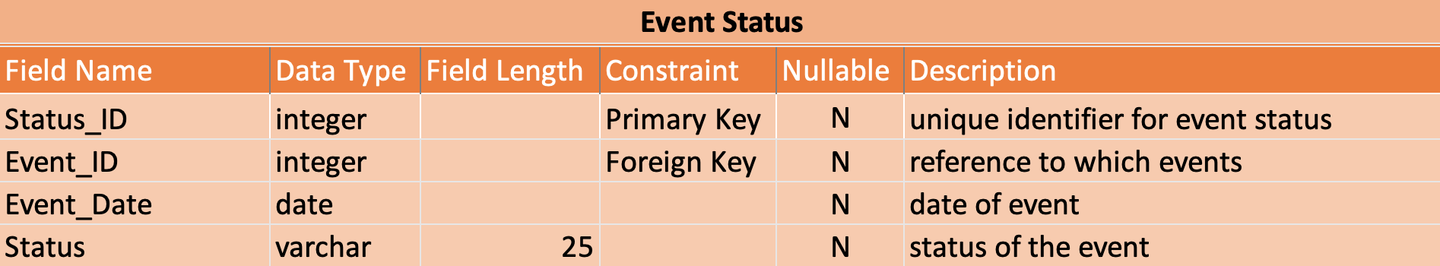

## Event_Type

Gives information on what event types are requested so that Lady BG can advertise their main sellers.

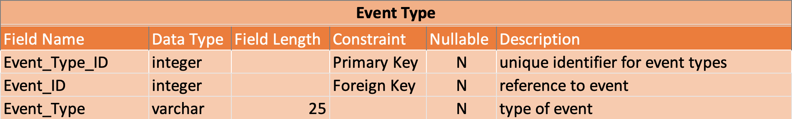

## Locations

Locations list all available company location. Each location has an ID that uniquely identifies them and is attached to each client and employee to know which company they request from.

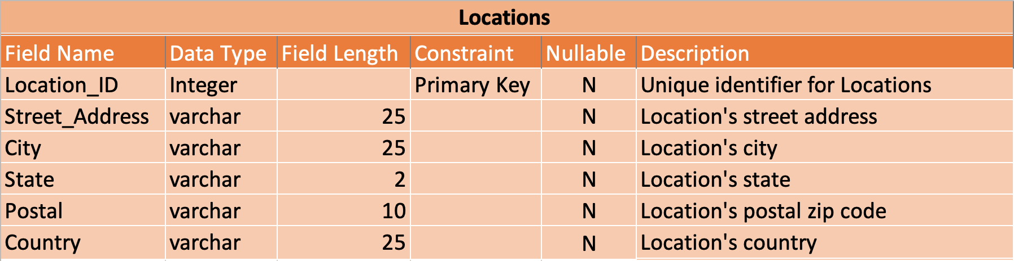

## Payment_Method

Listing of all payments made by customers. Can vary from card to cash or checks.

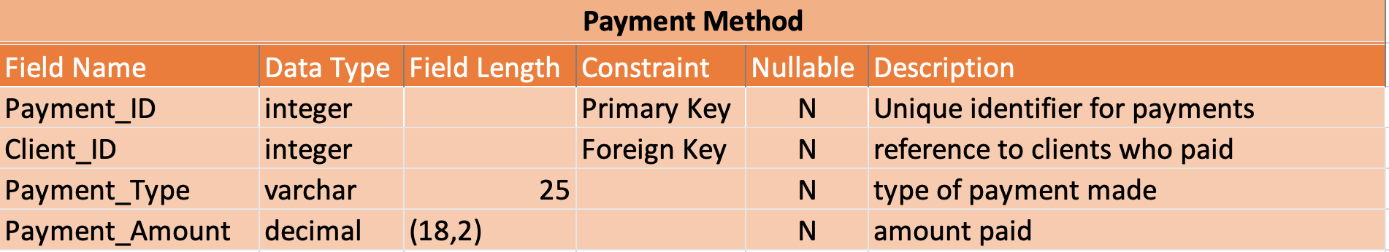

## Payroll

Payroll contains information from the timesheet where it pulls information to be sent to accountants or banks to generate paychecks.

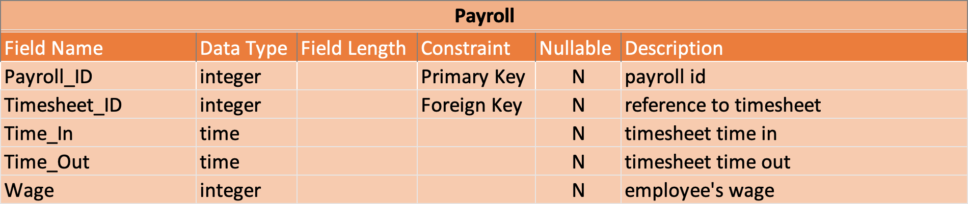

## Phone_Numbers

Listing of all available phone calls gathered from client’s who applied for an event.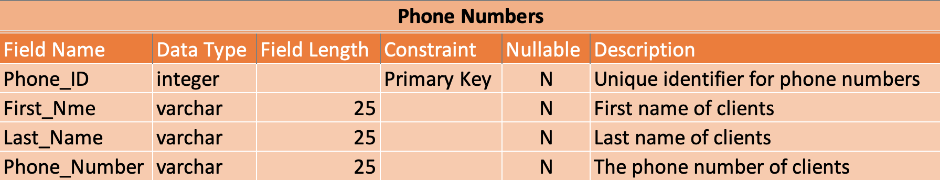

## Postal_Codes

Listing of all postal codes based on the information gained from clients and events.

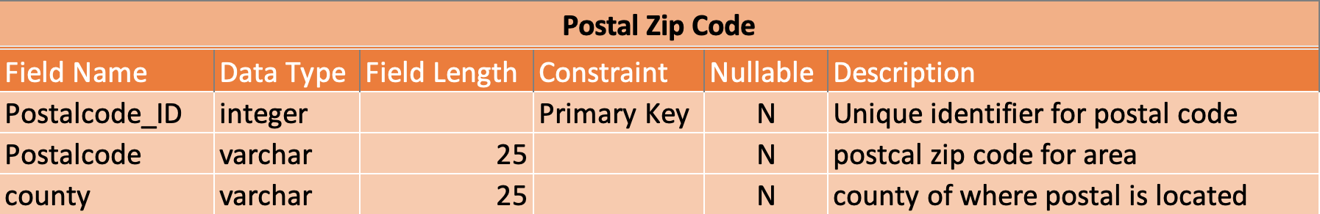

## Service_Requested

Listing of all services requested from clients so that we can statistically graph our best sellers.

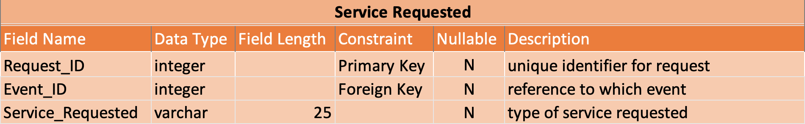

## Songs

List of all available songs so that we can sort them and track them based on preferences.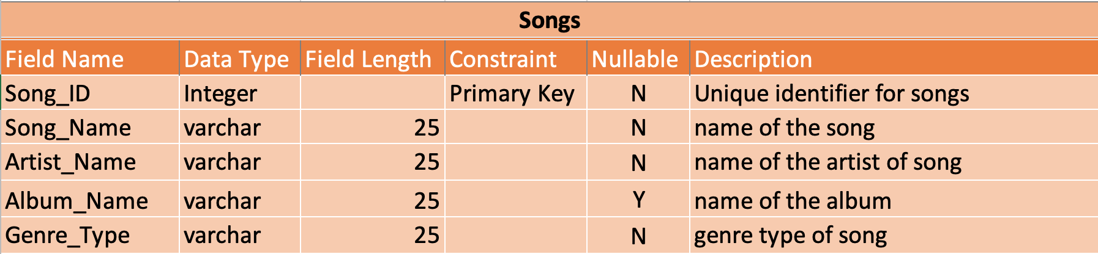

## Timesheet

List of all timesheets submitted by employees to be recorded for payroll.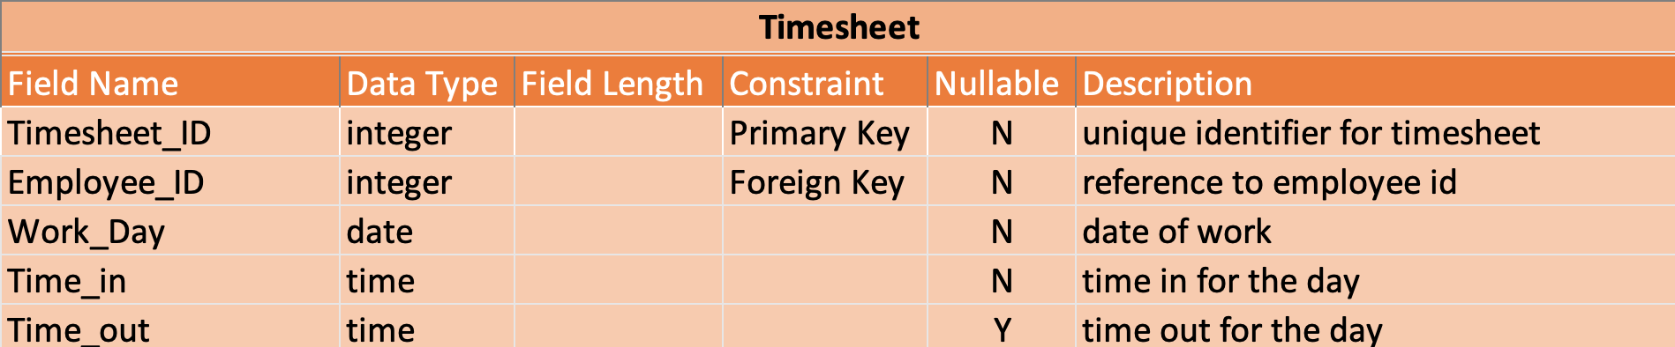

## Timesheet_Status

Gathers information from timesheet and owner can determine if the timesheets are inputted correct or not.

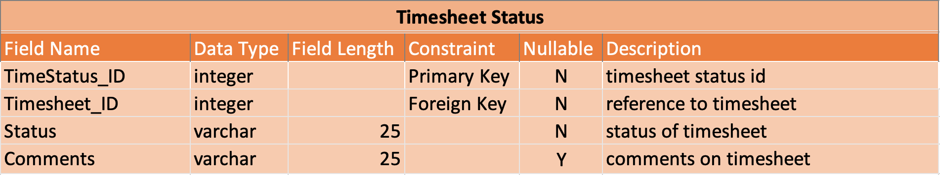

## User_Info

Information on all users for the interface.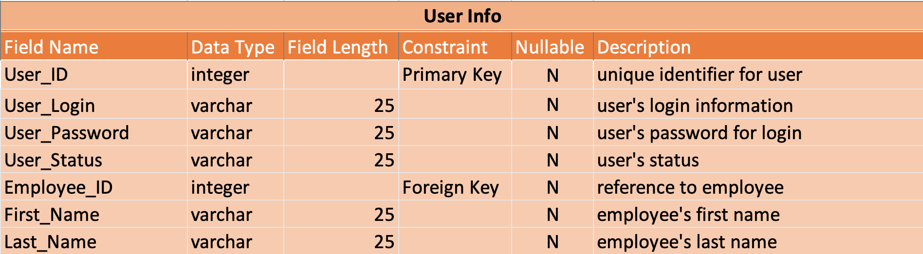

## User_Login

Detailing the user’s login for the system to check for validity.

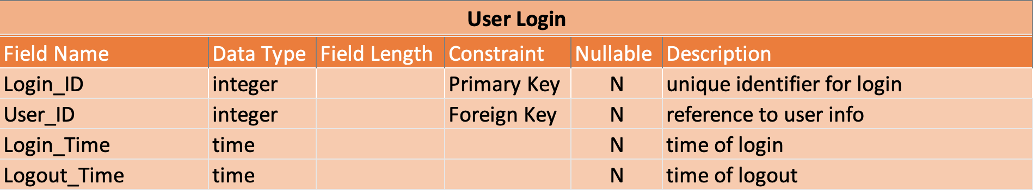

## Vacation_Request

A list for employees to send in a request to have vacation or off days.

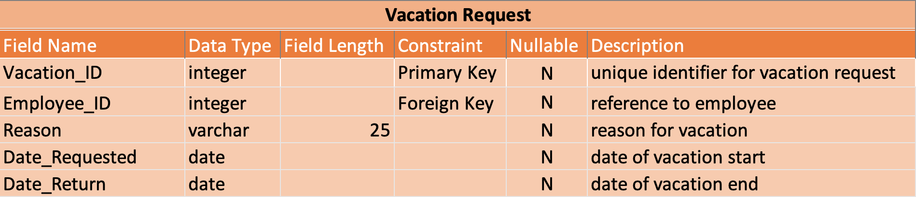

## Vacation_Status

Checks the status on vacation requests to see if they are approved or denied.

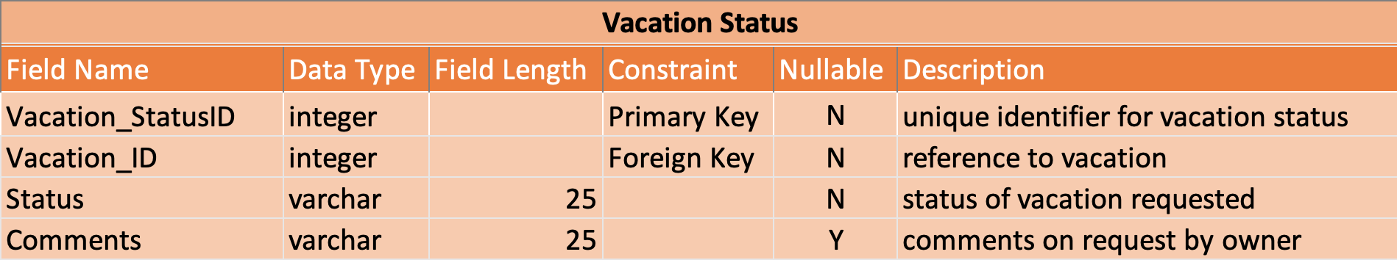

# Entity Relation Diagram (Primary Keys and Relationships)

## Relationships

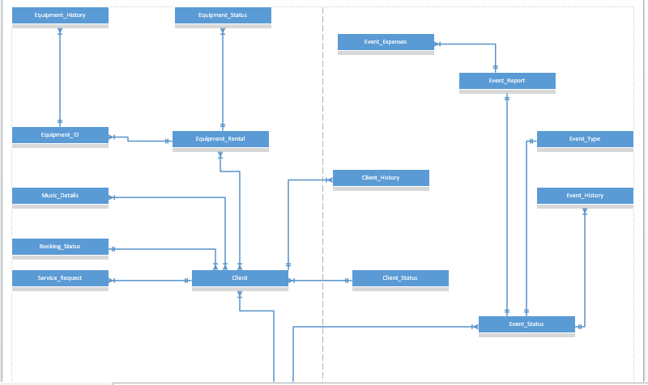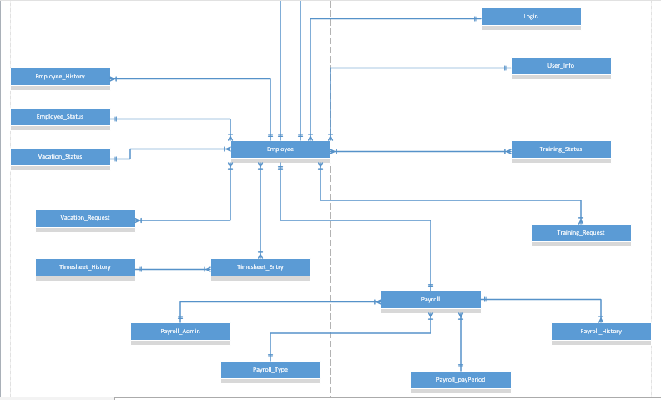

## Primary Keys and attributes

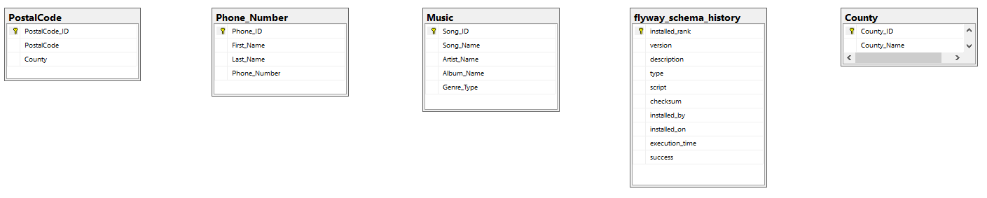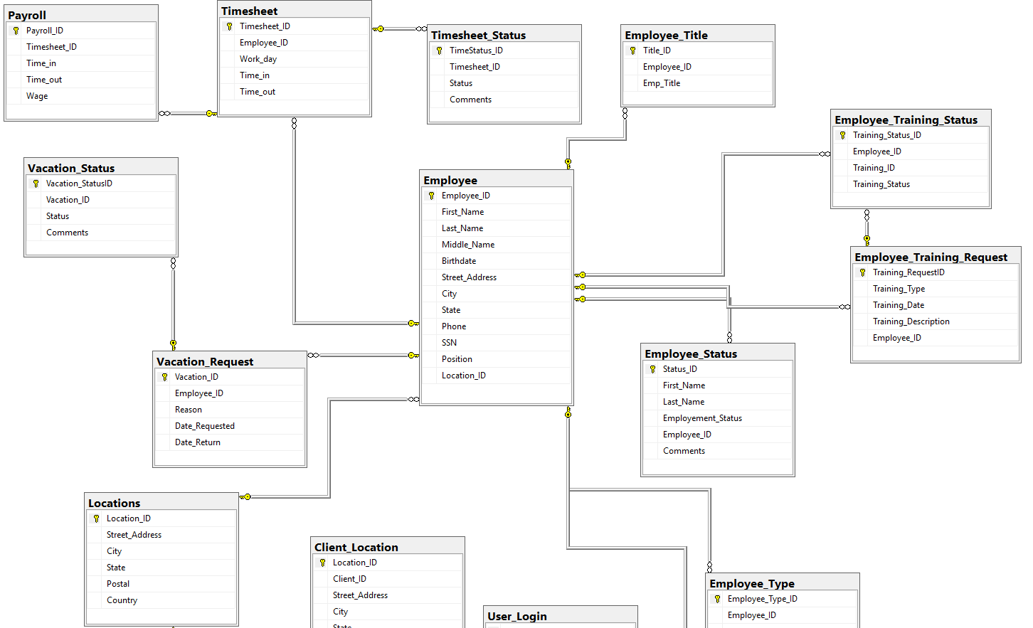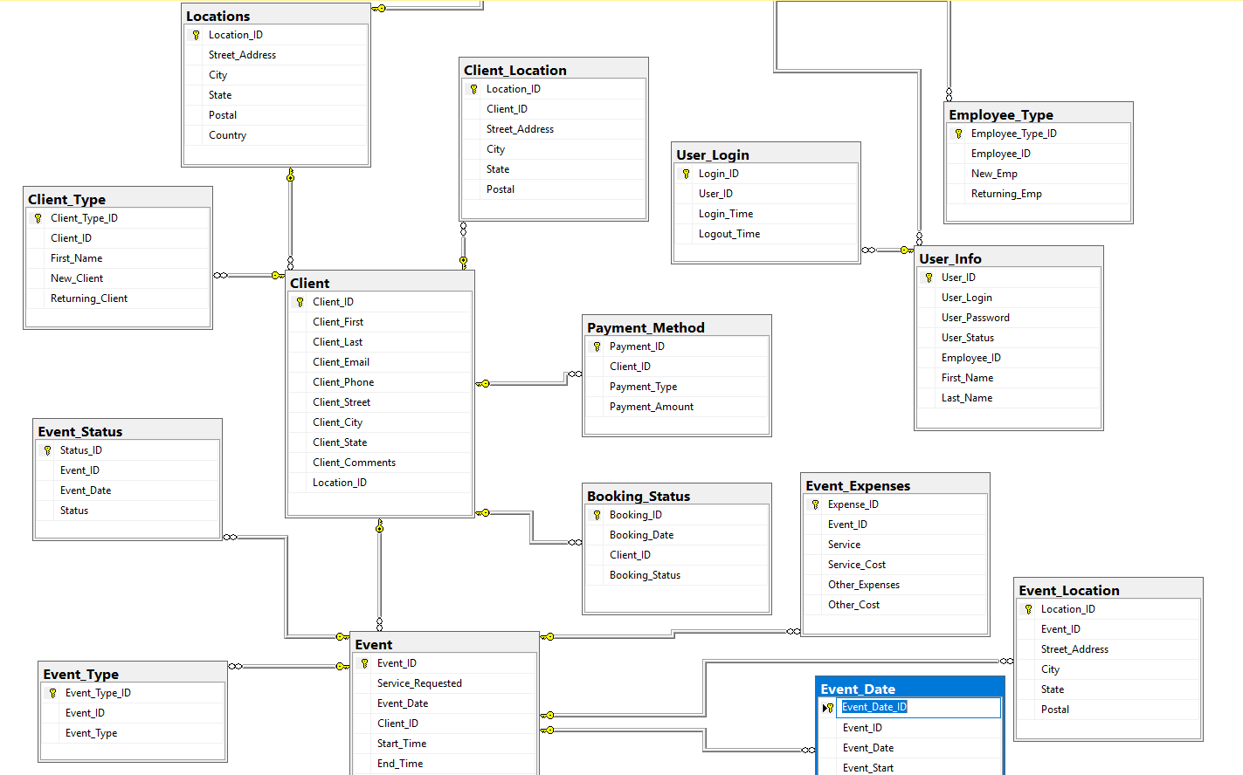

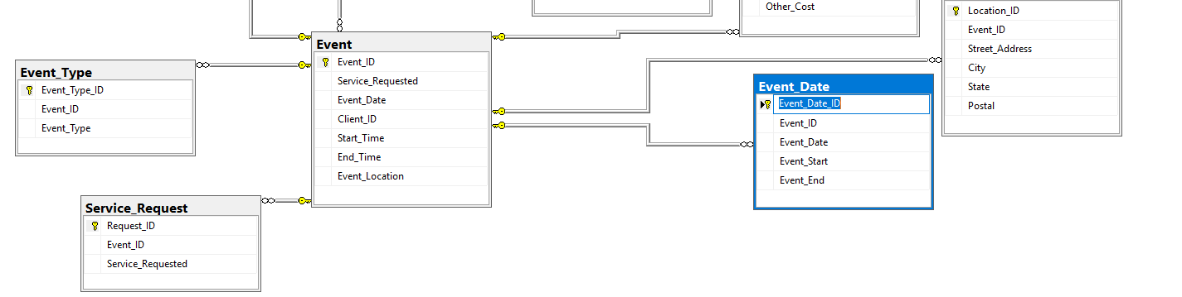

# Normalized Data Models

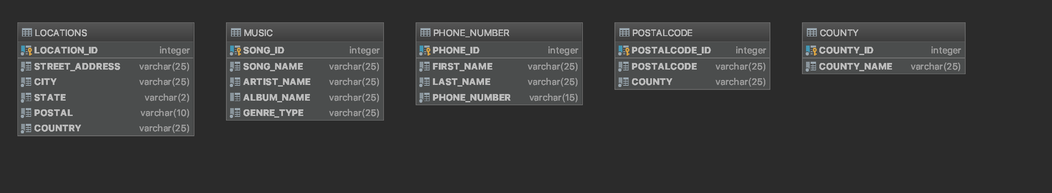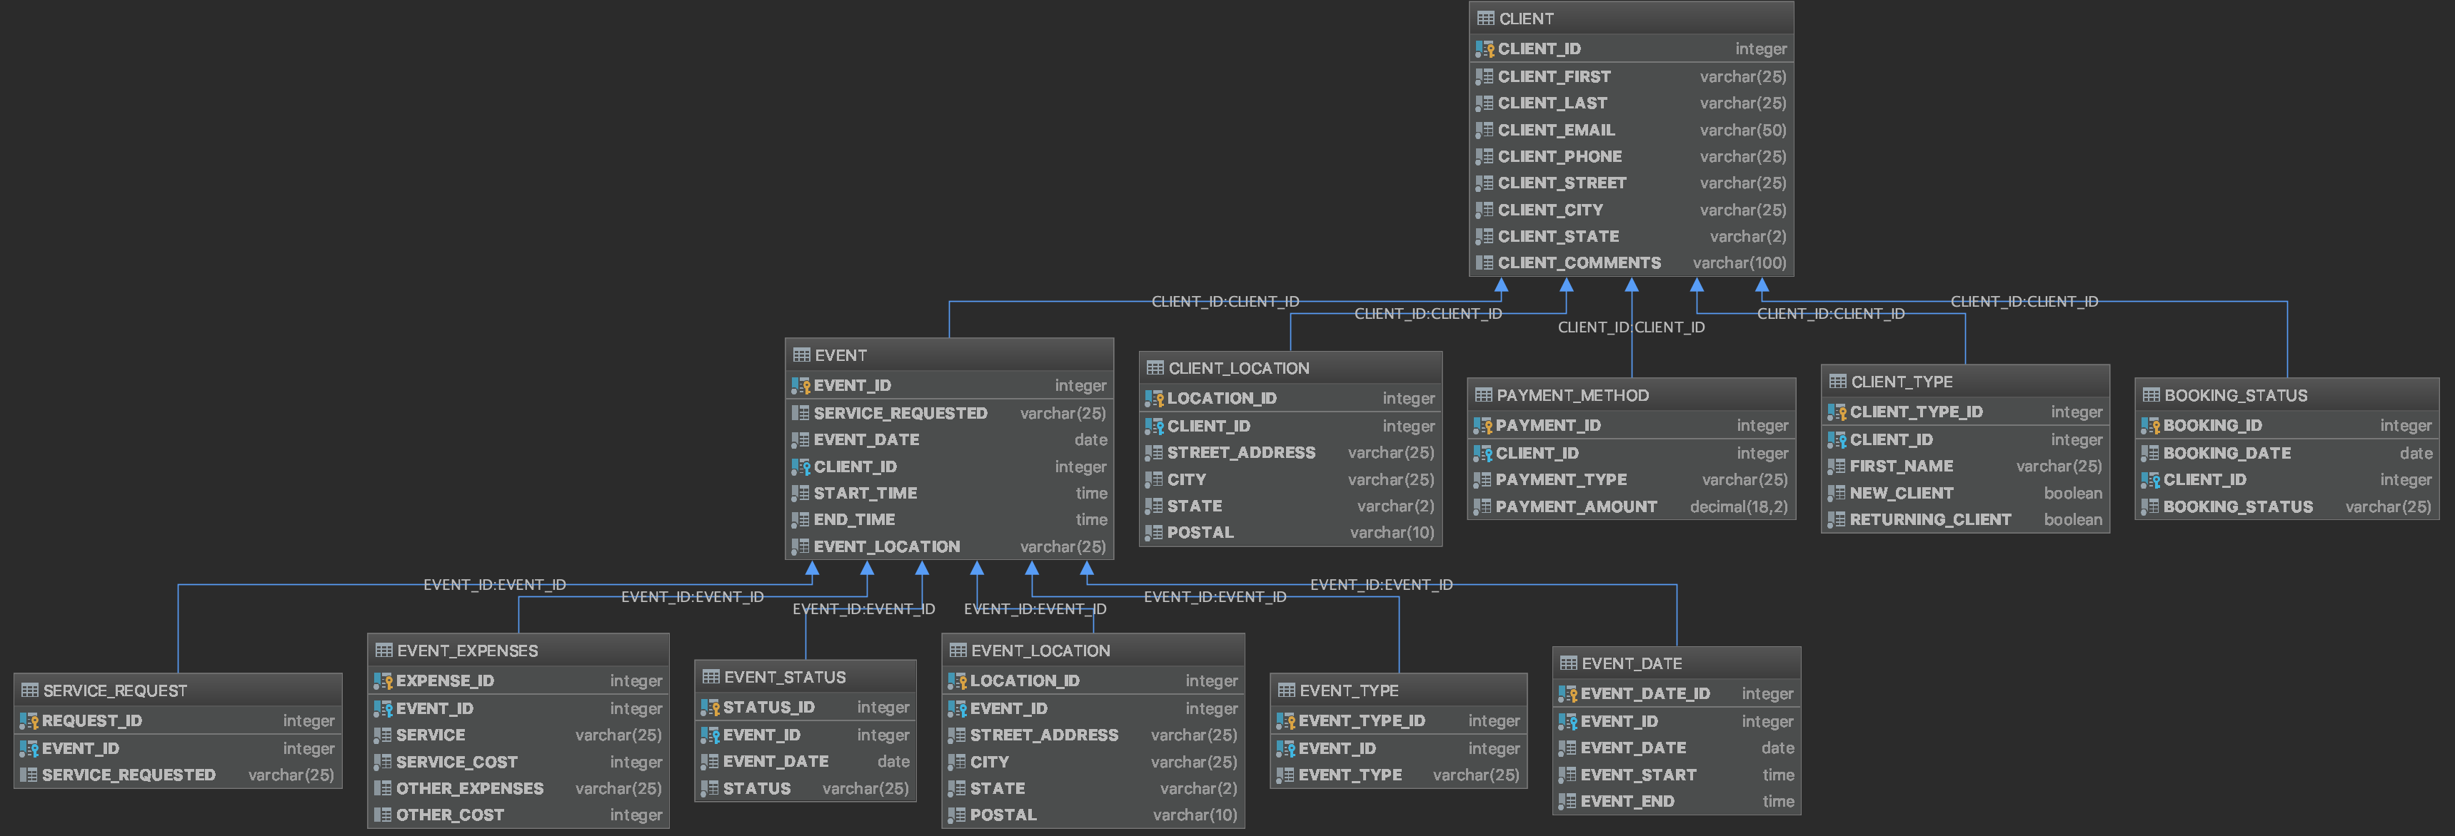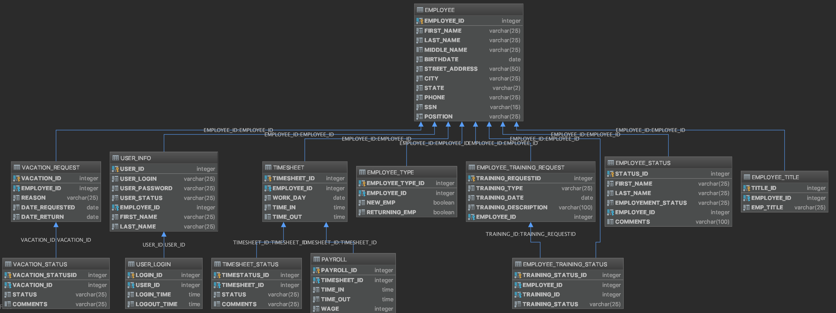

# Create Table Scripts

create table Locations

(

   Location_ID int not null identity(1,1),

   Street_Address varchar(25) not null,

   City varchar(25) not null,

   State varchar(2) not null,

   Postal varchar(10) not null,

   Country varchar(25) not null,

   constraint Locations_pk

       primary key (Location_ID)

);

create table County

(

   County_ID int not null identity(1,1),

   County_Name varchar(25) not null,

   constraint County_pk

       primary key (County_ID)

);

create table Phone_Number

(

   Phone_ID int not null identity(1,1),

   First_Name varchar(25) not null,

   Last_Name varchar(25) not null,

   Phone_Number varchar(15) not null,

   constraint Phone_Number_pk

       primary key (Phone_ID)

);

create table Client

(

   Client_ID int not null identity(1,1),

   Client_First varchar(25) not null,

   Client_Last varchar(25) not null,

   Client_Email varchar(50) not null,

   Client_Phone varchar(25) not null,

   Client_Street varchar(25) not null,

   Client_City varchar(25) not null,

   Client_State varchar(2) not null,

   Client_Comments varchar(100),

   constraint Client_pk

       primary key (Client_ID)

);

create table Client_Type

(

   Client_Type_ID int not null identity(1,1),

   Client_ID int not null,

   First_Name varchar(25) not null,

   New_Client bit not null,

   Returning_Client bit not null,

   constraint Client_Type_pk

       primary key (Client_Type_ID)

);

create table Client_Location

(

   Location_ID int not null identity(1,1),

   Client_ID int not null,

   Street_Address varchar(25) not null,

   City varchar(25) not null,

   State varchar(2) not null,

   Postal varchar(10) not null,

   constraint Client_Location_pk

       primary key (Location_ID)

);

create table PostalCode

(

   PostalCode_ID int not null identity(1,1),

   PostalCode varchar(25) not null,

   County varchar(25) not null,

   constraint PostalCode_pk

       primary key (PostalCode_ID)

);

create table Payment_Method

(

   Payment_ID int not null identity(1,1),

   Client_ID int not null,

   Payment_Type varchar(25) not null,

   Payment_Amount decimal(18,2) not null,

   constraint Payment_Method_pk

       primary key (Payment_ID)

);

create table Booking_Status

(

   Booking_ID int not null identity(1,1),

   Booking_Date date not null,

   Client_ID int not null,

   Booking_Status varchar(25) not null,

   constraint Booking_Status_pk

       primary key (Booking_ID)

);

create table Employee

(

   Employee_ID int not null identity(1,1),

   First_Name varchar(25) not null,

   Middle_Name varchar(25),

   Last_Name varchar(25) not null,

   Birthdate date not null,

   Street_Address varchar(50) not null,

   City varchar(25) not null,

   State varchar(2) not null,

   Phone varchar(25) not null,

   SSN varchar(15) null,

   Position varchar(25) not null,

   constraint Employee_pk

       primary key (Employee_ID)

);

create table Employee_Type

(

   Employee_Type_ID int not null identity(1,1),

   Employee_ID int not null,

   New_Emp bit not null,

   Returning_Emp bit not null,

   constraint Employee_Type_pk

       primary key (Employee_Type_ID)

);

create table Employee_Title

(

   Title_ID int not null identity(1,1),

   Employee_ID int not null,

   Emp_Title varchar(25) not null,

   constraint Employee_Title_pk

       primary key (Title_ID)

);

create table Employee_Status

(

   Status_ID int not null identity(1,1),

   First_Name varchar(25) not null,

   Last_Name varchar(25) not null,

   Employement_Status varchar(25) not null,

   Employee_ID int not null,

   Comments varchar(100),

   constraint Employee_Status_pk

       primary key (Status_ID)

);

create table Employee_Training_Request

(

   Training_RequestID int not null identity(1,1),

   Employee_ID int not null,

   Training_Date date not null,

   Training_Description varchar(100) not null,

   Training_Type varchar(25) not null,

   constraint Employee_Training_Request_pk

       primary key (Training_RequestID)

);

create table Employee_Training_Status

(

   Training_Status_ID int not null identity(1,1),

   Employee_ID int not null,

   Training_ID int not null,

   Training_Status varchar(25) not null,

   constraint Employee_Training_Status_pk

       primary key (Training_Status_ID)

);

create table Timesheet

(

   Timesheet_ID int not null identity(1,1),

   Employee_ID int not null,

   Work_day date not null,

   Time_in time not null,

   Time_out time,

   constraint Timesheet_pk

       primary key (Timesheet_ID)

);

create table Timesheet_Status

(

   TimeStatus_ID int not null identity(1,1),

   Timesheet_ID int not null,

   Status varchar(25) not null,

   Comments varchar(25),

   constraint Timesheet_Status_pk

       primary key (TimeStatus_ID)

);

create table Vacation_Request

(

   Vacation_ID int not null identity(1,1),

   Employee_ID int not null,

   Reason varchar(25) not null,

   Date_Requested date not null,

   Date_Return date not null,

   constraint Vacation_Request_pk

       primary key (Vacation_ID)

);

create table Vacation_Status

(

   Vacation_StatusID int not null identity(1,1),

   Vacation_ID int not null,

   Status varchar(25) not null,

   Comments varchar(25),

   constraint Vacation_Status_pk

       primary key (Vacation_StatusID)

);

create table User_Info

(

   User_ID int not null identity(1,1),

   User_Login varchar(25) not null,

   User_Password varchar(60) not null,

   User_Status varchar(25) not null,

   Employee_ID int not null,

   First_Name varchar(25) not null,

   Last_Name varchar(25) not null,

   constraint User_Info_pk

       primary key (User_ID)

);

create table User_Login

(

   Login_ID int not null identity(1,1),

   User_ID int not null,

   Login_Time time not null,

   Logout_Time time not null,

   constraint User_Login_pk

       primary key (Login_ID)

);

create table Payroll

(

   Payroll_ID int not null identity(1,1),

   Timesheet_ID int not null,

   Time_in time not null,

   Time_out time not null,

   Wage int not null,

   constraint Payroll_pk

       primary key (Payroll_ID)

);

create table Event

(

   Event_ID int not null identity(1,1),

   Service_Requested varchar(25),

   Event_Date date not null,

   Client_ID int not null,

   Start_Time time not null,

   End_Time time not null,

   Event_Location varchar(25) not null,

   constraint Event_pk

       primary key (Event_ID)

);

create table Event_Location

(

   Location_ID int not null identity(1,1),

   Event_ID int not null,

   Street_Address varchar(25) not null,

   City varchar(25) not null,

   State varchar(2) not null,

   Postal varchar(10) not null,

   constraint Event_Location_pk

       primary key (Location_ID)

);

create table Event_Date

(

   Event_Date_ID int not null identity(1,1),

   Event_ID int not null,

   Event_Date date not null,

   Event_Start time not null,

   Event_End time not null,

   constraint Event_Date_pk

       primary key (Event_Date_ID)

);

create table Event_Type

(

   Event_Type_ID int not null identity(1,1),

   Event_ID int not null,

   Event_Type varchar(25) not null,

   constraint Event_Type_pk

       primary key (Event_Type_ID)

);

create table Service_Request

(

   Request_ID int not null identity(1,1),

   Event_ID int not null,

   Service_Requested varchar(25),

   constraint Service_Request_pk

       primary key (Request_ID)

);

create table Event_Expenses

(

   Expense_ID int not null identity(1,1),

   Event_ID int not null,

   Service varchar(25) not null,

   Service_Cost int not null,

   Other_Expenses varchar(25),

   Other_Cost int,

   constraint Event_Expenses_pk

       primary key (Expense_ID)

);

create table Event_Status

(

   Status_ID int not null identity(1,1),

   Event_ID int not null,

   Event_Date date not null,

   Status varchar(25) not null,

   constraint Event_Status_pk

       primary key (Status_ID)

);

create table Music

(

   Song_ID int not null identity(1,1),

   Song_Name varchar(25) not null,

   Artist_Name varchar(25) not null,

   Album_Name varchar(25),

   Genre_Type varchar(25) not null,

   constraint Music_pk

       primary key (Song_ID)

);

# Alter Table Scripts

Alter table Client_Type

 Add constraint Fk_Client_Type_ID

   Foreign key(Client_ID) references Client(Client_ID);

Alter table Client_Location

 Add constraint Fk_Client_Location_ID

   Foreign key(Client_ID) references Client(Client_ID);

Alter table Payment_Method

 Add constraint Fk_Payment_ID

   Foreign key(Client_ID) references Client(Client_ID);

Alter table Booking_Status

 Add constraint Fk_Booking_ID

   Foreign key(Client_ID) references Client(Client_ID);

Alter table Employee_Type

 Add constraint Fk_Employee_Type_ID

   Foreign key(Employee_ID) references Employee(Employee_ID);

Alter table Employee_Title

 Add constraint Fk_Employee_Title_ID

   Foreign key(Employee_ID) references Employee(Employee_ID);

Alter table Employee_Status

 Add constraint Fk_Employee_Status_ID

   Foreign key(Employee_ID) references Employee(Employee_ID);

Alter table Employee_Training_Request

 Add constraint Fk_Employee_Training_RequestID

   Foreign key(Employee_ID) references Employee(Employee_ID);

Alter table Employee_Training_Status

 Add constraint Fk_Employee_Training_StatusID

   Foreign key(Employee_ID) references Employee(Employee_ID);

Alter table Employee_Training_Status

 Add constraint Fk_Employee_Training

   Foreign key(Training_ID) references Employee_Training_Request(Training_RequestID);

Alter table Timesheet

 Add constraint Fk_Timesheet_ID

   Foreign key(Employee_ID) references Employee(Employee_ID);

Alter table Timesheet_Status

 Add constraint Fk_Timesheet_StatusID

   Foreign key(Timesheet_ID) references Timesheet(Timesheet_ID);

Alter table Payroll

 Add constraint Fk_Payroll

   Foreign key(Timesheet_ID) references Timesheet(Timesheet_ID);

Alter table Vacation_Request

 Add constraint Fk_Vacation_Request

   Foreign key(Employee_ID) references Employee(Employee_ID);

Alter table Vacation_Status

 Add constraint Fk_Vacation_Status

   Foreign key(Vacation_ID) references Vacation_Request(Vacation_ID);

Alter table User_Info

 Add constraint Fk_User_Info

   Foreign key(Employee_ID) references Employee(Employee_ID);

Alter table User_Login

 Add constraint Fk_User_Login

   Foreign key(User_ID) references User_Info(User_ID);

Alter table Event

 Add constraint Fk_Event_ID

   Foreign key(Client_ID) references Client(Client_ID);

Alter table Event_Location

 Add constraint Fk_Event_Location

   Foreign key(Event_ID) references Event(Event_ID);

Alter table Event_Date

 Add constraint Fk_Event_Date

   Foreign key(Event_ID) references Event(Event_ID);

Alter table Event_Type

 Add constraint Fk_Event_Type

   Foreign key(Event_ID) references Event(Event_ID);

Alter table Service_Request

 Add constraint Fk_Service_Request

   Foreign key(Event_ID) references Event(Event_ID);

Alter table Event_Expenses

 Add constraint Fk_Event_Expenses

   Foreign key(Event_ID) references Event(Event_ID);

Alter table Event_Status

 Add constraint Fk_Event_Status

   Foreign key(Event_ID) references Event(Event_ID);

Alter table Client

Add Location_ID int not null;

Alter table Employee

Add Location_ID int not null;

Alter table Client

Add constraint Fk_Client_Location

foreign key(Location_ID) references Locations(Location_ID);

Alter table Employee

Add constraint Fk_Employee_Location

foreign key(Location_ID) references Locations(Location_ID);

# Data’s Loaded into Tables

## Song Records.csv file

1,Old Town Road ,Lil Nas X,,Hip Hop

2,Paranoid,Post Malone,BeerBongs&Bentleys,Hip Hop

3,Spoil my night,Post Malone,BeerBongs&Bentleys,Hip Hop

4,Rich & Sad,Post Malone,BeerBongs&Bentleys,Hip Hop

5,Zack and Codeine,Post Malone,BeerBongs&Bentleys,Hip Hop

6,Takin Shots,Post Malone,BeerBongs&Bentleys,Hip Hop

7,rockstar,Post Malone,BeerBongs&Bentleys,Hip Hop

8,over now,Post Malone,BeerBongs&Bentleys,Hip Hop

9,psycho,Post Malone,BeerBongs&Bentleys,Hip Hop

10,better now,Post Malone,BeerBongs&Bentleys,Hip Hop

11,ball for me,Post Malone,BeerBongs&Bentleys,Hip Hop

12,otherside,Post Malone,BeerBongs&Bentleys,Hip Hop

13,stay,Post Malone,BeerBongs&Bentleys,Hip Hop

14,blame it on me,Post Malone,BeerBongs&Bentleys,Hip Hop

15,same bitches,Post Malone,BeerBongs&Bentleys,Hip Hop

16,jonestown,Post Malone,BeerBongs&Bentleys,Hip Hop

17,92 explorer,Post Malone,BeerBongs&Bentleys,Hip Hop

18,candy paint,Post Malone,BeerBongs&Bentleys,Hip Hop

19,sugar wraith,Post Malone,BeerBongs&Bentleys,Hip Hop

20,Dark Sky,Big Sean,Dark Sky Paradise,Hip Hop

21,Blessings,Big Sean,Dark Sky Paradise,Hip Hop

22,All Your Fault,Big Sean,Dark Sky Paradise,Hip Hop

23,I Don't Fuck With You,Big Sean,Dark Sky Paradise,Hip Hop

24,Play No Games,Big Sean,Dark Sky Paradise,Hip Hop

25,Paradise,Big Sean,Dark Sky Paradise,Hip Hop

26,"Win Some, Lose Some",Big Sean,Dark Sky Paradise,Hip Hop

27,Stay Down,Big Sean,Dark Sky Paradise,Hip Hop

28,I Know,Big Sean,Dark Sky Paradise,Hip Hop

29,Deep,Big Sean,Dark Sky Paradise,Hip Hop

30,One Man,Big Sean,Dark Sky Paradise,Hip Hop

31,Outro,Big Sean,Dark Sky Paradise,Hip Hop

32,Deserve It,Big Sean,Dark Sky Paradise,Hip Hop

33,Research ,Big Sean,Dark Sky Paradise,Hip Hop

34,Platnium And Wood,Big Sean,Dark Sky Paradise,Hip Hop

35,Stargazing,Travis Scott,AstroWorld,Hip Hop

36,Carousel,Travis Scott,AstroWorld,Hip Hop

37,Sicko Mode,Travis Scott,AstroWorld,Hip Hop

38,Stop Trying To Be God,Travis Scott,AstroWorld,Hip Hop

39,No Bystanders,Travis Scott,AstroWorld,Hip Hop

40,Skeletons,Travis Scott,AstroWorld,Hip Hop

41,Wake Up,Travis Scott,AstroWorld,Hip Hop

42,5% Tint,Travis Scott,AstroWorld,Hip Hop

43,NC-17,Travis Scott,AstroWorld,Hip Hop

44,Astrothunder,Travis Scott,AstroWorld,Hip Hop

45,Yosemite,Travis Scott,AstroWorld,Hip Hop

46,Can't Say,Travis Scott,AstroWorld,Hip Hop

47,Who? What?,Travis Scott,AstroWorld,Hip Hop

48,Butterfly Effect,Travis Scott,AstroWorld,Hip Hop

49,Houstonfornication,Travis Scott,AstroWorld,Hip Hop

50,Coffee Bean,Travis Scott,AstroWorld,Hip Hop

51,Middle Child,J. Cole,,Hip Hop

52,Intro,J. Cole,Forest Hills Drive,Hip Hop

53,January,J. Cole,Forest Hills Drive,Hip Hop

54,Wet Dreamz,J. Cole,Forest Hills Drive,Hip Hop

55,03' Adolescence,J. Cole,Forest Hills Drive,Hip Hop

56,A Tale of 2 Citiez,J. Cole,Forest Hills Drive,Hip Hop

57,Fire Squad,J. Cole,Forest Hills Drive,Hip Hop

58,St. Tropez,J. Cole,Forest Hills Drive,Hip Hop

59,Intermission,J. Cole,Forest Hills Drive,Hip Hop

60,G.O.M.D.,J. Cole,Forest Hills Drive,Hip Hop

61,No Role Modelz,J. Cole,Forest Hills Drive,Hip Hop

62,Hello,J. Cole,Forest Hills Drive,Hip Hop

63,Apparently,J. Cole,Forest Hills Drive,Hip Hop

64,Love Yourz,J. Cole,Forest Hills Drive,Hip Hop

65,Bad Luck,Khalid,Free Spirit,Hip Hop

66,My Bad,Khalid,Free Spirit,Hip Hop

67,Better,Khalid,Free Spirit,Hip Hop

68,Talk,Khalid,Free Spirit,Hip Hop

69,Right Back,Khalid,Free Spirit,Hip Hop

70,Don't Pretend,Khalid,Free Spirit,Hip Hop

71,Paradise,Khalid,Free Spirit,Hip Hop

72,Hundred,Khalid,Free Spirit,Hip Hop

73,Outta My Head,Khalid,Free Spirit,Hip Hop

74,Free Spirit,Khalid,Free Spirit,Hip Hop

75,Twenty One,Khalid,Free Spirit,Hip Hop

76,Bluffin',Khalid,Free Spirit,Hip Hop

77,Self,Khalid,Free Spirit,Hip Hop

78,Alive,Khalid,Free Spirit,Hip Hop

79,Heaven,Khalid,Free Spirit,Hip Hop

80,Saturday Nights,Khalid,Free Spirit,Hip Hop

81,Imagine,Ariana Grande,"Thank u, next",Pop

82,Needy,Ariana Grande,"Thank u, next",Pop

83,NASA,Ariana Grande,"Thank u, next",Pop

84,Bloodline,Ariana Grande,"Thank u, next",Pop

85,Fake Smile,Ariana Grande,"Thank u, next",Pop

86,Bad Idea,Ariana Grande,"Thank u, next",Pop

87,Make Up,Ariana Grande,"Thank u, next",Pop

88,Ghostin,Ariana Grande,"Thank u, next",Pop

89,In My Head,Ariana Grande,"Thank u, next",Pop

90,7 Rings,Ariana Grande,"Thank u, next",Pop

91,"thank u, next",Ariana Grande,"Thank u, next",Pop

92,Break up with your gf,Ariana Grande,"Thank u, next",Pop

93,The Ringer,Ariana Grande,"Thank u, next",Pop

94,Lucky You,Eminem,Kamikaze,Hip Hop

95,Not Alike,Eminem,Kamikaze,Hip Hop

96,Fall,Eminem,Kamikaze,Hip Hop

97,Greatest,Eminem,Kamikaze,Hip Hop

98,Normal,Eminem,Kamikaze,Hip Hop

99,Stepping Stone,Eminem,Kamikaze,Hip Hop

100,Kill Shot,Eminem,,Hip Hop

## Locations.cvs file

1,9585 S. Main Blvd,Houston,TX,77025,United States

2,2727 Murworth Dr.,Houston,TX,77054,United States

3,219 Veltri Drive,Anchorage,AK,99503,United States

4,1221 Lonely Oak Drive,Mobile,AL,36602,United States

5,1513 Fittro Street,Lockesburg,AR,71846,United States

6,1145 Crowfield Road,Phoenix,AZ,85034,United States

7,8 Ashcraft Court,San Diego,CA,92111,United States

8,2007 Clover Drive,Pueblo,CO,81003,United States

9,3803 Whitman Court,New Haven,CT,06511,United States

10,4806 Massachusetts Ave,Washington,DC,20011,United States

11,2559 Argonne St,New Castle,DE,19720,United States

12,3671 Mapleview Dr.,Moon Lake,FL,33568,United States

13,3782 Edington Dr.,Decatur,GA,30030,United States

14,3396 Stratford Dr.,Honolulu,HI,96813,United States

15,1740 Pyramid Valley Rd,Ft. Madison,IA,52627,United States

16,4492 Science Center,Ririe,ID,83443,United States

17,4834 College View,Palestine,IL,62451,United States

18,1889 Capitol Ave.,Delphi,IN,46923,United States

19,2586 Better St.,Kansas City,KS,66215,United States

20,1332 Harper St.,Custer,KY,40115,United States

21,2260 Sherwood Cr.,Lafayette,LA,70501,United States

22,3915 C Street,E. Bridgewater,MA,02333,United States

23,2221 Five Points,Bel Air,MD,21014,United States

24,1207 Fantages Way,Westbrook,ME,04092,United States

25,2097 Robinson Ct.,Saginaw,MI,48607,United States

26,3968 Brighton Circle,Saint Cloud,MN,56303,United States

27,4562 chandler Dr.,Fairview,MO,64842,United States

28,1941 Gorby Ln.,Tylertown,MS,39667,United States

29,4595 Tibbs Ave.,Thompson Falls,MT,59873,United States

30,620 Hannah St.,Charlotte,NC,28273,United States

31,80 Catherine Dr.,Minot,ND,58701,United States

32,1808 Poling Farm Rd.,La Vista,NE,68128,United States

33,1256 Milford St.,Manchester,NH,03103,United States

34,3537 Watson St.,Laurel Springs,NJ,08021,United States

35,2037 Reel Ave.,Farmington,NM,87401,United States

36,4636 Martha Ellen Drive,Reno,NV,89501,United States

37,644 Redbud Dr.,New York,NY,10013,United States

38,1554 Carriage Lane,Toledo,OH,43609,United States

39,2325 Henry Ford,Broken Arrow,OK,74012,United States

40,1826 Mattson St,Portland,OR,97205,United States

41,277 Tipple Rd.,Philadelphia,PA,19115,United States

42,717 Winding Way,Providence ,RI,02903,United States

43,90 Wexford Way,Lancaster,SC,29720,United States

44,3540 Andy St.,Oldham,SD,57051,United States

45,4779 Point Dr.,Memphis,TN,38110,United States

46,2659 Whispering Pines,Lewisville,TX,75067,United States

47,450 Buck Dr.,Salt Lake City,UT,84119,United States

48,1972 Worley Ave.,Lynchburg,VA,24501,United States

49,590 Duff Ave.,South Burlington,VT,05403,United States

50,2929 Conifer Dr.,Tukwila,WA,98168,United States

51,1558 Irish Lane,Mt. Vernon,WI,53572,United States

52,1204 Froe St.,Lawford,WV,26409,United States

53,1548 Arbor Ct.,Casper,WY,82601,United States

54,2765 Acton Ave.,Toronto ,ON,M3H 4J1,Canada

55,1847 Scarth St.,Montreal,QC,S4P 3Y2,Canada

56,Ziegelstr. 80,Dietersburg,FB,84378,United Kingdom

57,638 W. Edgemont,Hartford,CT,06106,United States

58,99 S. Wellington Dr.,Middleburg,FL,32068,United States

59,9225 Union Lane,Maryvile,TN,37803,United States

60,36 Windsor St.,Mableton ,GA,30126,United States

61,183 Sulphur Springs,Lincoln Park,MI,48146,United States

62,9 3rd St.,Virginia Beach,VA,23451,United States

63,5 King Street,Noblesville,IN,46060,United States

64,946 State Court,Butler,PA,16001,United States

65,40 E. Baker St.,Greenwood,SC,29646,United States

66,9207 Hilldale St.,La Crosse ,WI,54601,United States

67,9424 W. Valley Lane,Ellicott City,MD,21042,United States

68,52 Pineknoll Ave.,Woodside,NY,11377,United States

69,8027 N. Spruce Lane,Jenison,MI,49428,United States

70,8015 East Dr.,Anchorage ,AK,99504,United States

71,298 Fordham St.,Hinesville,GA,31313,United States

72,9146 W. Railroad Dr.,Altoona,PA,16601,United States

73,153 Crescent St.,Hicksville,NY,11801,United States

74,877 Vane Dyke St.,Toledo,OH,43612,United States

75,79 Glen Creek St.,Supperior,WI,54880,United States

76,9584 Randall Mill,Sterling,VA,20164,United States

77,388 Lake View St,Wasilla ,AK,99654,United States

78,9356 Hanover,Hanover,PA,17331,United States

79,78 Woodside Dr.,Fairport,NY,14450,United States

80,32 Logan Circle,Winter Springs,FL,32708,United States

81,7896 W. Princeton St.,Jacksonville,FL,32250,United States

82,62 W. Arlington St.,Bethlehem,PA,18015,United States

83,7707 Constitution,Wantagh,NY,11793,United States

84,39 Old Euclid Ave.,Winona,MN,55987,United States

85,9 Rosewood Rd,Windsor Mill,MD,21244,United States

86,7563 N. Swanson St.,Mt. Vernon,NT,10550,United States

87,65 S. Somerset St.,Waterford,MI,48329,United States

88,8499 Plumb Branch,Fall River,MA,02720,United States

89,4 Pacific St.,Methuen,MA,01844,United States

90,8127 Lake Dr.,Coraopolis,PA,15108,United States

91,329 Whitemarsh St.,Birmingham,AL,35209,United States

92,528 Kent Street,Raleigh,NC,27603,United States

93,8222 E. Tallwood St,Raeford,NC,28376,United States

94,314 Riverside St.,Roseville,MI,48066,United States

95,9620 E. Pacific St.,Manassas ,VA,20109,United States

96,493 Leeton Ridge ,Graham,NV,27253,United States

97,9869 Arcadia Ave.,Temple Hills,MD,20748,United States

98,207 White Street,Bemidji,MN,56601,United States

99,484 Cemetery Rd,Knoxville,TN,37918,United States

100,23 Rockwell Court,Clearwater,FL,33756,United States

## Clients.csv file

1,Avis,Moroz,Avis.Moroz@gmail.com  ,(325) 372-8992,7811 E. Hamilton,Abbott,TX,No Comment,1

2,Floyd,Paek,Floyd.Paek@gmail.com  ,(706) 578-8078,409 N. Paris Hill St,Abernathy,TX,No Comment,1

3,Marjory,Gisi,Marjory.Gisi@gmail.com  ,(405) 676-2234,968 W. Lakeshore St.,Abilene,TX,No Comment,1

4,Lance,Garnett,Lance.Garnett@gmail.com  ,(338) 466-1980,863 N. Walt Whitman,Ackerly,TX,No Comment,1

5,Georgene,Bach,Georgene.Bach@gmail.com  ,(629) 397-4936,47 Lyme Ave,Addison,TX,No Comment,1

6,Evonne,Seales,Evonne.Seales@gmail.com  ,(553) 650-0503,35 N. Indian Summer,Adrian,TX,No Comment,1

7,Jeanette,Allinder,Jeanette.Allinder@gmail.com  ,(414) 383-1439,41 Carson St.,Agua Dulce,TX,No Comment,1

8,Anh,Currier,Anh.Currier@gmail.com  ,(503) 246-2251,80 North Pulaski Dr.,Alamo,TX,No Comment,1

9,Major,Fuller,Major.Fuller@gmail.com  ,(691) 946-7716,40 Roehampton Rd,Alamo Heights,TX,No Comment,1

10,Eldon,Mccolley,Eldon.Mccolley@gmail.com  ,(973) 836-1042,397 Randall Mill St.,Albany,TX,No Comment,1

11,Rudolf,Reza,Rudolf.Reza@gmail.com  ,(246) 581-8261,7293 Goldfield St,Aledo,TX,No Comment,1

12,Norma,Flemister,Norma.Flemister@gmail.com  ,(610) 503-6106,674 Del Monte St,Alice,TX,No Comment,1

13,Carman,Turco,Carman.Turco@gmail.com  ,(716) 346-8068,15 Oakland ,Allen,TX,No Comment,1

14,Lovella,Jennette,Lovella.Jennette@gmail.com  ,(817) 768-7173,468 Santa Clara St,Alpine,TX,No Comment,1

15,Rutha,Widman,Rutha.Widman@gmail.com  ,(447) 410-5693,44 Swanson St,Alon,TX,No Comment,1

16,Annamarie,Alpers,Annamarie.Alpers@gmail.com  ,(286) 468-4490,33 E. Piper Ave.,Alvarado,TX,No Comment,1

17,Kit,Blasko,Kit.Blasko@gmail.com  ,(393) 238-9026,7758 Manor St.,Alvin,TX,No Comment,1

18,Jeanice,Grennan,Jeanice.Grennan@gmail.com  ,(324) 772-6334,748 Brandywine Rd,Amarillo,TX,No Comment,1

19,Janice,Son,Janice.Son@gmail.com  ,(774) 850-5891,814 Trenton Lane,Ames,TX,No Comment,1

20,Alica,Alt,Alica.Alt@gmail.com  ,(992) 985-5684,8697 Oak Meadow St,Amherst,TX,No Comment,1

21,Etsuko,Canter,Etsuko.Canter@gmail.com  ,(615) 773-6740,601 Peg Shop,Anahuac,TX,No Comment,1

22,Ruby,Dube,Ruby.Dube@gmail.com  ,(250) 999-5792,432 Durham St.,Anderson,TX,No Comment,1

23,Laronda,Willcox,Laronda.Willcox@gmail.com  ,(938) 806-3607,73 Ridge Dr,Andrews,TX,No Comment,1

24,Clifford,Theis,Clifford.Theis@gmail.com  ,(828) 634-2499,92 Eagle Lane,Angelton,TX,No Comment,1

25,Mozella,Elmendorf,Mozella.Elmendorf@gmail.com  ,(289) 496-8187,61 E. Illinois St,Angus,TX,No Comment,1

26,Zofia,Speas,Zofia.Speas@gmail.com  ,(811) 257-0197,12 E. Atlantic St,Anna,TX,No Comment,1

27,Marco,Wiest,Marco.Wiest@gmail.com  ,(945) 376-6023,9020 Wintergreen St,Anson,TX,No Comment,1

28,Flavia,Blay,Flavia.Blay@gmail.com  ,(508) 217-8448,8900 N. Essex St,Anton,TX,No Comment,1

29,Tomoko,Gruber,Tomoko.Gruber@gmail.com  ,(277) 613-0285,67 Country Dr,Appleby,TX,No Comment,1

30,Maryanna,Tyer,Maryanna.Tyer@gmail.com  ,(572) 676-0400,381 N. Addison St,Aquilla,TX,No Comment,1

31,Lona,Muir,Lona.Muir@gmail.com  ,(781) 902-2575,49 New Lane,Aransas,TX,No Comment,1

32,Magdalen,Manges,Magdalen.Manges@gmail.com  ,(303) 514-2251,308 W. Edgewater Dr,Archer City,TX,No Comment,1

33,Ignacia,Hieber,Ignacia.Hieber@outlook.com  ,(242) 739-2009,5 Nicolls Dr,Arcola,TX,No Comment,1

34,Marty,Townes,Marty.Townes@outlook.com  ,(542) 786-3607,9712 Pawnee Lane,Argyle,TX,No Comment,1

35,Lyndon,Giffen,Lyndon.Giffen@outlook.com  ,(263) 388-6261,658 Fulton Ave,Arlington,TX,No Comment,1

36,Evelin,Trujillo,Evelin.Trujillo@outlook.com  ,(816) 891-5184,9438 2nd St,Arp,TX,No Comment,1

37,Yuri,Shasteen,Yuri.Shasteen@outlook.com  ,(406) 427-9084,40 Applegate St,Asherton,TX,No Comment,1

38,Carmel,Troyer,Carmel.Troyer@outlook.com  ,(457) 675-3209,131 Shirley St,Athens,TX,No Comment,1

39,Velma,Matthies,Velma.Matthies@outlook.com  ,(657) 822-9986,8748 Peachtree Dr,Atlanta,TX,No Comment,1

40,Lorna,Riker,Lorna.Riker@outlook.com  ,(873) 745-8698,5 Logan Ave,Aubrey,TX,No Comment,1

41,Jesenia,Sylvia,Jesenia.Sylvia@outlook.com  ,(452) 565-2100,596 Windsor St,Aurora,TX,No Comment,1

42,Marceline,Strayer,Marceline.Strayer@outlook.com  ,(511) 484-9118,1 Philmont Dr,Austin,TX,No Comment,1

43,Garth,Gilbert,Garth.Gilbert@outlook.com  ,(269) 965-6236,555 Tallwood St,Austwell,TX,No Comment,1

44,India,Marse,India.Marse@outlook.com  ,(406) 620-8984,7275 Schoolhouse st,Avery,TX,No Comment,1

45,Mayme,Dahle,Mayme.Dahle@outlook.com  ,(515) 748-9554,472 Williams st,Azel,TX,No Comment,1

46,Karena,Mangano,Karena.Mangano@outlook.com  ,(548) 589-5419,266 Wintergreen ave,Bailey,TX,No Comment,1

47,Rheba,Mcqueary,Rheba.Mcqueary@outlook.com  ,(429) 796-4991,8750 Sussex st,Baird,TX,No Comment,1

48,Echo,Kimbell,Echo.Kimbell@outlook.com  ,(385) 317-5465,477 Cemetery ave,Balch Springs,TX,No Comment,1

49,Richard,Maillet,Richard.Maillet@outlook.com  ,(889) 756-5131,8412 W. Oak dr,Balcones Heights,TX,No Comment,1

50,Flor,Gattis,Flor.Gattis@outlook.com  ,(773) 453-9843,65 Glenridge st,Ballinger,TX,No Comment,1

51,Cyndi,Whitmer,Cyndi.Whitemer@outlook.com,(463) 904-9541,7176 Carpenter ave,Balmorhea,TX,No Comment,1

52,Janett,Willey,Janett.Willey@outlook.com,(200) 977-9228,277 High Point st,Bandera,TX,No Comment,1

53,Meridith,Lyford,Meridith.Lyford@yahoo.com  ,(416) 824-8766,42 Border dr,Bangs,TX,No Comment,1

54,Malorie,Drost,Malorie.Drost@yahoo.com  ,(928) 999-1681,9250 Prairie dr,Bardwell,TX,No Comment,1

55,Belinda,Raber,Belinda.Raber@yahoo.com  ,(436) 214-7641,46 Harrison st,Barry,TX,No Comment,1

56,Rubie,Worthley,Rubie.Worthley@yahoo.com  ,(388) 548-8993,15 Mayfield st,Bellaire,TX,No Comment,1

57,Julissa,Mulero,Julissa.Mulero@yahoo.com  ,(743) 672-0562,8 Cleveland lan,Bellevue,TX,No Comment,1

58,Geoffrey,Mauk,Geoffrey.Mauk@yahoo.com  ,(398) 973-1290,806 Rock Creek st,Bellmead,TX,No Comment,1

59,Bailey,Hall,Bailey.Hall@yahoo.com  ,(541) 355-0783,992 S. Indian Summer,Bellville,TX,No Comment,1

60,Margert,Mahood,Margert.Mahood@yahoo.com  ,(791) 676-2053,7058 Kingston st,Belton,TX,No Comment,1

61,Linnie,Kizer,Linnie.Kizer@yahoo.com  ,(623) 893-0090,9347 Pin Oak dr,Benavides,TX,No Comment,1

62,Keneth,Drewes,Keneth.Drewes@yahoo.com  ,(625) 363-8483,938 Fifth rd,Benbrook,TX,No Comment,1

63,Damian,Vanmeter,Damian.Vanmeter@yahoo.com  ,(855) 580-2806,9299 Fieldstone ave,Benjamin,TX,No Comment,1

64,Jaclyn,Paden,Jaclyn.Paden@yahoo.com  ,(721) 434-6317,79 Old Tower ave,Bertram,TX,No Comment,1

65,Terrell,Craft,Terrell.Craft@yahoo.com  ,(282) 451-4984,9810 Bay Meadows ave,Beverly Hills,TX,No Comment,1

66,Kira,Oropeza,Kira.Oropeza@yahoo.com  ,(268) 395-5934,9421 Vernon st,Bevil Oaks,TX,No Comment,1

67,Cathy,Sowards,Cathy.Sowards@yahoo.com  ,(430) 304-3519,9643 E. Vine rd,Big Lake,TX,No Comment,1

68,Darlena,Meas,Darlena.Meas@yahoo.com  ,(854) 576-3606,7973 N. El Dorado,Big Spring,TX,No Comment,1

69,Albertha,Vogus,Albertha.Vogus@yahoo.com  ,(886) 476-7224,980 Canterbury st,Big Wells,TX,No Comment,1

70,Estrella,Mees,Estrella.Mees@yahoo.com  ,(614) 708-1396,9266 Rockville ave,Bishop,TX,No Comment,1

71,Latonia,Line,Latonia.Line@yahoo.com  ,(251) 751-9095,4 Poplar st,Blackwell,TX,No Comment,1

72,Cathern,Blackmer,Cathern.Blackmer@yahoo.com  ,(726) 601-3299,82 W. Hill Field,Blanco,TX,No Comment,1

73,Jonelle,Willman,Jonelle.Willman@yahoo.com  ,(925) 586-2806,680 River ave,Blessing,TX,No Comment,1

74,Mandy,Duke,Mandy.Duke@yahoo.com  ,(500) 202-3230,44 Laurel ave,Blossom,TX,No Comment,1

75,Yung,Capron,Yung.Capron@yahoo.com  ,(565) 938-2204,4 W. Cobblestone rd,Blue Mound,TX,No Comment,1

76,Mistie,Dorado,Mistie.Dorado@yahoo.com  ,(523) 526-7241,8571 Mayfair st,Blue Ridge,TX,No Comment,1

77,Jed,Powe,Jed.Powe@yahoo.com  ,(766) 421-1498,8109 Lafayette ave,Boerne,TX,No Comment,1

78,Gidget,Griffis,Gidget.Griffis@yahoo.com  ,(931) 638-8812,350 College rd,Bogata,TX,No Comment,1

79,Yvonne,Mcarthur,Yvonne.Mcarthur@live.com  ,(761) 796-2737,688 W. Kingston ave,Bonham,TX,No Comment,1

80,Mel,Godwin,Mel.Godwin@live.com  ,(894) 465-1154,594 Glendale dr,Borger,TX,No Comment,1

81,Cheryl,Webber,Cheryl.Webber@live.com  ,(443) 213-8770,490 Walk Whitman,Bovina,TX,No Comment,1

82,Frank,Sawyer,Frank.Sawyer@live.com  ,(620) 669-2992,9535 W. Ivy st,Bowie,TX,No Comment,1

83,Clarissa,Sugg,Clarissa.Sugg@live.com  ,(513) 439-8673,31 Shub Farm ave,Brackettville,TX,No Comment,1

84,Daniell,Bluford,Daniell.Bluford@live.com  ,(393) 525-9620,162 Manchester ave,Brady,TX,No Comment,1

85,Louann,Helget,Louann.Helget@live.com  ,(689) 772-8073,7723 Fairfield ave,Brazoria,TX,No Comment,1

86,Nathalie,Toms,Nathalie.Toms@live.com  ,(968) 687-3830,7722 N. Sunset ave,Brazos Country,TX,No Comment,1

87,Oretha,Duval,Oretha.Duval@live.com  ,(905) 590-3845,2 W. Bridge st,Bremond,TX,No Comment,1

88,Melony,Silberman,Melony.Silberman@live.com  ,(556) 692-7841,122 High Ridge rd,Brookshire,TX,No Comment,1

89,Ghislaine,Zaldivar,Ghislaine.Zaldivar@live.com  ,(250) 549-5157,80 S. Ivy st.,Houston,TX,No Comment,1

90,Haywood,Alward,Haywood.Alward@live.com  ,(762) 974-6699,102 Bay Meadows,Buda,TX,No Comment,1

91,Tillie,Mengel,Tillie.Mengel@live.com  ,(785) 890-8483,31 William st,Buffalo,TX,No Comment,1

92,Catharine,Thomason,Catharine.Thomason@live.com  ,(333) 251-2442,596 Penn st,Burke,TX,No Comment,1

93,Catrina,Coward,Catrina.Coward@live.com  ,(651) 876-4460,254 Princess st,Byers,TX,No Comment,1

94,Roman,Molitor,Roman.Molitor@live.com  ,(666) 859-2154,441 Old York st,Cactus,TX,No Comment,1

95,Mamie,Tennyson,Mamie.Tennyson@live.com  ,(210) 973-4467,9464 Baker dr,Cisco,TX,No Comment,1

96,Dulce,Vallee,Dulce.Vallee@live.com  ,(444) 220-6692,91 W. Boston rd,Celina,TX,No Comment,1

97,Tyrell,Downing,Tyrell.Downing@live.com  ,(580) 289-2019,418 E. Winchester ct,Chandler,TX,No Comment,1

98,Lang,Arthurs,Lang.Arthurs@live.com  ,(794) 395-6456,7615 Atlantic dr,Cleaveland,TX,No Comment,1

99,Rosie,Wallis,Rosie.Wallis@live.com  ,(921) 899-7329,915 San Carlos st,Coleman,TX,No Comment,1

100,Kiesha,Buendia,Kiesha.Buendia@live.com  ,(211) 835-9522,701 Rocky River st,Dayton,TX,No Comment,1

## Phone_Numbers.csv file

1,Avis,Moroz,(325) 372-8992

2,Floyd,Paek,(706) 578-8078

3,Marjory,Gisi,(405) 676-2234

4,Lance,Garnett,(338) 466-1980

5,Georgene,Bach,(629) 397-4936

6,Evonne,Seales,(553) 650-0503

7,Jeanette,Allinder,(414) 383-1439

8,Anh,Currier,(503) 246-2251

9,Major,Fuller,(691) 946-7716

10,Eldon,Mccolley,(973) 836-1042

11,Rudolf,Reza,(246) 581-8261

12,Norma,Flemister,(610) 503-6106

13,Carman,Turco,(716) 346-8068

14,Lovella,Jennette,(817) 768-7173

15,Rutha,Widman,(447) 410-5693

16,Annamarie,Alpers,(286) 468-4490

17,Kit,Blasko,(393) 238-9026

18,Jeanice,Grennan,(324) 772-6334

19,Janice,Son,(774) 850-5891

20,Alica,Alt,(992) 985-5684

21,Etsuko,Canter,(615) 773-6740

22,Ruby,Dube,(250) 999-5792

23,Laronda,Willcox,(938) 806-3607

24,Clifford,Theis,(828) 634-2499

25,Mozella,Elmendorf,(289) 496-8187

26,Zofia,Speas,(811) 257-0197

27,Marco,Wiest,(945) 376-6023

28,Flavia,Blay,(508) 217-8448

29,Tomoko,Gruber,(277) 613-0285

30,Maryanna,Tyer,(572) 676-0400

31,Lona,Muir,(781) 902-2575

32,Magdalen,Manges,(303) 514-2251

33,Ignacia,Hieber,(242) 739-2009

34,Marty,Townes,(542) 786-3607

35,Lyndon,Giffen,(263) 388-6261

36,Evelin,Trujillo,(816) 891-5184

37,Yuri,Shasteen,(406) 427-9084

38,Carmel,Troyer,(457) 675-3209

39,Velma,Matthies,(657) 822-9986

40,Lorna,Riker,(873) 745-8698

41,Jesenia,Sylvia,(452) 565-2100

42,Marceline,Strayer,(511) 484-9118

43,Garth,Gilbert,(269) 965-6236

44,India,Marse,(406) 620-8984

45,Mayme,Dahle,(515) 748-9554

46,Karena,Mangano,(548) 589-5419

47,Rheba,Mcqueary,(429) 796-4991

48,Echo,Kimbell,(385) 317-5465

49,Richard,Maillet,(889) 756-5131

50,Flor,Gattis,(773) 453-9843

51,Cyndi,Whitmer,(463) 904-9541

52,Janett,Willey,(200) 977-9228

53,Meridith,Lyford,(416) 824-8766

54,Malorie,Drost,(928) 999-1681

55,Belinda,Raber,(436) 214-7641

56,Rubie,Worthley,(388) 548-8993

57,Julissa,Mulero,(743) 672-0562

58,Geoffrey,Mauk,(398) 973-1290

59,Bailey,Hall,(541) 355-0783

60,Margert,Mahood,(791) 676-2053

61,Linnie,Kizer,(623) 893-0090

62,Keneth,Drewes,(625) 363-8483

63,Damian,Vanmeter,(855) 580-2806

64,Jaclyn,Paden,(721) 434-6317

65,Terrell,Craft,(282) 451-4984

66,Kira,Oropeza,(268) 395-5934

67,Cathy,Sowards,(430) 304-3519

68,Darlena,Meas,(854) 576-3606

69,Albertha,Vogus,(886) 476-7224

70,Estrella,Mees,(614) 708-1396

71,Latonia,Line,(251) 751-9095

72,Cathern,Blackmer,(726) 601-3299

73,Jonelle,Willman,(925) 586-2806

74,Mandy,Duke,(500) 202-3230

75,Yung,Capron,(565) 938-2204

76,Mistie,Dorado,(523) 526-7241

77,Jed,Powe,(766) 421-1498

78,Gidget,Griffis,(931) 638-8812

79,Yvonne,Mcarthur,(761) 796-2737

80,Mel,Godwin,(894) 465-1154

81,Cheryl,Webber,(443) 213-8770

82,Frank,Sawyer,(620) 669-2992

83,Clarissa,Sugg,(513) 439-8673

84,Daniell,Bluford,(393) 525-9620

85,Louann,Helget,(689) 772-8073

86,Nathalie,Toms,(968) 687-3830

87,Oretha,Duval,(905) 590-3845

88,Melony,Silberman,(556) 692-7841

89,Ghislaine,Zaldivar,(250) 549-5157

90,Haywood,Alward,(762) 974-6699

91,Tillie,Mengel,(785) 890-8483

92,Catharine,Thomason,(333) 251-2442

93,Catrina,Coward,(651) 876-4460

94,Roman,Molitor,(666) 859-2154

95,Mamie,Tennyson,(210) 973-4467

96,Dulce,Vallee,(444) 220-6692

97,Tyrell,Downing,(580) 289-2019

98,Lang,Arthurs,(794) 395-6456

99,Rosie,Wallis,(921) 899-7329

100,Kiesha,Buendia,(211) 835-9522

## Postal_Codes.csv file

1,77025,Harris

2,77054,Harris

3,99503,Anchorage

4,36602,Mobile

5,71846,Sevier

6,85034,Maricopa

7,92111,San Diego

8,81003,Pueblo

9,06511,New Haven

10,20011,District of Columbia

11,19720,New Castle

12,33568,Hillsborough

13,30030,Dekalb

14,96813,Honolulu

15,52627,Lee

16,83443,Jefferson

17,62451,Autauga

18,46923,Baldwin

19,66215,Barbour

20,40115,Bibb

21,70501,Blount

22,02333,Bullock

23,21014,Butler

24,04092,Calhoun

25,48607,Chambers

26,56303,Cherokee

27,64842,Chilton

28,39667,Choctaw

29,59873,Clarke

30,28273,Clay

31,58701,Cleburne

32,68128,coffee

33,03103,Colbert

34,08021,Conecuh

35,87401,Coosa

36,89501,covington

37,10013,Crenshaw

38,43609,Cullman

39,74012,Dale

40,97205,Dallas

41,19115,Dekalb

42,02903,elmore

43,29720,Escambia

44,57051,Etowah

45,38110,Fayette

46,75067,Franklin

47,84119,Geneva

48,24501,Greene

49,05403,Half

50,98168,Henry

51,53572,Houston

52,26409,Jackson

53,82601,Jefferson

54,M3H 4J1,Ontario

55,S4P 3Y2,Quebec

56,84378,Lamar

57,06106,Lauderdale

58,32068,Lawrence

59,37803,Lee

60,30126,Limestone

61,48146,Lowndes

62,23451,Macon

63,46060,Madison

64,16001,Marengo

65,29646,Marion

66,54601,Marshall

67,21042,Mobile

68,11377,Monroe

69,49428,Montgomery

70,99504,Morgan

71,31313,Perry

72,16601,Pickens

73,11801,Pike

74,43612,Randolph

75,54880,Russell

76,20164,St. Clair

77,99654,Shelby

78,17331,Sumter

79,14450,Talladega

80,32708,Tallapoosa

81,32250,Tuscaloosa

82,18015,Walker

83,11793,Washington

84,55987,Wilcox

85,21244,Winston

86,10550,Denali Borough

87,48329,Haines Borough

88,02720,Apache

89,01844,Cochise

90,15108,Coconino

91,35209,Gila

92,27603,Graham

93,28376,Greenlee

94,48066,La Paz

95,20109,Maricopa

96,27253,Mohave

97,20748,Navajo

98,56601,Pima

99,37918,Pinal

100,33756,Santa Cruz

## Counties.csv file

1,Harris

2,Harris

3,Anchorage

4,Mobile

5,Sevier

6,Maricopa

7,San Diego

8,Pueblo

9,New Haven

10,District of Columbia

11,New Castle

12,Hillsborough

13,Dekalb

14,Honolulu

15,Lee

16,Jefferson

17,Autauga

18,Baldwin

19,Barbour

20,Bibb

21,Blount

22,Bullock

23,Butler

24,Calhoun

25,Chambers

26,Cherokee

27,Chilton

28,Choctaw

29,Clarke

30,Clay

31,Cleburne

32,coffee

33,Colbert

34,Conecuh

35,Coosa

36,covington

37,Crenshaw

38,Cullman

39,Dale

40,Dallas

41,Dekalb

42,elmore

43,Escambia

44,Etowah

45,Fayette

46,Franklin

47,Geneva

48,Greene

49,Half

50,Henry

51,Houston

52,Jackson

53,Jefferson

54,Ontario

55,Quebec

56,Lamar

57,Lauderdale

58,Lawrence

59,Lee

60,Limestone

61,Lowndes

62,Macon

63,Madison

64,Marengo

65,Marion

66,Marshall

67,Mobile

68,Monroe

69,Montgomery

70,Morgan

71,Perry

72,Pickens

73,Pike

74,Randolph

75,Russell

76,St. Clair

77,Shelby

78,Sumter

79,Talladega

80,Tallapoosa

81,Tuscaloosa

82,Walker

83,Washington

84,Wilcox

85,Winston

86,Denali Borough

87,Haines Borough

88,Apache

89,Cochise

90,Coconino

91,Gila

92,Graham

93,Greenlee

94,La Paz

95,Maricopa

96,Mohave

97,Navajo

98,Pima

99,Pinal

100,Santa Cruz

## Client_Location.csv file

1,1,7811 E. Hamilton,Abbott,TX,97793

2,2,409 N. Paris Hill St,Abernathy,TX,34570

3,3,968 W. Lakeshore St.,Abilene,TX,77503

4,4,863 N. Walt Whitman,Ackerly,TX,84411

5,5,47 Lyme Ave,Addison,TX,54550

6,6,35 N. Indian Summer,Adrian,TX,85764

7,7,41 Carson St.,Agua Dulce,TX,91308

8,8,80 North Pulaski Dr.,Alamo,TX,87127

9,9,40 Roehampton Rd,Alamo Heights,TX,86185

10,10,397 Randall Mill St.,Albany,TX,65148

11,11,7293 Goldfield St,Aledo,TX,28544

12,12,674 Del Monte St,Alice,TX,76077

13,13,15 Oakland ,Allen,TX,84224

14,14,468 Santa Clara St,Alpine,TX,63248

15,15,44 Swanson St,Alon,TX,12956

16,16,33 E. Piper Ave.,Alvarado,TX,49568

17,17,7758 Manor St.,Alvin,TX,61380

18,18,748 Brandywine Rd,Amarillo,TX,81956

19,19,814 Trenton Lane,Ames,TX,86324

20,20,8697 Oak Meadow St,Amherst,TX,99906

21,21,601 Peg Shop,Anahuac,TX,70703

22,22,432 Durham St.,Anderson,TX,36499

23,23,73 Ridge Dr,Andrews,TX,75011

24,24,92 Eagle Lane,Angelton,TX,91760

25,25,61 E. Illinois St,Angus,TX,14445

26,26,12 E. Atlantic St,Anna,TX,15951

27,27,9020 Wintergreen St,Anson,TX,72838

28,28,8900 N. Essex St,Anton,TX,82263

29,29,67 Country Dr,Appleby,TX,41841

30,30,381 N. Addison St,Aquilla,TX,94513

31,31,49 New Lane,Aransas,TX,41159

32,32,308 W. Edgewater Dr,Archer City,TX,90639

33,33,5 Nicolls Dr,Arcola,TX,13538

34,34,9712 Pawnee Lane,Argyle,TX,35248

35,35,658 Fulton Ave,Arlington,TX,26136

36,36,9438 2nd St,Arp,TX,48818

37,37,40 Applegate St,Asherton,TX,14071

38,38,131 Shirley St,Athens,TX,92410

39,39,8748 Peachtree Dr,Atlanta,TX,15490

40,40,5 Logan Ave,Aubrey,TX,94256

41,41,596 Windsor St,Aurora,TX,16958

42,42,1 Philmont Dr,Austin,TX,72160

43,43,555 Tallwood St,Austwell,TX,95675

44,44,7275 Schoolhouse st,Avery,TX,35399

45,45,472 Williams st,Azel,TX,35701

46,46,266 Wintergreen ave,Bailey,TX,83681

47,47,8750 Sussex st,Baird,TX,48249

48,48,477 Cemetery ave,Balch Springs,TX,15575

49,49,8412 W. Oak dr,Balcones Heights,TX,37432

50,50,65 Glenridge st,Ballinger,TX,77227

51,51,7176 Carpenter ave,Balmorhea,TX,95464

52,52,277 High Point st,Bandera,TX,60837

53,53,42 Border dr,Bangs,TX,10260

54,54,9250 Prairie dr,Bardwell,TX,50664

55,55,46 Harrison st,Barry,TX,30054

56,56,15 Mayfield st,Bellaire,TX,64448

57,57,8 Cleveland lan,Bellevue,TX,22357

58,58,806 Rock Creek st,Bellmead,TX,76324

59,59,992 S. Indian Summer,Bellville,TX,72230

60,60,7058 Kingston st,Belton,TX,51215

61,61,9347 Pin Oak dr,Benavides,TX,10563

62,62,938 Fifth rd,Benbrook,TX,60862

63,63,9299 Fieldstone ave,Benjamin,TX,61646

64,64,79 Old Tower ave,Bertram,TX,23484

65,65,9810 Bay Meadows ave,Beverly Hills,TX,53902

66,66,9421 Vernon st,Bevil Oaks,TX,14920

67,67,9643 E. Vine rd,Big Lake,TX,61286

68,68,7973 N. El Dorado,Big Spring,TX,25038

69,69,980 Canterbury st,Big Wells,TX,99951

70,70,9266 Rockville ave,Bishop,TX,47097

71,71,4 Poplar st,Blackwell,TX,36794

72,72,82 W. Hill Field,Blanco,TX,79513

73,73,680 River ave,Blessing,TX,69717

74,74,44 Laurel ave,Blossom,TX,99543

75,75,4 W. Cobblestone rd,Blue Mound,TX,65410

76,76,8571 Mayfair st,Blue Ridge,TX,44045

77,77,8109 Lafayette ave,Boerne,TX,40684

78,78,350 College rd,Bogata,TX,98321

79,79,688 W. Kingston ave,Bonham,TX,22974

80,80,594 Glendale dr,Borger,TX,85595

81,81,490 Walk Whitman,Bovina,TX,58731

82,82,9535 W. Ivy st,Bowie,TX,42802

83,83,31 Shub Farm ave,Brackettville,TX,35419

84,84,162 Manchester ave,Brady,TX,91867

85,85,7723 Fairfield ave,Brazoria,TX,54191

86,86,7722 N. Sunset ave,Brazos Country,TX,87090

87,87,2 W. Bridge st,Bremond,TX,91971

88,88,122 High Ridge rd,Brookshire,TX,30209

89,89,80 S. Ivy st.,Houston,TX,64708

90,90,102 Bay Meadows,Buda,TX,55228

91,91,31 William st,Buffalo,TX,79002

92,92,596 Penn st,Burke,TX,81773

93,93,254 Princess st,Byers,TX,86040

94,94,441 Old York st,Cactus,TX,27989

95,95,9464 Baker dr,Cisco,TX,53098

96,96,91 W. Boston rd,Celina,TX,92069

97,97,418 E. Winchester ct,Chandler,TX,47229

98,98,7615 Atlantic dr,Cleaveland,TX,36557

99,99,915 San Carlos st,Coleman,TX,36736

100,100,701 Rocky River st,Dayton,TX,10101

## Client_Type_List.csv file

1,1,Avis,FALSE,TRUE

2,2,Floyd,TRUE,Frue

3,3,Marjory,TRUE,FALSE

4,4,Lance,TRUE,FALSE

5,5,Georgene,TRUE,FALSE

6,6,Evonne,FALSE,FALSE

7,7,Jeanette,FALSE,TRUE

8,8,Anh,FALSE,TRUE

9,9,Major,FALSE,TRUE

10,10,Eldon,FALSE,TRUE

11,11,Rudolf,FALSE,TRUE

12,12,Norma,FALSE,TRUE

13,13,Carman,FALSE,TRUE

14,14,Lovella,TRUE,TRUE

15,15,Rutha,FALSE,FALSE

16,16,Annamarie,TRUE,FALSE

17,17,Kit,FALSE,FALSE

18,18,Jeanice,FALSE,FALSE

19,19,Janice,FALSE,TRUE

20,20,Alica,FALSE,TRUE

21,21,Etsuko,FALSE,TRUE

22,22,Ruby,TRUE,TRUE

23,23,Laronda,FALSE,FALSE

24,24,Clifford,TRUE,FALSE

25,25,Mozella,TRUE,FALSE

26,26,Zofia,FALSE,TRUE

27,27,Marco,FALSE,FALSE

28,28,Flavia,FALSE,TRUE

29,29,Tomoko,FALSE,FALSE

30,30,Maryanna,FALSE,FALSE

31,31,Lona,TRUE,FALSE

32,32,Magdalen,TRUE,TRUE

33,33,Ignacia,FALSE,TRUE

34,34,Marty,TRUE,FALSE

35,35,Lyndon,TRUE,FALSE

36,36,Evelin,FALSE,TRUE

37,37,Yuri,TRUE,FALSE

38,38,Carmel,TRUE,FALSE

39,39,Velma,FALSE,TRUE

40,40,Lorna,FALSE,TRUE

41,41,Jesenia,FALSE,TRUE

42,42,Marceline,TRUE,FALSE

43,43,Garth,TRUE,FALSE

44,44,India,FALSE,TRUE

45,45,Mayme,FALSE,TRUE

46,46,Karena,TRUE,FALSE

47,47,Rheba,FALSE,TRUE

48,48,Echo,TRUE,FALSE

49,49,Richard,FALSE,TRUE

50,50,Flor,FALSE,TRUE

51,51,Cyndi,FALSE,TRUE

52,52,Janett,FALSE,TRUE

53,53,Meridith,TRUE,FALSE

54,54,Malorie,TRUE,FALSE

55,55,Belinda,TRUE,FALSE

56,56,Rubie,TRUE,FALSE

57,57,Julissa,FALSE,TRUE

58,58,Geoffrey,TRUE,FALSE

59,59,Bailey,TRUE,FALSE

60,60,Margert,FALSE,TRUE

61,61,Linnie,FALSE,TRUE

62,62,Keneth,TRUE,FALSE

63,63,Damian,TRUE,FALSE

64,64,Jaclyn,FALSE,TRUE

65,65,Terrell,FALSE,TRUE

66,66,Kira,FALSE,TRUE

67,67,Cathy,TRUE,FALSE

68,68,Darlena,TRUE,FALSE

69,69,Albertha,TRUE,FALSE

70,70,Estrella,FALSE,TRUE

71,71,Latonia,FALSE,TRUE

72,72,Cathern,TRUE,FALSE

73,73,Jonelle,TRUE,FALSE

74,74,Mandy,TRUE,FALSE

75,75,Yung,TRUE,FALSE

76,76,Mistie,TRUE,FALSE

77,77,Jed,FALSE,TRUE

78,78,Gidget,TRUE,FALSE

79,79,Yvonne,TRUE,FALSE

80,80,Mel,FALSE,TRUE

81,81,Cheryl,TRUE,FALSE

82,82,Frank,FALSE,TRUE

83,83,Clarissa,FALSE,TRUE

84,84,Daniell,TRUE,FALSE

85,85,Louann,FALSE,FALSE

86,86,Nathalie,TRUE,FALSE

87,87,Oretha,FALSE,TRUE

88,88,Melony,TRUE,FALSE

89,89,Ghislaine,TRUE,FALSE

90,90,Haywood,FALSE,TRUE

91,91,Tillie,FALSE,TRUE

92,92,Catharine,TRUE,FALSE

93,93,Catrina,FALSE,TRUE

94,94,Roman,TRUE,FALSE

95,95,Mamie,TRUE,FALSE

96,96,Dulce,FALSE,TRUE

97,97,Tyrell,FALSE,FALSE

98,98,Lang,TRUE,FALSE

99,99,Rosie,TRUE,FALSE

100,100,Kiesha,TRUE,FALSE

## Booking_Status.csv file

1,09/15/2019,1,Pending

2,03/21/2020,2,Cancelled

3,04/17/2018,3,Pending

4,11/24/2018,4,Confirmed

5,08/21/2018,5,Confirmed

6,08/26/2019,6,Pending

7,03/19/2019,7,Confirmed

8,07/19/2018,8,Suspended

9,04/16/2018,9,Confirmed

10,04/11/2020,10,Cancelled

11,08/24/2018,11,Confirmed

12,02/26/2020,12,Cancelled

13,09/07/2019,13,Pending

14,07/06/2019,14,Confirmed

15,04/09/2020,15,Pending

16,04/26/2018,16,Confirmed

17,09/02/2019,17,Pending

18,05/05/2018,18,Pending

19,07/07/2018,19,Pending

20,07/18/2019,20,Confirmed

21,11/30/2019,21,Pending

22,03/25/2020,22,Pending

23,08/26/2019,23,Pending

24,04/29/2019,24,Cancelled

25,01/22/2020,25,Waiting

26,03/20/2019,26,ReScheduled

27,10/19/2018,27,ReScheduled

28,10/15/2019,28,ReScheduled

29,11/18/2018,29,ReScheduled

30,12/16/2019,30,Pending

31,07/11/2019,31,Pending

32,04/29/2018,32,Pending

33,04/02/2019,33,Pending

34,12/30/2018,34,Pending

35,07/09/2018,35,Cancelled

36,05/24/2018,36,Cancelled

37,04/06/2019,37,Cancelled

38,09/14/2018,38,Confirmed

39,04/16/2019,39,Confirmed

40,01/08/2020,40,Confirmed

41,05/08/2018,41,Confirmed

42,08/13/2019,42,ReScheduled

43,11/20/2018,43,ReScheduled

44,06/22/2018,44,ReScheduled

45,06/14/2019,45,ReScheduled

46,05/16/2019,46,Waiting

47,08/26/2019,47,Waiting

48,08/21/2019,48,Waiting

49,01/08/2020,49,ReScheduled

50,09/05/2019,50,Confirmed

51,01/02/2020,51,Confirmed

52,03/15/2020,52,Confirmed

53,06/03/2018,53,Confirmed

54,10/12/2018,54,Confirmed

55,10/22/2018,55,Confirmed

56,08/01/2018,56,Confirmed

57,10/05/2019,57,Confirmed

58,01/20/2020,58,Confirmed

59,10/28/2019,59,Confirmed

60,08/16/2019,60,Confirmed

61,11/27/2019,61,Confirmed

62,06/10/2018,62,Cancelled

63,12/07/2019,63,Cancelled

64,02/22/2020,64,Cancelled

65,07/10/2019,65,Cancelled

66,04/14/2019,66,Cancelled

67,01/06/2020,67,Pending

68,02/16/2020,68,Pending

69,11/26/2019,69,Pending

70,10/30/2019,70,Pending

71,03/07/2020,71,Pending

72,04/02/2019,72,ReScheduled

73,09/26/2018,73,Pending

74,07/14/2019,74,Confirmed

75,02/18/2020,75,Confirmed

76,02/21/2020,76,ReScheduled

77,04/09/2019,77,ReScheduled

78,02/09/2020,78,Waiting

79,01/01/2019,79,Waiting

80,05/02/2019,80,Confirmed

81,10/21/2019,81,ReScheduled

82,05/08/2018,82,Confirmed

83,09/28/2019,83,Confirmed

84,10/31/2019,84,Confirmed

85,11/07/2019,85,Confirmed

86,08/29/2019,86,Confirmed

87,11/15/2018,87,ReScheduled

88,03/30/2019,88,ReScheduled

89,08/06/2019,89,ReScheduled

90,10/21/2019,90,Confirmed

91,06/07/2019,91,Confirmed

92,11/11/2019,92,Confirmed

93,04/18/2018,93,Confirmed

94,12/11/2018,94,Confirmed

95,08/07/2019,95,Confirmed

96,12/22/2018,96,Confirmed

97,02/05/2019,97,Confirmed

98,10/08/2019,98,Confirmed

99,05/26/2018,99,Confirmed

100,11/27/2019,100,Confirmed

## Payment_Method.csv file

1,1,Chase,500.87

2,2,Bank of America,400.00

3,3,MasterCard,200.15

4,4,Wells Fargo,800.67

5,5,Visa,400.00

6,6,Citibank,900.00

7,7,Citibank,550.25

8,8,Wells Fargo,500.55

9,9,MasterCard,250.85

10,10,American Express,500.00

11,11,Maestro,900.70

12,12,Capital One,500.00

13,13,Maestro,500.00

14,14,UnionPay,1011.13

15,15,Wells Fargo,234.74

16,16,American Express,523.55

17,17,Bank of America,1224.15

18,18,MasterCard,754.34

19,19,Visa,107.80

20,20,Chase,74.19

21,21,UnionPay,54.52

22,22,Citibank,85.18

23,23,American Express,857.34

24,24,Capital One,352.63

25,25,Wells Fargo,1447.59

26,26,Citibank,1077.68

27,27,Bank of America,1087.57

28,28,Citibank,1270.85

29,29,Chase,421.11

30,30,Discover,551.88

31,31,Capital One,1449.96

32,32,Citibank,918.08

33,33,Wells Fargo,417.47

34,34,Citibank,782.95

35,35,Discover,1483.82

36,36,Bank of America,1098.90

37,37,Bank of America,628.83

38,38,Bank of America,229.07

39,39,Bank of America,80.74

40,40,Wells Fargo,597.51

41,41,Citibank,249.84

42,42,Visa,768.42

43,43,American Express,229.70

44,44,Visa,589.93

45,45,Maestro,498.44

46,46,Visa,499.52

47,47,Maestro,612.01

48,48,Chase,795.85

49,49,Cash App,951.59

50,50,Cash App,845.42

51,51,Discover,963.39

52,52,UnionPay,212.53

53,53,Chase,654.44

54,54,UnionPay,964.10

55,55,American Express,284.36

56,56,Bank of America,368.21

57,57,MasterCard,342.98

58,58,Discover,606.33

59,59,Wells Fargo,88.60

60,60,Wells Fargo,638.77

61,61,American Express,170.24

62,62,Cash App,961.76

63,63,Cash App,225.51

64,64,American Express,424.90

65,65,Bank of America,780.15

66,66,Discover,692.04

67,67,Chase,371.00

68,68,Visa,564.36

69,69,MasterCard,540.41

70,70,Cash App,518.37

71,71,Discover,186.97

72,72,Wells Fargo,719.39

73,73,Discover,58.57

74,74,Cash App,572.41

75,75,Wells Fargo,67.24

76,76,Chase,189.52

77,77,Wells Fargo,295.77

78,78,Chase,157.04

79,79,Chase,252.71

80,80,Visa,999.87

81,81,Citibank,844.49

82,82,Capital One,520.27

83,83,Chase,767.61

84,84,Capital One,560.83

85,85,American Express,328.28

86,86,MasterCard,178.71

87,87,Chase,256.30

88,88,Cash App,673.86

89,89,Visa,549.33

90,90,Bank of America,482.66

91,91,Cash App,10.73

92,92,Cash App,124.88

93,93,Discover,826.68

94,94,American Express,910.69

95,95,Capital One,710.54

96,96,MasterCard,351.48

97,97,Visa,364.93

98,98,American Express,22.31

99,99,Capital One,395.77

100,100,Cash App,198.78

## Event.csv file

1,Karaoke Only,1/2/2012,1,5:00,9:00,Downtown

2,DJ & Karaoke,8/17/2012,2,3:00,7:00,Upper Kirby

3,Undecided,10/18/2012,3,4:00,8:00,Greater Northside

4,DJ & Karaoke,2/15/2013,4,3:00,8:00,Baybrook

5,DJ & Karaoke,5/19/2014,5,3:30,7:30,Downtown

6,Karaoke Only,11/4/2014,6,4:00,7:00,Memorial

7,Karaoke Only,3/23/2015,7,4:00,8:00,Sharpstown

8,Karaoke Only,4/2/2015,8,5:00,8:00,Greater East End

9,Karaoke Only,4/22/2015,9,5:00,9:00,Houston Southeast

10,Undecided,5/13/2015,10,5:00,9:00,Uptown Houston

11,Karaoke Only,5/18/2015,11,4:00,8:00,Spring Branch

12,Karaoke Only,7/21/2015,12,4:00,9:00,Greater Northside

13,Karaoke Only,6/30/2016,13,6:00,10:00,Downtown

14,DJ & Karaoke,1/5/2019,14,5:00,10:00,Spring Branch

15,DJ & Karaoke,12/9/2017,15,6:00,9:00,Houston Southeast

16,DJ & Karaoke,1/12/2019,16,6:30,10:30,Baybrook

17,Karaoke Only,12/15/2017,17,4:00,9:00,Greater Northside

18,Karaoke Only,1/19/2019,18,4:00,8:00,Westchase

19,DJ & Karaoke,1/26/2019,19,5:30,9:30,Chinatown

20,Karaoke Only,1/12/2018,20,3:00,6:00,Uptown Houston

21,Karaoke Only,2/2/2019,21,6:30,10:30,Memorial

22,Karaoke Only,2/9/2019,22,3:30,6:30,Alief

23,DJ & Karaoke,1/21/2018,23,4:00,8:00,Midtown

24,Karaoke Only,3/2/2019,24,3:30,7:30,Greenspoint

25,DJ & Karaoke,2/23/2019,25,3:30,7:30,Baybrook

26,Karaoke Only,3/9/2019,26,5:00,9:00,Memorial

27,DJ & Karaoke,3/16/2019,27,6:00,10:00,Greater East End

28,DJ & Karaoke,2/3/2018,28,6:00,9:00,Spring Branch

29,DJ & Karaoke,3/23/2019,29,5:00,8:00,Greater Northside

30,DJ & Karaoke,2/9/2018,30,5:00,9:00,Downtown

31,Karaoke Only,2/10/2018,31,5:00,9:00,Upper Kirby

32,Karaoke Only,2/11/2018,32,4:00,8:00,Midtown

33,Karaoke Only,3/30/2019,33,3:30,7:30,Houston Southeast

34,DJ & Karaoke,2/23/2018,34,6:00,10:00,Memorial

35,Karaoke Only,4/6/2019,35,3:30,7:30,Alief

36,DJ & Karaoke,4/13/2019,36,5:00,10:00,Uptown Houston

37,Undecided,3/2/2018,37,6:00,10:00,Greater Northside

38,Karaoke Only,4/19/2019,38,4:00,8:00,Greenspoint

39,Karaoke Only,4/20/2019,39,3:00,9:00,Midtown

40,Karaoke Only,3/11/2018,40,2:00,6:00,Downtown

41,Karaoke Only,4/27/2019,41,5:00,8:00,Memorial

42,Karaoke Only,3/15/2018,42,5:00,9:00,Sharpstown

43,Karaoke Only,5/3/2019,43,3:00,6:00,Baybrook

44,DJ & Karaoke,3/24/2018,44,5:00,9:00,Uptown Houston

45,DJ & Karaoke,3/25/2018,45,5:00,10:00,Alief

46,DJ & Karaoke,5/4/2019,46,7:00,11:00,Chinatown

47,Karaoke Only,3/30/2018,47,4:00,7:00,Upper Kirby

48,DJ & Karaoke,3/31/2018,48,6:00,10:00,Greater East End

49,DJ & Karaoke,4/5/2018,49,6:30,10:30,Houston Southeast

50,DJ & Karaoke,4/6/2018,50,6:00,11:00,Greenspoint

51,DJ & Karaoke,4/7/2018,51,5:00,10:00,Upper Kirby

52,Karaoke Only,5/10/2019,52,3:30,7:30,Uptown Houston

53,DJ & Karaoke,5/11/2019,53,5:00,9:00,Midtown

54,DJ & Karaoke,5/17/2019,54,6:00,10:00,Greater East End

55,DJ & Karaoke,5/18/2019,55,6:00,10:00,Spring Branch

56,Karaoke Only,5/24/2019,56,3:00,7:00,Baybrook

57,Karaoke Only,5/25/2019,57,4:00,7:00,Memorial

58,DJ & Karaoke,4/28/2018,58,6:30,10:30,Memorial

59,DJ & Karaoke,5/31/2019,59,6:30,10:30,Baybrook

60,DJ & Karaoke,6/1/2019,60,7:00,11:00,Greater Northside

61,DJ & Karaoke,5/5/2018,61,6:00,10:00,Greater Northside

62,DJ & Karaoke,6/7/2019,62,5:00,10:00,Alief

63,DJ & Karaoke,6/8/2019,63,6:00,10:00,Midtown

64,DJ & Karaoke,5/12/2018,64,5:00,10:00,Westchase

65,DJ & Karaoke,6/14/2019,65,7:00,11:00,Memorial

66,DJ & Karaoke,6/15/2019,66,6:00,10:00,Upper Kirby

67,Karaoke Only,5/19/2018,67,4:00,8:00,Midtown

68,Karaoke Only,5/20/2018,68,3:00,6:00,Alief

69,DJ & Karaoke,5/18/2019,69,3:00,6:00,Westchase

70,DJ & Karaoke,5/26/2018,70,7:00,11:00,Memorial

71,Karaoke Only,5/25/2019,71,2:00,6:00,Upper Kirby

72,Undecided,5/31/2019,72,5:00,9:00,Greater Northside

73,Karaoke Only,6/3/2018,73,4:00,8:00,Greater Northside

74,Karaoke Only,6/17/2018,74,5:00,9:00,Greenspoint

75,DJ & Karaoke,6/1/2019,75,6:00,10:00,Alief

76,DJ & Karaoke,6/24/2018,76,5:30,9:30,Baybrook

77,DJ & Karaoke,6/7/2019,77,4:30,8:30,Westchase

78,DJ & Karaoke,6/29/2018,78,4:00,8:00,Memorial

79,Karaoke Only,6/30/2018,79,4:00,7:00,Alief

80,DJ & Karaoke,7/6/2018,80,5:00,9:00,Greater Northside

81,Karaoke Only,7/7/2018,81,4:30,7:30,Greater Northside

82,DJ & Karaoke,7/14/2018,82,5:00,9:00,Greater East End

83,DJ & Karaoke,7/15/2018,83,6:00,10:00,Greenspoint

84,DJ & Karaoke,7/21/2018,84,6:30,10:30,Uptown Houston

85,Karaoke Only,7/22/2018,85,6:00,9:00,Baybrook

86,Karaoke Only,7/27/2018,86,3:00,6:00,Memorial

87,Karaoke Only,7/28/2018,87,4:00,7:00,Greater Northside

88,DJ & Karaoke,8/4/2018,88,6:00,10:00,Alief

89,Karaoke Only,8/11/2018,89,4:00,7:00,Alief

90,DJ & Karaoke,8/18/2018,90,4:00,9:00,Greater Northside

91,Karaoke Only,8/25/2018,91,3:00,6:00,Greater Northside

92,Karaoke Only,9/1/2018,92,3:30,6:30,Uptown Houston

93,DJ & Karaoke,9/8/2018,93,7:00,11:00,Sharpstown

94,Karaoke Only,9/15/2018,94,4:00,8:00,Westchase

95,DJ & Karaoke,9/22/2018,95,6:00,10:00,Houston Southeast

96,DJ & Karaoke,9/29/2018,96,5:30,9:30,Alief

97,Karaoke Only,10/6/2018,97,4:30,8:30,Houston Southeast

98,DJ & Karaoke,10/13/2018,98,5:00,9:00,Spring Branch

99,Karaoke Only,11/3/2018,99,3:00,7:00,Alief

100,Undecided,12/1/2018,100,5:00,9:00,Greater Northside

## Event_Type.csv file

1,1,Private Event

2,2,Kid Friendly

3,3,Kid Friendly

4,4,Kid Friendly

5,5,Private Event

6,6,Private Event

7,7,Private Event

8,8,Corporate Event

9,9,Corporate Event

10,10,Religious

11,11,Corporate Event

12,12,Kid Friendly

13,13,Kid Friendly

14,14,Corporate Event

15,15,Religious

16,16,Kid Friendly

17,17,Kid Friendly

18,18,Private Event

19,19,Private Event

20,20,Private Event

21,21,Private Event

22,22,Kid Friendly

23,23,Private Event

24,24,Private Event

25,25,Private Event

26,26,Corporate Event

27,27,Private Event

28,28,Private Event

29,29,Corporate Event

30,30,Corporate Event

31,31,Private Event

32,32,Private Event

33,33,Private Event

34,34,Private Event

35,35,Private Event

36,36,Kid Friendly

37,37,Kid Friendly

38,38,Kid Friendly

39,39,Private Event

40,40,Kid Friendly

41,41,Corporate Event

42,42,Private Event

43,43,Corporate Event

44,44,Private Event

45,45,Private Event

46,46,Private Event

47,47,Private Event

48,48,Kid Friendly

49,49,Private Event

50,50,Private Event

51,51,Private Event

52,52,Religious

53,53,Private Event

54,54,Private Event

55,55,Private Event

56,56,Private Event

57,57,Private Event

58,58,Private Event

59,59,Private Event

60,60,Private Event

61,61,Private Event

62,62,Private Event

63,63,Kid Friendly

64,64,Private Event

65,65,Private Event

66,66,Private Event

67,67,Corporate Event

68,68,Corporate Event

69,69,Private Event

70,70,Kid Friendly

71,71,Private Event

72,72,Private Event

73,73,Private Event

74,74,Private Event

75,75,Private Event

76,76,Kid Friendly

77,77,Private Event

78,78,Private Event

79,79,Private Event

80,80,Kid Friendly

81,81,Private Event

82,82,Corporate Event

83,83,Private Event

84,84,Private Event

85,85,Private Event

86,86,Kid Friendly

87,87,Private Event

88,88,Corporate Event

89,89,Private Event

90,90,Kid Friendly

91,91,Private Event

92,92,Kid Friendly

93,93,Private Event

94,94,Private Event

95,95,Religious

96,96,Private Event

97,97,Private Event

98,98,Kid Friendly

99,99,Corporate Event

100,100,Private Event

## Event_Status.csv file

Status_ID,Event_ID,Event_Date,Status

1,1,1/2/2012,Fulfilled

2,2,8/17/2012,Fulfilled

3,3,10/18/2012,Fulfilled

4,4,2/15/2013,Fulfilled

5,5,5/19/2014,Fulfilled

6,6,11/4/2014,Fulfilled

7,7,3/23/2015,Fulfilled

8,8,4/2/2015,Fulfilled

9,9,4/22/2015,Fulfilled

10,10,5/13/2015,Fulfilled

11,11,5/18/2015,Fulfilled

12,12,7/21/2015,Fulfilled

13,13,6/30/2016,Fulfilled

14,14,1/5/2019,Fulfilled

15,15,12/9/2017,Fulfilled

16,16,1/12/2019,Fulfilled

17,17,12/15/2017,Fulfilled

18,18,1/19/2019,Fulfilled

19,19,1/26/2019,Fulfilled

20,20,1/12/2018,Fulfilled

21,21,2/2/2019,Fulfilled

22,22,2/9/2019,Fulfilled

23,23,1/21/2018,Fulfilled

24,24,3/2/2019,Fulfilled

25,25,2/23/2019,Fulfilled

26,26,3/9/2019,Fulfilled

27,27,3/16/2019,Fulfilled

28,28,2/3/2018,Fulfilled

29,29,3/23/2019,Fulfilled

30,30,2/9/2018,Fulfilled

31,31,2/10/2018,Fulfilled

32,32,2/11/2018,Fulfilled

33,33,3/30/2019,Fulfilled

34,34,2/23/2018,Fulfilled

35,35,4/6/2019,Fulfilled

36,36,4/13/2019,Fulfilled

37,37,3/2/2018,Fulfilled

38,38,4/19/2019,upcoming

39,39,4/20/2019,upcoming

40,40,3/11/2018,Fulfilled

41,41,4/27/2019,upcoming

42,42,3/15/2018,Fulfilled

43,43,5/3/2019,upcoming

44,44,3/24/2018,Fulfilled

45,45,3/25/2018,Fulfilled

46,46,5/4/2019,upcoming

47,47,3/30/2018,Fulfilled

48,48,3/31/2018,Fulfilled

49,49,4/5/2018,Fulfilled

50,50,4/6/2018,Fulfilled

51,51,4/7/2018,Fulfilled

52,52,5/10/2019,upcoming

53,53,5/11/2019,upcoming

54,54,5/17/2019,upcoming

55,55,5/18/2019,upcoming

56,56,5/24/2019,upcoming

57,57,5/25/2019,upcoming

58,58,4/28/2018,Fulfilled

59,59,5/31/2019,upcoming

60,60,6/1/2019,upcoming

61,61,5/5/2018,Fulfilled

62,62,6/7/2019,upcoming

63,63,6/8/2019,upcoming

64,64,5/12/2018,Fulfilled

65,65,6/14/2019,upcoming

66,66,6/15/2019,upcoming

67,67,5/19/2018,Fulfilled

68,68,5/20/2018,Fulfilled

69,69,5/18/2019,upcoming

70,70,5/26/2018,Fulfilled

71,71,5/25/2019,upcoming

72,72,5/31/2019,upcoming

73,73,6/3/2018,Fulfilled

74,74,6/17/2018,Fulfilled

75,75,6/1/2019,upcoming

76,76,6/24/2018,Fulfilled

77,77,6/7/2019,upcoming

78,78,6/29/2018,Fulfilled

79,79,6/30/2018,Fulfilled

80,80,7/6/2018,Fulfilled

81,81,7/7/2018,Fulfilled

82,82,7/14/2018,Fulfilled

83,83,7/15/2018,Fulfilled

84,84,7/21/2018,Fulfilled

85,85,7/22/2018,Fulfilled

86,86,7/27/2018,Fulfilled

87,87,7/28/2018,Fulfilled

88,88,8/4/2018,Fulfilled

89,89,8/11/2018,Fulfilled

90,90,8/18/2018,Fulfilled

91,91,8/25/2018,Fulfilled

92,92,9/1/2018,Fulfilled

93,93,9/8/2018,Fulfilled

94,94,9/15/2018,Fulfilled

95,95,9/22/2018,Fulfilled

96,96,9/29/2018,Fulfilled

97,97,10/6/2018,Fulfilled

98,98,10/13/2018,Fulfilled

99,99,11/3/2018,Fulfilled

100,100,12/1/2018,Fulfilled

## Event_Expenses.csv file

1,1,Karaoke Only,200,KJ,50

2,2,DJ & Karaoke,500,Outdoor Setup,90

3,3,Undecided,400,KJ,50

4,4,DJ & Karaoke,550,Outdoor Setup,90

5,5,DJ & Karaoke,500,KJ,50

6,6,Karaoke Only,300,KJ,50

7,7,Karaoke Only,400,Outdoor Setup,90

8,8,Karaoke Only,300,KJ,50

9,9,Karaoke Only,400,KJ,50

10,10,Undecided,400,Outdoor Setup,90

11,11,Karaoke Only,300,KJ,50

12,12,Karaoke Only,500,KJ,50

13,13,Karaoke Only,400,KJ,50

14,14,DJ & Karaoke,575,KJ,50

15,15,DJ & Karaoke,425,KJ,50

16,16,DJ & Karaoke,575,KJ,50

17,17,Karaoke Only,500,KJ,50

18,18,Karaoke Only,400,KJ,50

19,19,DJ & Karaoke,575,KJ,50

20,20,Karaoke Only,300,KJ,50

21,21,Karaoke Only,400,Outdoor Relocation,115

22,22,Karaoke Only,300,Outdoor Setup,90

23,23,DJ & Karaoke,575,KJ,50

24,24,Karaoke Only,400,Outdoor Setup,90

25,25,DJ & Karaoke,575,KJ,50

26,26,Karaoke Only,400,KJ,50

27,27,DJ & Karaoke,575,KJ,50

28,28,DJ & Karaoke,425,KJ,50

29,29,DJ & Karaoke,425,KJ,50

30,30,DJ & Karaoke,575,KJ,50

31,31,Karaoke Only,400,KJ,50

32,32,Karaoke Only,400,KJ,50

33,33,Karaoke Only,400,KJ,50

34,34,DJ & Karaoke,575,KJ,50

35,35,Karaoke Only,400,KJ,50

36,36,DJ & Karaoke,683,KJ,50

37,37,Undecided,400,LED Party Lighting,125

38,38,Karaoke Only,400,LED Party Lighting,125

39,39,Karaoke Only,600,Outdoor Setup,90

40,40,Karaoke Only,400,KJ,50

41,41,Karaoke Only,300,KJ,50

42,42,Karaoke Only,400,KJ,50

43,43,Karaoke Only,300,Outdoor Setup,90

44,44,DJ & Karaoke,575,KJ,50

45,45,DJ & Karaoke,683,KJ,50

46,46,DJ & Karaoke,575,KJ,50

47,47,Karaoke Only,300,KJ,50

48,48,DJ & Karaoke,575,KJ,50

49,49,DJ & Karaoke,575,KJ,50

50,50,DJ & Karaoke,683,Outdoor Setup,90

51,51,DJ & Karaoke,683,KJ,50

52,52,Karaoke Only,400,KJ,50

53,53,DJ & Karaoke,575,Outdoor Setup,90

54,54,DJ & Karaoke,575,KJ,50

55,55,DJ & Karaoke,575,KJ,50

56,56,Karaoke Only,400,KJ,50

57,57,Karaoke Only,300,Outdoor Setup,90

58,58,DJ & Karaoke,575,KJ,50

59,59,DJ & Karaoke,575,KJ,50

60,60,DJ & Karaoke,575,KJ,50

61,61,DJ & Karaoke,575,KJ,50

62,62,DJ & Karaoke,683,KJ,50

63,63,DJ & Karaoke,575,KJ,50

64,64,DJ & Karaoke,683,KJ,50

65,65,DJ & Karaoke,575,Outdoor Setup,90

66,66,DJ & Karaoke,575,KJ,50

67,67,Karaoke Only,400,KJ,50

68,68,Karaoke Only,300,KJ,50

69,69,DJ & Karaoke,425,KJ,50

70,70,DJ & Karaoke,575,KJ,50

71,71,Karaoke Only,400,Outdoor Setup,90

72,72,Undecided,575,KJ,50

73,73,Karaoke Only,400,KJ,50

74,74,Karaoke Only,400,KJ,50

75,75,DJ & Karaoke,575,KJ,50

76,76,DJ & Karaoke,575,LED Party Lighting,125

77,77,DJ & Karaoke,575,Outdoor Setup,90

78,78,DJ & Karaoke,575,Outdoor Setup,90

79,79,Karaoke Only,300,KJ,50

80,80,DJ & Karaoke,575,Outdoor Setup,90

81,81,Karaoke Only,300,KJ,50

82,82,DJ & Karaoke,575,KJ,50

83,83,DJ & Karaoke,575,KJ,50

84,84,DJ & Karaoke,575,KJ,50

85,85,Karaoke Only,300,KJ,50

86,86,Karaoke Only,300,KJ,50

87,87,Karaoke Only,300,KJ,50

88,88,DJ & Karaoke,575,KJ,50

89,89,Karaoke Only,300,KJ,50

90,90,DJ & Karaoke,575,KJ,50

91,91,Karaoke Only,300,KJ,50

92,92,Karaoke Only,300,Outdoor Setup,90

93,93,DJ & Karaoke,575,KJ,50

94,94,Karaoke Only,400,KJ,50

95,95,DJ & Karaoke,575,KJ,50

96,96,DJ & Karaoke,575,KJ,50

97,97,Karaoke Only,400,KJ,50

98,98,DJ & Karaoke,575,KJ,50

99,99,Karaoke Only,400,KJ,50

100,100,Undecided,575,KJ,50

## Employee.csv file

1,Estele,Gunstone,Rossie,10/15/1992,90 Michigan Place,Hialeah,FL,305-138-9932,287-66-2187,Director of Sales,1

2,Clair,Clague,Winnie,9/12/1997,56 Gina Pass,Battle Creek,MI,269-778-2446,553-40-9847,Geological Engineer,2

3,Marylou,Barfield,Leta,1/19/1992,9 Brickson Park Way,Chicago,IL,773-501-1727,881-41-4101,Research Nurse,3

4,Jaime,Derkes,Bab,5/9/1990,9 Dixon Point,Colorado Springs,CO,719-710-2194,245-42-9453,VP Product Management,4

5,Augy,Larmet,Aloysius,12/1/1999,0886 Bowman Junction,Seattle,WA,206-400-9944,631-73-0874,Research Nurse,5

6,Dionisio,Fludgate,Aurlie,10/17/1990,8840 Luster Point,Saint Louis,MO,314-963-9236,689-66-6011,Registered Nurse,6

7,Arel,Patterfield,Albertine,11/7/1991,22438 Forster Circle,Columbus,OH,614-508-1120,128-92-4801,Project Manager,7

8,Ode,Gebhard,Aldin,7/14/1998,196 School Road,San Diego,CA,619-858-4440,308-24-4291,Recruiting Manager,8

9,Stuart,Mooreed,Alyss,3/14/1996,3 Moulton Point,Spokane,WA,509-752-4757,828-90-6978,Recruiting Manager,9

10,Emmalynne,Reddington,Audrye,3/2/1997,56 Twin Pines Pass,New Orleans,LA,504-692-6910,740-79-1096,Food Chemist,10

11,Borden,Ector,Gardener,6/7/1997,86499 Dunning Center,Las Vegas,NV,702-387-0048,793-37-2854,Administrative Officer,11

12,Dionysus,Whitham,Hobart,2/7/1990,209 2nd Street,Philadelphia,PA,215-657-1818,270-21-9769,Structural Engineer,12

13,Casey,Digance,Sibilla,8/13/1995,04294 Nelson Parkway,Watertown,MA,978-455-4013,841-48-0849,Systems Administrator III,13

14,Ibrahim,Hansie,Delbert,9/4/1997,1429 Westend Alley,Springfield,VA,571-503-3171,870-06-2531,Administrative Assistant IV,14

15,Jasmina,Terbrug,Gracie,3/4/2000,028 Melody Terrace,San Jose,CA,408-299-2557,578-13-0134,Assistant Professor,15

16,Bernie,Bastard,Ilysa,2/14/1991,2 Larry Court,Lynn,MA,339-239-0174,780-31-5304,Structural Engineer,16

17,Martha,Owbridge,Hoebart,2/5/1997,87 Scoville Way,Springfield,MO,417-435-7390,566-53-4846,Human Resources Assistant III,17

18,Coleen,Davidovitch,Hillery,5/7/1993,36571 Village Green Way,Lexington,KY,859-214-7189,823-38-1836,Human Resources Assistant IV,18

19,Aubrey,Drowsfield,Flossi,3/9/1994,3 Loftsgordon Way,New Haven,CT,203-873-1533,455-07-6289,Research Assistant III,19

20,Kimberley,Hassey,Cam,10/15/1999,0 Warbler Terrace,Huntington Beach,CA,562-752-5310,591-14-2871,Analyst Programmer,20

21,Mavra,Edlin,Laird,11/14/1997,36110 Anthes Pass,New York City,NY,917-591-7186,672-61-9942,Paralegal,21

22,Nikolas,Platt,Dixie,10/7/1996,07186 Becker Trail,Oklahoma City,OK,405-571-0405,823-99-1280,Project Manager,22

23,Chrissy,Plaid,Ainslie,12/15/1994,6 Sunnyside Place,Valdosta,GA,229-851-1675,364-37-9385,Nurse,23

24,Jacquenetta,McGarel,Kirk,4/11/1997,203 Carioca Lane,Olympia,WA,253-502-7376,272-18-6541,Tax Accountant,24

25,Rudy,Lanney,Ewen,4/6/1993,6 John Wall Court,Joliet,IL,815-350-2748,695-73-4027,Developer III,25

26,Marti,Midden,Ronald,1/18/1994,698 Fuller Avenue,Austin,TX,512-743-6722,694-36-2352,Structural Analysis Engineer,26

27,Eartha,Ganniclifft,Wiley,1/16/1990,110 Algoma Point,San Diego,CA,619-547-1140,280-11-0224,Software Consultant,27

28,Eva,Whinray,Mable,4/2/1997,8 Warbler Junction,Minneapolis,MN,612-469-1654,590-26-9988,Analog Circuit Design manager,28

29,Tarrah,Bruhke,Cassius,1/9/1990,1 Division Court,Newark,NJ,973-447-4982,342-20-8045,Graphic Designer,29

30,Rayner,MacDuffie,Cecilia,9/2/1992,32141 Union Lane,Fort Smith,AR,479-712-1240,771-74-1209,Assistant Manager,30

31,Allyn,Lilleycrop,Lishe,9/11/2000,4 Talisman Road,Baltimore,MD,443-927-0852,881-11-3922,Administrative Assistant III,31

32,Welbie,Carmen,Doug,7/28/1998,0584 Sycamore Way,Silver Spring,MD,240-764-7466,352-97-3902,Database Administrator III,32

33,Lorette,Halsey,Dianne,4/31/1997,78 Moose Plaza,Boulder,CO,303-762-8815,468-83-9340,Software Engineer II,33

34,Zeke,Whittlesey,Aleda,1/18/1995,04679 Gulseth Parkway,Des Moines,IA,515-570-4009,417-91-0289,Recruiting Manager,34

35,Laina,Goodliffe,Beverlee,1/2/1998,9566 Kinsman Court,Shreveport,LA,318-674-7645,892-60-2800,Research Nurse,35

36,Alexandra,Manie,Duncan,8/27/1996,9501 Mallory Plaza,Houston,TX,713-900-7401,176-44-7911,Technical Writer,36

37,Ursola,Bartoli,Garret,8/21/2001,3 Iowa Center,Amarillo,TX,806-719-2982,306-88-9954,Project Manager,37

38,Gretna,Giacobbo,Winna,1/19/2001,0 Northfield Pass,Detroit,MI,586-553-4174,514-73-8844,General Manager,38

39,Alan,Castelin,Zorina,7/30/1993,630 Gina Avenue,Lake Charles,LA,337-714-5654,621-26-8181,Food Chemist,39

40,Hoyt,Lidgely,Brocky,2/24/1999,373 Lerdahl Center,Houston,TX,281-834-8973,616-97-2686,Design Engineer,40

41,Abrahan,Matthias,Demetrius,12/27/1995,7 Anthes Terrace,Dallas,TX,214-121-2523,382-02-9682,Analog Circuit Design manager,41

42,Marney,Sidary,Bonnee,7/4/2001,92 Gale Street,Pittsburgh,PA,412-935-1711,846-14-6883,Internal Auditor,42

43,Godfrey,Jirka,Hadleigh,6/9/1994,0052 Clarendon Hill,Temple,TX,254-519-9207,394-11-2337,Engineer III,43

44,Marin,Prestney,August,3/11/1996,9469 Hazelcrest Point,Minneapolis,MN,952-308-9662,272-62-8808,Recruiter,44

45,Kathye,Hendrickx,Godard,2/17/1999,88 Sherman Drive,Chicago,IL,773-607-9847,563-22-6946,Financial Analyst,45

46,Wilie,O'Connell,Luciana,6/9/2002,6730 Scoville Alley,Des Moines,IA,515-271-7148,701-94-4534,Food Chemist,46

47,Corella,Ply,Kathleen,4/13/1997,83753 Knutson Hill,Syracuse,NY,315-321-1623,491-12-1284,Desktop Support Technician,47

48,Frieda,Bassam,Cass,5/8/1999,925 Iowa Plaza,San Jose,CA,408-991-3592,883-85-0402,Physical Therapy Assistant,48

49,Ginny,Devanny,Gerianna,3/14/1996,24983 Muir Terrace,Corona,CA,951-560-9428,826-19-4903,Geological Engineer,49

50,Marvin,Bradforth,Wilie,9/2/1998,87 Merchant Avenue,Lincoln,NE,402-242-7259,164-40-8261,Analog Circuit Design manager,50

51,Pavla,Robardey,Helge,1/15/1992,60 Sutherland Lane,Wichita,KS,316-971-7111,421-38-8740,Compensation Analyst,51

52,Nelia,Hiscocks,Randa,10/15/1989,9827 Graceland Junction,New York City,NY,212-471-5968,460-82-5061,Geological Engineer,52

53,Kennie,Kundert,Vanni,4/10/1996,693 Ridge Oak Center,Wilmington,DE,302-851-4506,874-49-5622,Community Outreach Specialist,53

54,Marylin,Besant,Mellisent,10/30/1989,91 Ohio Crossing,Cincinnati,OH,513-337-6154,313-70-1606,Librarian,54

55,Dawn,Murrthum,Roddy,2/22/1991,663 Delaware Place,Dayton,OH,937-621-0925,185-51-6186,Social Worker,55

56,Leslie,Crook,Cordy,5/9/1994,8959 Acker Pass,Atlanta,GA,404-506-8054,526-42-2334,Product Engineer,56

57,Maxine,Cabrara,Zahara,6/10/1996,811 Forest Run Crossing,Naples,FL,239-911-0026,633-66-3212,Graphic Designer,57

58,Bride,Bausor,Doyle,8/9/1990,2275 Ruskin Plaza,Atlanta,GA,404-563-4888,553-07-4555,Software Engineer I,58

59,Leslie,Marsy,Godfree,12/10/2001,02700 Summer Ridge Avenue,Alexandria,VA,703-247-8519,260-90-8035,VP Product Management,59

60,Sile,Fitzpatrick,Ferdie,12/19/2000,3 Eastwood Court,Minneapolis,MN,952-682-1118,896-43-5654,Teacher,60

61,Klemens,Bennetts,Noel,9/23/1996,9 Blaine Avenue,Corpus Christi,TX,361-726-3737,317-28-4019,Assistant Media Planner,61

62,Sibel,Surmon,Janina,7/16/1995,0240 Chive Trail,El Paso,TX,915-135-8425,611-39-4244,Nuclear Power Engineer,62

63,Lacie,Fordyce,Darbie,1/5/1996,0 Sommers Way,Fairbanks,AK,907-340-1362,252-78-8054,Nurse,63

64,Wynnie,Jenkinson,Tymothy,8/19/1999,0667 Lakewood Drive,Chicago,IL,312-463-4979,128-03-5423,Payment Adjustment Coordinator,64

65,Helene,Walling,Annnora,12/1/1994,652 Eliot Drive,Corpus Christi,TX,361-254-1927,823-36-7751,VP Quality Control,65

66,Randy,Benjefield,Walther,4/4/1994,47 Melody Parkway,Gainesville,FL,352-185-9271,398-46-5045,Cost Accountant,66

67,Kerri,Koba,Rey,9/4/1996,194 Hollow Ridge Trail,Washington,DC,202-514-5494,238-54-6599,Social Worker,67

68,Corabella,Ortsmann,Phyllis,9/1/1996,5 Bayside Avenue,Elmira,NY,607-748-2600,642-07-3229,Actuary,68

69,Maggy,Jery,Lacey,4/19/1996,6300 North Terrace,Boca Raton,FL,561-275-2902,211-40-4608,Budget/Accounting Analyst I,69

70,Colby,Gennrich,Nissie,12/8/1996,04 Welch Road,Elmira,NY,607-656-8983,596-63-7023,Geologist III,70

71,Blithe,Axleby,Cherry,12/9/1990,87625 Cascade Way,Palo Alto,CA,310-713-4727,485-57-9489,Senior Quality Engineer,71

72,Bord,Allworthy,Aeriela,10/31/1997,16 Kensington Road,Akron,OH,330-895-0061,359-62-9323,Director of Sales,72

73,Ly,Moutray Read,Auberta,10/15/1997,49 Express Crossing,Cleveland,OH,440-555-2101,578-27-9443,Recruiter,73

74,Mead,Ovens,Tobye,4/10/1994,30 Eagle Crest Road,Oklahoma City,OK,405-635-2974,400-48-8089,Professor,74

75,Wylie,Mansour,Raynor,8/19/1991,48 Pennsylvania Court,Baton Rouge,LA,225-320-1627,310-16-0742,Paralegal,75

76,Tallie,Sangar,Margareta,5/17/1988,70 Pond Trail,New York City,NY,212-921-5198,592-27-2459,Senior Quality Engineer,76

77,Lucien,Beggio,Gerrilee,6/19/1997,7 Tomscot Drive,Springfield,VA,571-779-5441,675-40-7987,Financial Analyst,77

78,Araldo,Gosforth,Stevana,5/9/1993,9 Shopko Circle,Des Moines,IA,515-615-9334,513-33-3995,Web Designer III,78

79,Pyotr,Bartelot,Sullivan,5/30/1992,159 Canary Parkway,Lakewood,WA,253-520-0248,155-12-6123,Environmental Specialist,79

80,Electra,Manjot,Jourdan,4/30/1999,719 Nancy Lane,Chicago,IL,312-678-4450,140-75-6375,Mechanical Systems Engineer,80

81,Madlen,Fleischmann,Tailor,7/9/1987,0258 Judy Lane,Savannah,GA,912-587-7749,882-86-8025,Nurse Practicioner,81

82,Jeffy,Sconce,Gnni,5/7/1981,424 Nelson Avenue,Atlanta,GA,404-400-7668,372-39-5671,Speech Pathologist,82

83,Reggi,Aldersea,Nowell,6/4/1993,230 Trailsway Crossing,New Haven,CT,203-359-6150,167-89-5858,Graphic Designer,83

84,Abran,Applegate,Jaclin,4/10/1999,977 Roth Crossing,New Haven,CT,203-792-2176,126-08-1336,Information Systems Manager,84

85,Donella,Goforth,Maurizio,9/4/1993,7 Lukken Terrace,Jamaica,NY,212-232-5320,171-38-6095,Safety Technician III,85

86,Marje,Sanja,Berkly,8/27/1997,7 Beilfuss Place,Birmingham,AL,205-757-1163,737-30-6619,Registered Nurse,86

87,Erl,Guilleton,Tandy,5/19/1997,426 Scott Terrace,Houston,TX,713-455-7867,511-32-2250,Electrical Engineer,87

88,Chloe,Couvert,Penny,5/10/1989,389 Fair Oaks Terrace,Ashburn,VA,571-459-9053,773-98-2648,Senior Quality Engineer,88

89,Clotilda,Ayres,Chan,4/20/1998,47 Kenwood Road,Syracuse,NY,315-204-7427,183-78-5499,Operator,89

90,Flynn,Bloggett,Nappie,4/13/1990,9673 Sunfield Hill,Honolulu,HI,808-809-1741,568-24-9622,Professor,90

91,Korney,Fehner,Law,5/7/1989,97 Menomonie Hill,El Paso,TX,915-793-2864,544-13-1797,Librarian,91

92,Tiena,Artindale,Reba,8/19/1987,8846 Corben Court,Salt Lake City,UT,801-123-7762,804-53-2866,Office Assistant III,92

93,Kimberlee,Sabie,Kalvin,12/1/1997,560 Portage Center,Tampa,FL,813-100-6911,528-69-5590,Office Assistant IV,93

94,Jeana,Hurburt,Artus,3/19/1994,560 Hermina Way,Colorado Springs,CO,719-202-7498,211-28-3299,Computer Systems Analyst IV,94

95,Rebecka,Heselwood,Ignacio,2/11/1999,47479 Orin Street,Tucson,AZ,520-213-1011,308-29-7605,Editor,95

96,Baillie,Hamon,Marshall,1/18/1990,09633 Stang Road,West Palm Beach,FL,561-491-7761,230-74-4921,Software Engineer II,96

97,Maxy,More,Alane,1/14/1989,80933 Scofield Junction,Pittsburgh,PA,412-890-1208,785-53-3702,Actuary,97

98,Giles,Wray,Jamill,12/16/1994,58488 Spenser Pass,Santa Barbara,CA,702-931-4304,320-52-3391,Senior Quality Engineer,98

99,Eugene,Larder,Bria,12/14/1996,8070 Village Avenue,Tucson,AZ,520-432-6684,807-77-2749,Project Manager,99

100,Catie,McGawn,Jimmie,1/17/1994,75 Arizona Parkway,Washington,DC,202-150-2628,430-87-9931,Design Engineer,100

## Employee_Type.csv file

1,1,TRUE,FALSE

2,2,TRUE,TRUE

3,3,FALSE,FALSE

4,4,FALSE,FALSE

5,5,FALSE,TRUE

6,6,FALSE,TRUE

7,7,TRUE,TRUE

8,8,FALSE,FALSE

9,9,FALSE,FALSE

10,10,FALSE,TRUE

11,11,FALSE,TRUE

12,12,TRUE,TRUE

13,13,FALSE,FALSE

14,14,FALSE,TRUE

15,15,TRUE,FALSE

16,16,TRUE,FALSE

17,17,TRUE,TRUE

18,18,TRUE,FALSE

19,19,TRUE,TRUE

20,20,TRUE,TRUE

21,21,TRUE,TRUE

22,22,TRUE,TRUE

23,23,TRUE,TRUE

24,24,TRUE,TRUE

25,25,TRUE,TRUE

26,26,TRUE,TRUE

27,27,TRUE,TRUE

28,28,FALSE,TRUE

29,29,FALSE,TRUE

30,30,FALSE,FALSE

31,31,TRUE,TRUE

32,32,TRUE,FALSE

33,33,FALSE,TRUE

34,34,TRUE,TRUE

35,35,TRUE,FALSE

36,36,FALSE,FALSE

37,37,FALSE,FALSE

38,38,FALSE,TRUE

39,39,FALSE,TRUE

40,40,TRUE,TRUE

41,41,TRUE,FALSE

42,42,FALSE,FALSE

43,43,TRUE,FALSE

44,44,TRUE,TRUE

45,45,FALSE,FALSE

46,46,FALSE,TRUE

47,47,TRUE,TRUE

48,48,TRUE,FALSE

49,49,FALSE,FALSE

50,50,FALSE,TRUE

51,51,TRUE,FALSE

52,52,FALSE,FALSE

53,53,TRUE,FALSE

54,54,TRUE,TRUE

55,55,FALSE,TRUE

56,56,FALSE,TRUE

57,57,TRUE,TRUE

58,58,TRUE,TRUE

59,59,FALSE,TRUE

60,60,TRUE,TRUE

61,61,FALSE,FALSE

62,62,FALSE,FALSE

63,63,TRUE,FALSE

64,64,TRUE,FALSE

65,65,TRUE,TRUE

66,66,TRUE,FALSE

67,67,FALSE,FALSE

68,68,TRUE,FALSE

69,69,FALSE,TRUE

70,70,FALSE,FALSE

71,71,FALSE,FALSE

72,72,TRUE,FALSE

73,73,TRUE,FALSE

74,74,TRUE,FALSE

75,75,TRUE,TRUE

76,76,FALSE,TRUE

77,77,FALSE,FALSE

78,78,FALSE,FALSE

79,79,TRUE,FALSE

80,80,TRUE,TRUE

81,81,TRUE,TRUE

82,82,FALSE,FALSE

83,83,TRUE,FALSE

84,84,FALSE,FALSE

85,85,FALSE,TRUE

86,86,TRUE,FALSE

87,87,FALSE,TRUE

88,88,TRUE,TRUE

89,89,TRUE,TRUE

90,90,TRUE,FALSE

91,91,FALSE,FALSE

92,92,TRUE,TRUE

93,93,TRUE,TRUE

94,94,FALSE,TRUE

95,95,FALSE,TRUE

96,96,TRUE,TRUE

97,97,TRUE,TRUE

98,98,TRUE,FALSE

99,99,TRUE,TRUE

100,100,FALSE,TRUE

## User_Login.csv file

1,1,15:27,23:06

2,2,10:18,21:17

3,3,16:42,20:44

4,4,15:01,23:34

5,5,12:44,18:17

6,6,17:44,20:23

7,7,9:00,19:06

8,8,9:30,20:41

9,9,14:58,21:06

10,10,16:06,22:05

11,11,12:47,19:36

12,12,13:53,23:37

13,13,16:06,18:28

14,14,10:08,22:09

15,15,15:36,19:34

16,16,8:36,18:35

17,17,16:09,19:16

18,18,14:44,18:52

19,19,11:33,20:46

20,20,11:14,18:20

21,21,17:28,21:22

22,22,10:33,22:59

23,23,16:47,19:40

24,24,15:04,23:19

25,25,10:09,23:35

26,26,9:45,23:05

27,27,16:36,23:08

28,28,13:29,22:02

29,29,12:33,22:36

30,30,13:54,18:09

31,31,16:34,20:51

32,32,9:32,20:20

33,33,9:28,22:27

34,34,10:57,18:32

35,35,10:12,22:26

36,36,16:31,18:36

37,37,12:53,22:16

38,38,17:05,19:03

39,39,11:43,20:03

40,40,9:14,23:11

41,41,17:19,21:03

42,42,13:22,20:34

43,43,9:32,19:59

44,44,17:02,18:18

45,45,16:27,22:33

46,46,17:26,22:28

47,47,12:51,19:48

48,48,10:53,20:36

49,49,8:45,18:27

50,50,13:19,23:36

51,51,13:46,21:19

52,52,16:22,20:52

53,53,14:00,18:57

54,54,9:35,21:33

55,55,12:52,22:12

56,56,17:52,23:45

57,57,10:20,19:39

58,58,13:08,20:56

59,59,13:05,19:30

60,60,14:20,23:17

61,61,8:32,23:04

62,62,11:51,20:31

63,63,10:39,19:12

64,64,9:20,21:34

65,65,8:41,21:11

66,66,15:24,21:56

67,67,10:41,20:21

68,68,16:23,18:23

69,69,15:05,20:09

70,70,10:13,23:47

71,71,16:53,20:06

72,72,11:53,23:10

73,73,16:47,21:48

74,74,17:19,23:49

75,75,14:15,23:18

76,76,15:49,23:46

77,77,14:20,22:36

78,78,12:24,18:50

79,79,10:26,20:31

80,80,13:52,22:44

81,81,9:47,20:49

82,82,16:06,21:55

83,83,13:02,18:36

84,84,16:20,18:09

85,85,14:22,21:03

86,86,17:10,19:10

87,87,12:33,22:44

88,88,12:57,18:47

89,89,17:43,18:33

90,90,13:17,23:15

91,91,13:17,21:25

92,92,15:32,19:35

93,93,17:49,22:09

94,94,16:42,20:30

95,95,14:05,18:46

96,96,11:06,19:02

97,97,14:53,21:39

98,98,8:15,19:28

99,99,10:40,19:49

100,100,14:53,19:57

101,101,12:17,21:42

102,102,17:08,18:53

103,103,15:47,20:57

104,104,11:14,21:50

105,105,9:14,18:31

106,106,8:25,18:14

107,107,13:48,18:26

108,108,17:05,23:49

109,109,17:28,23:47

110,110,16:45,19:39

111,111,14:12,22:08

112,112,10:49,21:26

113,113,17:16,21:04

114,114,8:26,20:53

115,115,12:18,22:39

116,116,8:43,18:20

117,117,11:53,22:32

118,118,15:58,20:56

119,119,11:11,22:11

120,120,11:45,20:33

121,121,10:57,19:27

122,122,17:44,23:29

123,123,14:42,19:44

124,124,10:40,22:23

125,125,14:09,20:19

126,126,13:16,20:39

127,127,14:22,18:56

128,128,9:30,21:01

129,129,16:30,21:42

130,130,16:15,18:33

131,131,16:24,22:45

132,132,14:44,21:19

133,133,14:28,19:05

134,134,13:24,18:05

135,135,17:59,22:23

136,136,9:07,19:38

137,137,17:20,19:00

138,138,15:11,21:14

## Event_Date.csv file

1,2019/10/28,0:47,1,22:00

2,2019/09/13,1:39,2,22:57

3,2019/12/04,0:35,3,20:58

4,2019/09/04,1:00,4,23:55

5,2019/08/29,1:52,5,22:41

6,2019/05/23,0:11,6,20:58

7,2019/08/15,1:04,7,22:50

8,2019/12/03,1:30,8,23:44

9,2019/07/11,1:05,9,23:28

10,2019/06/12,0:46,10,21:02

11,2019/05/20,0:57,11,20:06

12,2019/05/15,1:14,12,22:31

13,2019/10/25,0:01,13,20:18

14,2019/05/21,1:39,14,23:14

15,2019/11/23,1:09,15,20:22

16,2019/12/29,1:43,16,21:32

17,2019/10/26,1:20,17,22:40

18,2019/12/18,1:44,18,22:42

19,2019/06/05,0:04,19,23:27

20,2019/05/28,0:19,20,23:32

21,2019/08/24,1:32,21,20:56

22,2019/09/07,0:00,22,21:37

23,2019/06/06,1:46,23,23:54

24,2019/08/03,1:59,24,20:13

25,2019/11/19,1:23,25,23:18

26,2019/11/09,0:33,26,20:18

27,2019/06/24,0:03,27,21:07

28,2019/10/22,1:13,28,22:24

29,2019/12/10,1:26,29,21:23

30,2019/06/12,1:40,30,21:23

31,2019/09/15,1:11,31,23:30

32,2019/12/06,0:25,32,23:27

33,2019/12/01,0:09,33,20:12

34,2019/09/11,0:13,34,22:18

35,2019/11/24,1:21,35,23:57

36,2019/11/30,0:36,36,20:39

37,2019/10/16,0:27,37,21:04

38,2019/06/08,1:27,38,23:19

39,2019/12/02,1:05,39,22:03

40,2019/12/16,0:48,40,22:55

41,2019/10/30,1:43,41,20:24

42,2019/11/29,0:10,42,22:18

43,2019/10/02,0:18,43,22:12

44,2019/11/21,1:41,44,21:29

45,2019/07/29,0:20,45,20:48

46,2019/06/28,0:29,46,21:54

47,2019/07/26,1:36,47,20:43

48,2019/07/17,1:40,48,22:55

49,2019/06/25,1:59,49,22:30

50,2019/07/24,0:42,50,22:49

51,2019/11/17,1:01,51,23:16

52,2019/05/13,1:20,52,23:35

53,2019/05/15,0:01,53,20:42

54,2019/06/19,0:44,54,21:28

55,2019/07/13,0:00,55,21:56

56,2019/06/08,1:42,56,20:09

57,2019/08/15,0:27,57,23:40

58,2019/10/02,0:38,58,20:44

59,2019/12/02,0:30,59,23:33

60,2019/09/25,0:40,60,23:45

61,2019/08/07,1:57,61,21:52

62,2019/11/15,0:40,62,20:54

63,2019/10/27,1:59,63,23:57

64,2019/12/21,0:36,64,20:08

65,2019/05/01,1:43,65,22:53

66,2019/07/01,1:20,66,21:31

67,2019/08/28,1:10,67,21:17

68,2019/06/19,0:15,68,22:08

69,2019/09/30,1:39,69,21:25

70,2019/09/09,1:13,70,21:23

71,2019/10/27,0:35,71,23:14

72,2019/05/30,1:56,72,22:17

73,2019/07/13,1:58,73,21:35

74,2019/12/21,1:23,74,23:06

75,2019/05/01,1:43,75,22:05

76,2019/08/09,1:42,76,23:08

77,2019/10/16,1:53,77,20:01

78,2019/11/18,0:27,78,20:08

79,2019/07/22,1:18,79,23:29

80,2019/08/09,0:27,80,22:42

81,2019/05/23,0:02,81,23:09

82,2019/09/30,0:31,82,23:39

83,2019/07/31,0:10,83,23:18

84,2019/12/07,1:43,84,23:01

85,2019/05/23,1:54,85,23:42

86,2019/07/04,0:07,86,22:12

87,2019/06/13,1:44,87,20:18

88,2019/12/13,0:42,88,22:21

89,2019/12/20,0:18,89,23:19

90,2019/09/18,0:15,90,21:34

91,2019/08/14,0:15,91,23:57

92,2019/07/06,1:07,92,21:57

93,2019/10/20,1:20,93,20:42

94,2019/08/07,0:25,94,20:27

95,2019/09/11,0:36,95,22:17

96,2019/11/23,1:52,96,21:45

97,2019/10/15,0:57,97,23:11

98,2019/08/25,1:31,98,21:23

99,2019/12/02,0:06,99,21:08

100,2019/05/25,1:20,100,23:32

## Payroll.csv file

1,21:38,1:06,1,15

2,22:18,1:52,2,15

3,20:40,1:37,3,15

4,22:26,0:58,4,15

5,23:24,1:55,5,15

6,22:10,1:08,6,15

7,23:02,1:18,7,15

8,20:35,0:54,8,15

9,22:44,1:43,9,20

10,23:35,1:55,10,20

11,20:36,1:54,11,20

12,20:41,1:28,12,20

13,22:43,1:16,13,20

14,20:23,0:57,14,20

15,21:11,0:21,15,20

16,22:11,1:02,16,20

17,21:54,0:47,17,25

18,23:19,1:40,18,25

19,20:39,0:09,19,25

20,23:03,1:03,20,23

21,23:31,0:32,21,23

22,20:48,0:29,22,23

23,22:13,0:41,23,23

24,20:40,0:20,24,15

25,23:50,0:17,25,15

26,21:37,0:13,26,15

27,21:13,0:57,27,15

28,21:36,1:31,28,15

29,23:49,1:55,29,20

30,21:59,1:22,30,15

31,21:19,1:24,31,23

32,22:23,1:36,32,25

33,22:12,0:16,33,20

34,23:48,1:36,34,15

35,22:26,1:32,35,23

36,22:06,0:49,36,25

37,20:54,1:11,37,15

38,23:30,0:22,38,12

39,20:27,0:44,39,13

40,22:53,0:24,40,14

41,20:39,1:58,41,15

42,20:50,1:44,42,20

43,22:50,0:50,43,25

44,23:04,0:43,44,23

45,20:49,0:37,45,25

46,21:56,0:15,46,20

47,23:34,0:46,47,23

48,20:09,0:17,48,25

49,20:06,0:07,49,15

50,21:19,1:44,50,14

51,21:29,0:06,51,25

52,21:49,0:26,52,23

53,20:16,0:29,53,20

54,21:21,1:22,54,20

55,23:52,1:24,55,25

56,21:50,0:13,56,23

57,22:27,1:53,57,22

58,21:22,1:18,58,25

59,20:47,1:33,59,20

60,22:38,1:33,60,15

61,21:16,1:34,61,18

62,23:56,0:52,62,13

63,22:00,1:27,63,15

64,22:46,1:14,64,20

65,23:21,0:31,65,23

66,22:31,0:56,66,25

67,22:20,0:40,67,23

68,22:34,0:33,68,25

69,22:50,1:34,69,20

70,20:11,1:00,70,24

71,23:11,1:14,71,25

72,22:58,0:48,72,20

73,23:22,1:27,73,25

74,22:29,1:54,74,23

75,20:58,1:47,75,25

76,22:45,0:31,76,20

77,21:33,1:18,77,15

78,22:13,0:03,78,18

79,21:52,1:35,79,20

80,21:01,0:12,80,25

81,21:20,1:30,81,24

82,21:21,0:42,82,25

83,20:27,1:25,83,30

84,23:22,1:55,84,32

85,21:10,0:55,85,30

86,22:50,0:21,86,32

87,23:12,0:51,87,31

88,20:52,1:42,88,30

89,22:23,0:54,89,32

90,20:38,1:13,90,31

91,21:24,1:42,91,25

92,21:56,0:51,92,28

93,21:33,1:37,93,27

94,21:25,0:19,94,23

95,21:58,1:40,95,25

96,22:02,0:54,96,20

97,20:07,1:06,97,21

98,21:09,0:19,98,20

99,20:19,1:46,99,21

100,20:48,0:40,100,23

## Timesheet_Status.csv file

1,,Pending,1

2,,Recorded,2

3,,Pending,3

4,,Pending,4

5,,Pending,5

6,,Pending,6

7,,Pending,7

8,,Recorded,8

9,,Pending,9

10,,Pending,10

11,,Pending,11

12,,Pending,12

13,,Pending,13

14,,Pending,14

15,,Recorded,15

16,,Recorded,16

17,,Pending,17

18,,Pending,18

19,,Recorded,19

20,,Pending,20

21,,Recorded,21

22,,Pending,22

23,,Pending,23

24,,Pending,24

25,,Pending,25

26,,Recorded,26

27,,Pending,27

28,,Recorded,28

29,,Pending,29

30,,Pending,30

31,,Pending,31

32,,Pending,32

33,,Recorded,33

34,,Pending,34

35,,Pending,35

36,,Pending,36

37,,Pending,37

38,,Pending,38

39,,Recorded,39

40,,Recorded,40

41,,Pending,41

42,,Recorded,42

43,,Pending,43

44,,Pending,44

45,,Recorded,45

46,,Pending,46

47,,Pending,47

48,,Recorded,48

49,,Pending,49

50,,Pending,50

51,,Recorded,51

52,,Recorded,52

53,,Pending,53

54,,Recorded,54

55,,Recorded,55

56,,Pending,56

57,,Recorded,57

58,,Recorded,58

59,,Pending,59

60,,Recorded,60

61,,Recorded,61

62,,Pending,62

63,,Recorded,63

64,,Pending,64

65,,Pending,65

66,,Recorded,66

67,,Pending,67

68,,Pending,68

69,,Pending,69

70,,Recorded,70

71,,Pending,71

72,,Recorded,72

73,,Recorded,73

74,,Pending,74

75,,Pending,75

76,,Pending,76

77,,Recorded,77

78,,Pending,78

79,,Recorded,79

80,,Pending,80

81,,Pending,81

82,,Recorded,82

83,,Pending,83

84,,Recorded,84

85,,Pending,85

86,,Pending,86

87,,Recorded,87

88,,Recorded,88

89,,Pending,89

90,,Pending,90

91,,Pending,91

92,,Recorded,92

93,,Recorded,93

94,,Recorded,94

95,,Recorded,95

96,,Pending,96

97,,Recorded,97

98,,Pending,98

99,,Recorded,99

100,,Recorded,100

## Timesheet.csv file

1,1,23:41,1:10,2019/12/16

2,2,22:46,0:39,2019/12/10

3,3,22:40,1:54,2019/07/14

4,4,22:28,1:00,2019/11/28

5,5,21:32,1:58,2019/10/31

6,6,23:42,1:43,2019/09/28

7,7,23:22,1:55,2019/12/29

8,8,23:06,1:10,2019/08/01

9,9,22:12,1:42,2019/11/01

10,10,22:41,0:06,2019/11/08

11,11,21:51,0:52,2019/12/10

12,12,23:23,0:47,2019/12/13

13,13,21:27,0:02,2019/06/07

14,14,23:41,1:13,2019/06/15

15,15,20:31,0:05,2019/11/28

16,16,21:46,1:10,2019/06/11

17,17,21:54,0:41,2019/11/11

18,18,23:17,1:52,2019/11/04

19,19,21:22,1:40,2019/05/26

20,20,22:33,0:13,2019/12/20

21,21,20:50,0:29,2019/10/05

22,22,21:02,1:32,2019/07/22

23,23,23:10,0:48,2019/10/17

24,24,21:23,1:35,2019/10/13

25,25,21:51,0:58,2019/07/05

26,26,20:33,1:53,2019/12/29

27,27,21:44,0:00,2019/06/27

28,28,21:07,1:21,2019/12/03

29,29,20:10,0:22,2019/06/22

30,30,20:48,1:11,2019/07/26

31,31,23:27,0:33,2019/07/13

32,32,20:43,0:02,2019/10/14

33,33,23:04,0:39,2019/10/13

34,34,23:01,0:58,2019/08/24

35,35,23:14,0:49,2019/09/11

36,36,23:31,1:24,2019/12/21

37,37,22:59,0:18,2019/05/20

38,38,21:32,0:07,2019/10/15

39,39,21:40,1:59,2019/07/19

40,40,23:57,1:31,2019/09/22

41,41,22:28,1:52,2019/12/30

42,42,22:12,0:59,2019/08/03

43,43,21:14,1:56,2019/08/14

44,44,21:32,1:31,2019/07/31

45,45,21:14,1:07,2019/09/26

46,46,23:38,0:03,2019/11/20

47,47,22:38,0:48,2019/09/18

48,48,20:17,1:24,2019/10/23

49,49,22:59,0:17,2019/10/23

50,50,22:32,1:31,2019/12/11

51,51,21:19,1:29,2019/08/13

52,52,23:33,0:49,2019/11/27

53,53,20:17,0:52,2019/08/16

54,54,23:22,1:52,2019/10/06

55,55,21:57,0:38,2019/09/26

56,56,23:02,1:28,2019/05/31

57,57,23:21,0:09,2019/12/02

58,58,23:37,1:57,2019/06/14

59,59,21:53,1:08,2019/07/29

60,60,20:41,0:18,2019/05/28

61,61,21:01,1:50,2019/10/26

62,62,20:40,1:31,2019/07/10

63,63,20:45,0:02,2019/12/26

64,64,21:13,0:37,2019/10/06

65,65,21:09,0:44,2019/12/19

66,66,20:05,0:15,2019/08/05

67,67,21:41,1:57,2019/12/25

68,68,21:09,0:51,2019/08/28

69,69,21:05,1:21,2019/09/21

70,70,21:44,0:42,2019/06/24

71,71,20:47,0:52,2019/10/25

72,72,21:58,0:27,2019/07/07

73,73,21:12,0:41,2019/07/07

74,74,20:26,1:46,2019/07/29

75,75,20:55,0:08,2019/07/29

76,76,21:26,0:33,2019/06/13

77,77,20:11,0:14,2019/10/20

78,78,20:14,0:35,2019/12/20

79,79,23:27,1:48,2019/09/20

80,80,22:14,1:40,2019/05/31

81,81,20:13,1:45,2019/09/01

82,82,21:44,1:34,2019/07/20

83,83,20:50,0:40,2019/07/28

84,84,22:58,0:45,2019/10/12

85,85,22:13,0:05,2019/10/02

86,86,21:34,1:26,2019/09/11

87,87,22:03,0:23,2019/07/03

88,88,22:36,0:18,2019/09/03

89,89,21:54,0:26,2019/07/31

90,90,20:40,0:47,2019/08/25

91,91,22:16,0:52,2019/06/27

92,92,20:02,1:41,2019/07/12

93,93,20:25,0:09,2019/08/13

94,94,20:27,1:59,2019/12/23

95,95,21:07,0:27,2019/08/02

96,96,22:07,1:46,2019/06/07

97,97,21:19,0:53,2019/10/26

98,98,20:28,0:17,2019/11/04

99,99,23:02,0:30,2019/09/03

100,100,20:23,1:16,2019/06/17

## Employee_Status.csv file

1,,1,Active,Estele,Gunstone

2,,2,Active,Clair,Clague

3,,3,Active,Marylou,Barfield

4,,4,Active,Jaime,Derkes

5,,5,Active,Augy,Larmet

6,,6,Active,Dionisio,Fludgate

7,,7,Active,Arel,Patterfield

8,,8,Active,Ode,Gebhard

9,,9,Active,Stuart,Mooreed

10,,10,Active,Emmalynne,Reddington

11,,11,Active,Borden,Ector

12,,12,Active,Dionysus,Whitham

13,,13,Active,Casey,Digance

14,,14,Active,Ibrahim,Hansie

15,,15,Active,Jasmina,Terbrug

16,,16,Active,Bernie,Bastard

17,,17,Active,Martha,Owbridge

18,,18,Inactive ,Coleen,Davidovitch

19,,19,Active,Aubrey,Drowsfield

20,,20,Active,Kimberley,Hassey

21,,21,Active,Mavra,Edlin

22,,22,Active,Nikolas,Platt

23,,23,Active,Chrissy,Plaid

24,,24,Active,Jacquenetta,McGarel

25,,25,Active,Rudy,Lanney

26,,26,Active,Marti,Midden

27,,27,Active,Eartha,Ganniclifft

28,,28,Inactive ,Eva,Whinray

29,,29,Active,Tarrah,Bruhke

30,,30,Active,Rayner,MacDuffie

31,,31,Active,Allyn,Lilleycrop

32,,32,Active,Welbie,Carmen

33,,33,Active,Lorette,Halsey

34,,34,Active,Zeke,Whittlesey

35,,35,Active,Laina,Goodliffe

36,,36,Active,Alexandra,Manie

37,,37,Active,Ursola,Bartoli

38,,38,Inactive ,Gretna,Giacobbo

39,,39,Active,Alan,Castelin

40,,40,Active,Hoyt,Lidgely

41,,41,Active,Abrahan,Matthias

42,,42,Active,Marney,Sidary

43,,43,Active,Godfrey,Jirka

44,,44,Active,Marin,Prestney

45,,45,Active,Kathye,Hendrickx

46,,46,Active,Wilie,O'Connell

47,,47,Active,Corella,Ply

48,,48,Inactive ,Frieda,Bassam

49,,49,Active,Ginny,Devanny

50,,50,Active,Marvin,Bradforth

51,,51,Active,Pavla,Robardey

52,,52,Active,Nelia,Hiscocks

53,,53,Active,Kennie,Kundert

54,,54,Active,Marylin,Besant

55,,55,Active,Dawn,Murrthum

56,,56,Active,Leslie,Crook

57,,57,Active,Maxine,Cabrara

58,,58,Active,Bride,Bausor

59,,59,Active,Leslie,Marsy

60,,60,Active,Sile,Fitzpatrick

61,,61,Active,Klemens,Bennetts

62,,62,Active,Sibel,Surmon

63,,63,Active,Lacie,Fordyce

64,,64,Active,Wynnie,Jenkinson

65,,65,Active,Helene,Walling

66,,66,Active,Randy,Benjefield

67,,67,Active,Kerri,Koba

68,,68,Active,Corabella,Ortsmann

69,,69,Active,Maggy,Jery

70,,70,Active,Colby,Gennrich

71,,71,Active,Blithe,Axleby

72,,72,Active,Bord,Allworthy

73,,73,Active,Ly,Moutray Read

74,,74,Active,Mead,Ovens

75,,75,Active,Wylie,Mansour

76,,76,Active,Tallie,Sangar

77,,77,Active,Lucien,Beggio

78,,78,Active,Araldo,Gosforth

79,,79,Inactive ,Pyotr,Bartelot

80,,80,Active,Electra,Manjot

81,,81,Active,Madlen,Fleischmann

82,,82,Active,Jeffy,Sconce

83,,83,Active,Reggi,Aldersea

84,,84,Active,Abran,Applegate

85,,85,Active,Donella,Goforth

86,,86,Active,Marje,Sanja

87,,87,Active,Erl,Guilleton

88,,88,Active,Chloe,Couvert

89,,89,Active,Clotilda,Ayres

90,,90,Active,Flynn,Bloggett

91,,91,Active,Korney,Fehner

92,,92,Inactive ,Tiena,Artindale

93,,93,Inactive ,Kimberlee,Sabie

94,,94,Active,Jeana,Hurburt

95,,95,Active,Rebecka,Heselwood

96,,96,Active,Baillie,Hamon

97,,97,Active,Maxy,More

98,,98,Active,Giles,Wray

99,,99,Active,Eugene,Larder

## Employee_Title.csv file

1,,1,Active,Estele,Gunstone

2,,2,Active,Clair,Clague

3,,3,Active,Marylou,Barfield

4,,4,Active,Jaime,Derkes

5,,5,Active,Augy,Larmet

6,,6,Active,Dionisio,Fludgate

7,,7,Active,Arel,Patterfield

8,,8,Active,Ode,Gebhard

9,,9,Active,Stuart,Mooreed

10,,10,Active,Emmalynne,Reddington

11,,11,Active,Borden,Ector

12,,12,Active,Dionysus,Whitham

13,,13,Active,Casey,Digance

14,,14,Active,Ibrahim,Hansie

15,,15,Active,Jasmina,Terbrug

16,,16,Active,Bernie,Bastard

17,,17,Active,Martha,Owbridge

18,,18,Inactive ,Coleen,Davidovitch

19,,19,Active,Aubrey,Drowsfield

20,,20,Active,Kimberley,Hassey

21,,21,Active,Mavra,Edlin

22,,22,Active,Nikolas,Platt

23,,23,Active,Chrissy,Plaid

24,,24,Active,Jacquenetta,McGarel

25,,25,Active,Rudy,Lanney

26,,26,Active,Marti,Midden

27,,27,Active,Eartha,Ganniclifft

28,,28,Inactive ,Eva,Whinray

29,,29,Active,Tarrah,Bruhke

30,,30,Active,Rayner,MacDuffie

31,,31,Active,Allyn,Lilleycrop

32,,32,Active,Welbie,Carmen

33,,33,Active,Lorette,Halsey

34,,34,Active,Zeke,Whittlesey

35,,35,Active,Laina,Goodliffe

36,,36,Active,Alexandra,Manie

37,,37,Active,Ursola,Bartoli

38,,38,Inactive ,Gretna,Giacobbo

39,,39,Active,Alan,Castelin

40,,40,Active,Hoyt,Lidgely

41,,41,Active,Abrahan,Matthias

42,,42,Active,Marney,Sidary

43,,43,Active,Godfrey,Jirka

44,,44,Active,Marin,Prestney

45,,45,Active,Kathye,Hendrickx

46,,46,Active,Wilie,O'Connell

47,,47,Active,Corella,Ply

48,,48,Inactive ,Frieda,Bassam

49,,49,Active,Ginny,Devanny

50,,50,Active,Marvin,Bradforth

51,,51,Active,Pavla,Robardey

52,,52,Active,Nelia,Hiscocks

53,,53,Active,Kennie,Kundert

54,,54,Active,Marylin,Besant

55,,55,Active,Dawn,Murrthum

56,,56,Active,Leslie,Crook

57,,57,Active,Maxine,Cabrara

58,,58,Active,Bride,Bausor

59,,59,Active,Leslie,Marsy

60,,60,Active,Sile,Fitzpatrick

61,,61,Active,Klemens,Bennetts

62,,62,Active,Sibel,Surmon

63,,63,Active,Lacie,Fordyce

64,,64,Active,Wynnie,Jenkinson

65,,65,Active,Helene,Walling

66,,66,Active,Randy,Benjefield

67,,67,Active,Kerri,Koba

68,,68,Active,Corabella,Ortsmann

69,,69,Active,Maggy,Jery

70,,70,Active,Colby,Gennrich

71,,71,Active,Blithe,Axleby

72,,72,Active,Bord,Allworthy

73,,73,Active,Ly,Moutray Read

74,,74,Active,Mead,Ovens

75,,75,Active,Wylie,Mansour

76,,76,Active,Tallie,Sangar

77,,77,Active,Lucien,Beggio

78,,78,Active,Araldo,Gosforth

79,,79,Inactive ,Pyotr,Bartelot

80,,80,Active,Electra,Manjot

81,,81,Active,Madlen,Fleischmann

82,,82,Active,Jeffy,Sconce

83,,83,Active,Reggi,Aldersea

84,,84,Active,Abran,Applegate

85,,85,Active,Donella,Goforth

86,,86,Active,Marje,Sanja

87,,87,Active,Erl,Guilleton

88,,88,Active,Chloe,Couvert

89,,89,Active,Clotilda,Ayres

90,,90,Active,Flynn,Bloggett

91,,91,Active,Korney,Fehner

92,,92,Inactive ,Tiena,Artindale

93,,93,Inactive ,Kimberlee,Sabie

94,,94,Active,Jeana,Hurburt

95,,95,Active,Rebecka,Heselwood

96,,96,Active,Baillie,Hamon

97,,97,Active,Maxy,More

98,,98,Active,Giles,Wray

99,,99,Active,Eugene,Larder

## Employee_Training_Request.csv file

1,,1,Active,Estele,Gunstone

2,,2,Active,Clair,Clague

3,,3,Active,Marylou,Barfield

4,,4,Active,Jaime,Derkes

5,,5,Active,Augy,Larmet

6,,6,Active,Dionisio,Fludgate

7,,7,Active,Arel,Patterfield

8,,8,Active,Ode,Gebhard

9,,9,Active,Stuart,Mooreed

10,,10,Active,Emmalynne,Reddington

11,,11,Active,Borden,Ector

12,,12,Active,Dionysus,Whitham

13,,13,Active,Casey,Digance

14,,14,Active,Ibrahim,Hansie

15,,15,Active,Jasmina,Terbrug

16,,16,Active,Bernie,Bastard

17,,17,Active,Martha,Owbridge

18,,18,Inactive ,Coleen,Davidovitch

19,,19,Active,Aubrey,Drowsfield

20,,20,Active,Kimberley,Hassey

21,,21,Active,Mavra,Edlin

22,,22,Active,Nikolas,Platt

23,,23,Active,Chrissy,Plaid

24,,24,Active,Jacquenetta,McGarel

25,,25,Active,Rudy,Lanney

26,,26,Active,Marti,Midden

27,,27,Active,Eartha,Ganniclifft

28,,28,Inactive ,Eva,Whinray

29,,29,Active,Tarrah,Bruhke

30,,30,Active,Rayner,MacDuffie

31,,31,Active,Allyn,Lilleycrop

32,,32,Active,Welbie,Carmen

33,,33,Active,Lorette,Halsey

34,,34,Active,Zeke,Whittlesey

35,,35,Active,Laina,Goodliffe

36,,36,Active,Alexandra,Manie

37,,37,Active,Ursola,Bartoli

38,,38,Inactive ,Gretna,Giacobbo

39,,39,Active,Alan,Castelin

40,,40,Active,Hoyt,Lidgely

41,,41,Active,Abrahan,Matthias

42,,42,Active,Marney,Sidary

43,,43,Active,Godfrey,Jirka

44,,44,Active,Marin,Prestney

45,,45,Active,Kathye,Hendrickx

46,,46,Active,Wilie,O'Connell

47,,47,Active,Corella,Ply

48,,48,Inactive ,Frieda,Bassam

49,,49,Active,Ginny,Devanny

50,,50,Active,Marvin,Bradforth

51,,51,Active,Pavla,Robardey

52,,52,Active,Nelia,Hiscocks

53,,53,Active,Kennie,Kundert

54,,54,Active,Marylin,Besant

55,,55,Active,Dawn,Murrthum

56,,56,Active,Leslie,Crook

57,,57,Active,Maxine,Cabrara

58,,58,Active,Bride,Bausor

59,,59,Active,Leslie,Marsy

60,,60,Active,Sile,Fitzpatrick

61,,61,Active,Klemens,Bennetts

62,,62,Active,Sibel,Surmon

63,,63,Active,Lacie,Fordyce

64,,64,Active,Wynnie,Jenkinson

65,,65,Active,Helene,Walling

66,,66,Active,Randy,Benjefield

67,,67,Active,Kerri,Koba

68,,68,Active,Corabella,Ortsmann

69,,69,Active,Maggy,Jery

70,,70,Active,Colby,Gennrich

71,,71,Active,Blithe,Axleby

72,,72,Active,Bord,Allworthy

73,,73,Active,Ly,Moutray Read

74,,74,Active,Mead,Ovens

75,,75,Active,Wylie,Mansour

76,,76,Active,Tallie,Sangar

77,,77,Active,Lucien,Beggio

78,,78,Active,Araldo,Gosforth

79,,79,Inactive ,Pyotr,Bartelot

80,,80,Active,Electra,Manjot

81,,81,Active,Madlen,Fleischmann

82,,82,Active,Jeffy,Sconce

83,,83,Active,Reggi,Aldersea

84,,84,Active,Abran,Applegate

85,,85,Active,Donella,Goforth

86,,86,Active,Marje,Sanja

87,,87,Active,Erl,Guilleton

88,,88,Active,Chloe,Couvert

89,,89,Active,Clotilda,Ayres

90,,90,Active,Flynn,Bloggett

91,,91,Active,Korney,Fehner

92,,92,Inactive ,Tiena,Artindale

93,,93,Inactive ,Kimberlee,Sabie

94,,94,Active,Jeana,Hurburt

95,,95,Active,Rebecka,Heselwood

96,,96,Active,Baillie,Hamon

97,,97,Active,Maxy,More

98,,98,Active,Giles,Wray

99,,99,Active,Eugene,Larder

## Employee_Training_Status.csv file

1,1,1,Pending

2,2,2,Pending

3,3,3,Approved

4,4,4,Pending

5,5,5,Approved

6,6,6,Approved

7,7,7,Approved

8,8,8,Approved

9,9,9,Approved

10,10,10,Approved

11,11,11,Approved

12,12,12,Approved

13,13,13,Approved

14,14,14,Approved

15,15,15,Approved

16,16,16,Approved

17,17,17,Approved

18,18,18,Approved

19,19,19,Approved

20,20,20,Approved

21,21,21,Approved

22,22,22,Approved

23,23,23,Approved

24,24,24,Approved

25,25,25,Approved

26,26,26,Pending

27,27,27,Pending

28,28,28,Pending

29,29,29,Pending

30,30,30,Approved

31,31,31,Approved

32,32,32,Approved

33,33,33,Approved

34,34,34,Approved

35,35,35,Pending

36,36,36,Pending

37,37,37,Pending

38,38,38,Approved

39,39,39,Approved

40,40,40,Approved

41,41,41,Approved

42,42,42,Approved

43,43,43,Approved

44,44,44,Pending

45,45,45,Pending

46,46,46,Approved

47,47,47,Approved

48,48,48,Approved

49,49,49,Approved

50,50,50,Approved

51,51,51,Approved

52,52,52,Pending

53,53,53,Pending

54,54,54,Approved

55,55,55,Approved

56,56,56,Approved

57,57,57,Approved

58,58,58,Approved

59,59,59,Approved

60,60,60,Approved

61,61,61,Approved

62,62,62,Pending

63,63,63,Pending

64,64,64,Approved

65,65,65,Approved

66,66,66,Approved

67,67,67,Approved

68,68,68,Approved

69,69,69,Approved

70,70,70,Pending

71,71,71,Approved

72,72,72,Approved

73,73,73,Approved

74,74,74,Approved

75,75,75,Approved

76,76,76,Approved

77,77,77,Approved

78,78,78,Approved

79,79,79,Approved

80,80,80,Approved

81,81,81,Approved

82,82,82,Approved

83,83,83,Approved

84,84,84,Approved

85,85,85,Approved

86,86,86,Approved

87,87,87,Approved

88,88,88,Approved

89,89,89,Approved

90,90,90,Approved

91,91,91,Approved

92,92,92,Approved

93,93,93,Approved

94,94,94,Approved

95,95,95,Approved

96,96,96,Approved

97,97,97,Approved

98,98,98,Approved

99,99,99,Approved

100,100,100,Approved

101,101,101,Approved

## User_Info.csv file

1,btatersale0,5JtMutnkltr,ACTIVE,1,Brad,Tatersale

2,mdionis1,ifDAtsI,ACTIVE,2,Marcus,Dionis

3,tzecchii2,sUpEqs5rqxU,ACTIVE,3,Tiffani,Zecchii

4,pgronow3,d3YHdR,INACTIVE,4,Pincus,Gronow

5,ischimmang4,AhN1p7IlMac,INACTIVE,5,Issie,Schimmang

6,ssowerby5,Bw1WQcST,ACTIVE,6,Sheilakathryn,Sowerby

7,cbedenham6,iRVtqMH0DeC,INACTIVE,7,Clarie,Bedenham

8,rmandry7,ygy6whY,INACTIVE,8,Riane,Mandry

9,crosander8,bVp0uh,ACTIVE,9,Christoffer,Rosander

10,lfusedale9,A9TTuvnmXdUO,ACTIVE,10,Lana,Fusedale

11,cpapachristophoroua,Q9mKI9,ACTIVE,11,Carol-jean,Papachristophorou

12,bbealb,TrqE8Cvfj,ACTIVE,12,Brodie,Beal

13,rtewc,8oQjPoRc,ACTIVE,13,Rory,Tew

14,obrookesd,e5TDNNO6S,ACTIVE,14,Orran,Brookes

15,kferentze,4J2GIM,ACTIVE,15,Katee,Ferentz

16,achisholmef,f2Ho2X39,INACTIVE,16,Ambur,Chisholme

17,ccornelisseg,XFAfmA,LOA,17,Culley,Cornelisse

18,gradborneh,zM1XsakSfhZQ,ACTIVE,18,George,Radborne

19,rgustusi,Su11w5ttD7Om,LOA,19,Richart,Gustus

20,gpiercyj,fcT1Sct,LOA,20,Granny,Piercy

21,abowsteadk,1beQ4cO,ACTIVE,21,Angeli,Bowstead

22,arubanenkol,CUTDfGI,ACTIVE,22,Amandi,Rubanenko

23,smcilhattonm,yn4SRlsU2s8,ACTIVE,23,Sharlene,McIlhatton

24,lbolithon,GiEKdgY3ZHe,ACTIVE,24,Liz,Bolitho

25,rtresloveo,bduz8x,ACTIVE,25,Ryley,Treslove

26,jlongshawp,9n0amJ,INACTIVE,26,Jaquelyn,Longshaw

27,lestabrookq,TBar2MI,INACTIVE,27,Lola,Estabrook

28,mstrottonr,Urmx9Kspqq,INACTIVE,28,Minnie,Strotton

29,rolsens,uv4iris9Er,ACTIVE,29,Remus,Olsen

30,tatlingt,N9xvfHD2,ACTIVE,30,Teodoor,Atling

31,ehavvocku,JEGJO8wQM8,ACTIVE,31,Ethe,Havvock

32,fdalglishv,lsuicEtH,ACTIVE,32,Fransisco,Dalglish

33,lfleisw,lmX7B3,LOA,33,Langston,Fleis

34,avescovinix,cPUi2rDdRV,LOA,34,Addi,Vescovini

35,npetrovy,pgRMYzhV,ACTIVE,35,Nike,Petrov

36,flongthornz,WD8MUHysUpA,ACTIVE,36,Farrell,Longthorn

37,abaldung10,hXpgNz9AiP,ACTIVE,37,Andriette,Baldung

38,bboow11,w0U86FHo6AP8,INACTIVE,38,Barb,Boow

39,gpetriello12,OxFf6ONEvN,INACTIVE,39,Gwenni,Petriello

40,cnelius13,AHz6DEUZ7,ACTIVE,40,Con,Nelius

41,kfaccini14,GmlzzhcK5,ACTIVE,41,Kenton,Faccini

42,fedgeller15,GBlERDz,LOA,42,Fabiano,Edgeller

43,mbonus16,V3eTTitbEfIg,ACTIVE,43,Michel,Bonus

44,mwalas17,9axzJ5tb,ACTIVE,44,Modesta,Walas

45,jvanichev18,qQLleY8tgetL,ACTIVE,45,Jan,Vanichev

46,fsolway19,zFlsgUvndD1l,LOA,46,Florina,Solway

47,kgiamitti1a,x4OLOCyOnomr,INACTIVE,47,Keelby,Giamitti

48,gbardwell1b,xZ6c0g8S,INACTIVE,48,Giorgio,Bardwell

49,crochford1c,pUaORx0D,INACTIVE,49,Catharine,Rochford

50,lmakepeace1d,GbEcRdsyQ,ACTIVE,50,Lewiss,Makepeace

51,wbaynard1e,OchYy4UYm,ACTIVE,51,Wallache,Baynard

52,lbroome1f,GiSFlPLV1BoR,ACTIVE,52,Lodovico,Broome

53,broon1g,C6D5uKg8rEF,ACTIVE,53,Bord,Roon

54,cjouhan1h,4CdFvV0TNuMv,ACTIVE,54,Cherise,Jouhan

55,stuttle1i,BmzPUnXr,INACTIVE,55,Shina,Tuttle

56,trushton1j,zk8Bof2qx,ACTIVE,56,Tamma,Rushton

57,lboness1k,FMhjmabpYFr,ACTIVE,57,Lari,Boness

58,nmanoch1l,8EIoQnUy51az,ACTIVE,58,Nani,Manoch

59,spinwell1m,FIcrwvp,ACTIVE,59,Selle,Pinwell

60,dcorten1n,I1xu6SfOpc,INACTIVE,60,Devora,Corten

61,lqueree1o,qH4cvMnRHqX,INACTIVE,61,Luelle,Queree

62,abenedyktowicz1p,9tJW4cH,ACTIVE,62,Arlen,Benedyktowicz

63,bmcclure1q,FIHjgPi2tI,ACTIVE,63,Bengt,McClure

64,dhaglinton1r,Tw05FiOH,LOA,64,Dulcy,Haglinton

65,ttargetter1s,RrarM32oL,ACTIVE,65,Thedrick,Targetter

66,dreasce1t,9bLQzmWJ,ACTIVE,66,Dyan,Reasce

67,iabrahamson1u,eJmTNOz2NdVp,ACTIVE,67,Issiah,Abrahamson

68,ncosham1v,wfsygIyO,LOA,68,Norine,Cosham

69,fdewer1w,7BBHwln1VB,ACTIVE,69,Falito,Dewer

70,kgrief1x,lck7mLB03Ax,ACTIVE,70,Kipp,Grief

71,tmatys1y,2o4Ot85e3CG,ACTIVE,71,Tobye,Matys

72,lcousins1z,ybZDmPs,ACTIVE,72,Lucinda,Cousins

73,gadams20,OBLsOM,INACTIVE,73,Georgie,Adams

74,aadshed21,PZs3hR5cbQxn,ACTIVE,74,Allis,Adshed

75,jconibeer22,xrHOSJilLPQ,INACTIVE,75,Jewel,Conibeer

76,cworton23,8PnIfxTnCO8,ACTIVE,76,Channa,Worton

77,ayakobovitz24,z8QFdVacTqQ,ACTIVE,77,Alfonse,Yakobovitz

78,bkulas25,RPQVGa7,ACTIVE,78,Beitris,Kulas

79,tfloch26,5l7Hyv,ACTIVE,79,Tedi,Floch

80,ebyres27,1plZXn78,LOA,80,Emery,Byres

81,gdielhenn28,S0ThmwF,ACTIVE,81,Ginelle,Dielhenn

82,gtreadgear29,H1TwDBO,ACTIVE,82,Gene,Treadgear

83,hswatten2a,6xpWNU5zKiJU,ACTIVE,83,Hayward,Swatten

84,mwoehler2b,XMPrAD6ELB7T,LOA,84,Marylee,Woehler

85,mmollatt2c,apa9ZzrQP8S,LOA,85,Mahala,Mollatt

86,mshallcross2d,aTE2np4W9hL,ACTIVE,86,Mei,Shallcross

87,pfeatherston2e,Io8vrcCF,ACTIVE,87,Perle,Featherston

88,bgebhardt2f,eX3MnjMcN,ACTIVE,88,Beverlie,Gebhardt

89,hbuckles2g,Vns9rXwRoO69,ACTIVE,89,Hasheem,Buckles

90,mhughland2h,qzeMSn,ACTIVE,90,Minni,Hughland

91,dyerby2i,2memZQdln,INACTIVE,91,Drugi,Yerby

92,msolan2j,bCi58aiEZ,ACTIVE,92,Madelyn,Solan

93,mfessby2k,1JEBTIXcnU,ACTIVE,93,Morie,Fessby

94,mphare2l,DBLdE6b,ACTIVE,94,Matelda,Phare

95,estrevens2m,LfJpQEO09,ACTIVE,95,Emili,Strevens

96,pnissle2n,ujWrZpX,LOA,96,Paola,Nissle

97,mmooring2o,pKJySyytUa9w,ACTIVE,97,Minette,Mooring

98,asarsfield2p,ZJW1W083AYQ,ACTIVE,98,Aprilette,Sarsfield

99,ekeaveny2q,zkocwkANK,INACTIVE,99,Evangelia,Keaveny

100,flambard2r,ENGCjp6G9pY,ACTIVE,100,Farrell,Lambard

## Event_Location.csv file

1,Austin,1,78759,TX,6972 Anzinger Junction

2,Aiken,2,29805,SC,66 Memorial Court

3,Saint Joseph,3,64504,MO,02800 Chinook Pass

4,Peoria,4,61656,IL,218 Dwight Pass

5,Tulsa,5,74103,OK,36 Grim Lane

6,New Orleans,6,70142,LA,2278 Green Ridge Park

7,Clearwater,7,34629,FL,3355 Dapin Way

8,Fort Lauderdale,8,33320,FL,971 Sunnyside Avenue

9,Newark,9,7104,NJ,04 Vera Junction

10,Washington,10,20057,DC,14669 Main Court

11,Johnstown,11,15906,PA,67 Victoria Drive

12,Sacramento,12,95813,CA,67 New Castle Plaza

13,San Francisco,13,94105,CA,16612 Parkside Trail

14,Washington,14,20470,DC,3619 Vidon Road

15,Wichita,15,67210,KS,333 Magdeline Street

16,Johnson City,16,37605,TN,124 Gateway Hill

17,Tulsa,17,74108,OK,4 Katie Crossing

18,Inglewood,18,90398,CA,571 Charing Cross Point

19,New York City,19,10014,NY,776 Kings Alley

20,Omaha,20,68110,NE,411 American Ash Center

21,Houston,21,77234,TX,8981 Buena Vista Street

22,Greenville,22,29610,SC,45 Chive Park

23,New Haven,23,6538,CT,8 Pierstorff Park

24,Houston,24,77030,TX,89 Thompson Center

25,Jackson,25,38308,TN,090 Derek Road

26,Indianapolis,26,46221,IN,7656 Blackbird Street

27,San Francisco,27,94159,CA,56170 Del Sol Street

28,Dallas,28,75205,TX,2756 Stoughton Circle

29,New York City,29,10045,NY,90843 Namekagon Plaza

30,Savannah,30,31410,GA,032 Sommers Center

31,Washington,31,20078,DC,7749 Sheridan Park

32,Kansas City,32,64193,MO,3 Meadow Ridge Hill

33,Baltimore,33,21216,MD,1656 Aberg Drive

34,Syracuse,34,13205,NY,59 Londonderry Lane

35,Albany,35,31704,GA,37895 Stoughton Way

36,New York City,36,10184,NY,1062 Warner Circle

37,Colorado Springs,37,80925,CO,1 Jenifer Way

38,Vancouver,38,98687,WA,6368 Hoffman Lane

39,Fort Worth,39,76134,TX,75 Carpenter Way

40,Long Beach,40,90847,CA,777 Stang Hill

41,Louisville,41,40250,KY,802 Daystar Hill

42,Bridgeport,42,6673,CT,9186 Green Ridge Terrace

43,Springfield,43,1105,MA,6 Almo Parkway

44,Lake Worth,44,33462,FL,2 Kenwood Avenue

45,Colorado Springs,45,80930,CO,9431 David Street

46,Riverside,46,92505,CA,2 Portage Street

47,Las Vegas,47,89145,NV,850 Columbus Place

48,Nashville,48,37250,TN,6553 Miller Hill

49,Chandler,49,85246,AZ,71 Jana Pass

50,Erie,50,16534,PA,92448 Swallow Crossing

51,San Antonio,51,78291,TX,92 Scott Alley

52,Jersey City,52,7310,NJ,1939 Sachs Pass

53,Oceanside,53,92056,CA,3546 Garrison Point

54,Lincoln,54,68531,NE,032 Petterle Junction

55,Troy,55,48098,MI,93 Chive Center

56,Richmond,56,23213,VA,8 Village Green Point

57,Buffalo,57,14220,NY,4 Troy Parkway

58,Tucson,58,85732,AZ,26651 Sunbrook Road

59,Greenville,59,29615,SC,06 Meadow Valley Drive

60,Hartford,60,6152,CT,4 Forest Run Street

61,Cleveland,61,44197,OH,9 Packers Circle

62,Shreveport,62,71105,LA,756 Chinook Park

63,Gainesville,63,32627,FL,4804 Glendale Junction

64,Portland,64,97240,OR,88 Bluejay Place

65,Corona,65,92878,CA,959 Anderson Park

66,Metairie,66,70033,LA,908 Florence Lane

67,Winston Salem,67,27157,NC,629 Milwaukee Point

68,Louisville,68,40266,KY,8592 Bay Park

69,Reston,69,20195,VA,795 International Court

70,Memphis,70,38168,TN,3973 Elmside Plaza

71,Des Moines,71,50310,IA,7 Clarendon Alley

72,Austin,72,78715,TX,188 Sunfield Junction

73,Bridgeport,73,6606,CT,5 Luster Crossing

74,Phoenix,74,85040,AZ,10369 Merry Park

75,Lakeland,75,33811,FL,97 Cordelia Junction

76,Fort Lauderdale,76,33305,FL,138 Grim Lane

77,Tyler,77,75799,TX,9 Maywood Pass

78,Columbia,78,29208,SC,588 Bluejay Drive

79,Fresno,79,93704,CA,32 Crownhardt Junction

80,Houston,80,77223,TX,46741 Buhler Crossing

81,Anaheim,81,92812,CA,7696 Rowland Point

82,Bronx,82,10454,NY,63092 Muir Park

83,Ocala,83,34479,FL,65767 Sutteridge Drive

84,Washington,84,20210,DC,508 Sherman Place

85,Honolulu,85,96815,HI,1 Sundown Circle

86,Birmingham,86,35220,AL,99 Elka Circle

87,San Diego,87,92110,CA,495 Dennis Crossing

88,Paterson,88,7505,NJ,98226 Browning Street

89,Milwaukee,89,53234,WI,122 Hudson Way

90,San Antonio,90,78235,TX,733 Havey Center

91,Salt Lake City,91,84105,UT,06734 Morningstar Street

92,Pittsburgh,92,15215,PA,1 Spaight Circle

93,Winter Haven,93,33884,FL,78 Oriole Plaza

94,Lafayette,94,70505,LA,517 Fair Oaks Center

95,Baltimore,95,21216,MD,94 Daystar Drive

96,Montgomery,96,36109,AL,7187 Bartelt Terrace

97,New Orleans,97,70183,LA,81 4th Crossing

98,Orange,98,92668,CA,9 Farwell Pass

99,New York City,99,10292,NY,4976 Brentwood Point

100,San Bernardino,100,92415,CA,202 Bowman Terrace

## Vacation_Request.csv file

1,1,Sickness,6/26/2016,7/11/2016

2,2,Emergency,3/3/2017,3/18/2017

3,3,Leisure,1/16/2016,1/22/2016

4,4,Maternity leave,11/9/2017,11/25/2017

5,5,Leisure,8/15/2017,8/21/2017

6,6,Maternity leave,7/14/2018,7/30/2018

7,7,Leisure,4/11/2016,4/19/2016

8,8,Leisure,1/27/2017,1/31/2017

9,9,Emergency,5/28/2017,6/9/2017

10,10,Sickness,6/12/2015,6/14/2015

11,11,Maternity leave,9/17/2018,10/23/2018

12,12,Emergency,12/3/2016,12/19/2016

13,13,Sickness,6/10/2018,6/13/2018

14,14,Leisure,9/28/2017,10/7/2017

15,15,Leisure,2/19/2018,2/23/2018

16,16,Leisure,1/31/2018,2/10/2018

17,17,Leisure,2/22/2019,3/1/2019

18,18,Sickness,5/5/2016,5/8/2016

19,19,Emergency,11/30/2018,12/12/2018

20,20,Emergency,11/12/2017,11/25/2017

21,21,Leisure,11/5/2018,11/15/2018

22,22,Sickness,8/24/2018,8/26/2018

23,23,Leisure,10/5/2018,10/12/2018

24,24,Sickness,8/4/2015,8/5/2015

25,25,Leisure,12/16/2016,12/22/2016

26,26,Leisure,8/18/2016,8/25/2016

27,27,Sickness,12/18/2017,12/22/2017

28,28,Sickness,7/8/2018,7/10/2018

29,29,Leisure,5/11/2016,5/25/2016

30,30,Leisure,8/5/2018,8/12/2018

31,31,Leisure,6/30/2018,7/9/2018

32,32,Sickness,7/18/2016,7/23/2016

33,33,Leisure,4/29/2017,5/4/2017

34,34,Emergency,4/26/2017,5/9/2017

35,35,Leisure,5/13/2017,5/15/2017

36,36,Sickness,3/28/2019,4/1/2019

37,37,Leisure,6/8/2017,6/17/2017

38,38,Leisure,1/25/2018,2/2/2018

39,39,Leisure,8/16/2015,8/22/2015

40,40,Sickness,8/23/2018,8/25/2016

41,41,Leisure,5/9/2015,5/17/2015

42,42,Emergency,10/2/2018,10/19/2018

43,43,Sickness,10/14/2017,10/17/2017

44,44,Leisure,7/15/2016,7/22/2016

45,45,Leisure,12/19/2015,12/26/2015

46,46,Leisure,3/10/2016,3/18/2016

47,47,Leisure,6/3/2017,6/9/2017

48,48,Emergency,1/2/2015,1/9/2015

49,49,Sickness,7/10/2015,7/19/2015

50,50,Maternity leave,7/31/2018,8/13/2018

51,51,Sickness,8/3/2016,8/6/2016

52,52,Maternity leave,10/1/2016,10/16/2016

53,53,Leisure,4/5/2018,4/11/2018

54,54,Leisure,10/22/2017,10/29/2017

55,55,Leisure,4/5/2015,4/14/2015

56,56,Emergency,2/19/2019,2/27/2019

57,57,Emergency,3/26/2019,4/5/2016

58,58,Sickness,10/9/2017,10/11/2017

59,59,Leisure,3/26/2017,4/4/2019

60,60,Sickness,11/3/2015,11/8/2015

61,61,Leisure,11/14/2016,11/20/2016

62,62,Sickness,10/24/2018,10/25/2018

63,63,Leisure,8/11/2017,8/14/2017

64,64,Sickness,5/8/2018,5/17/2018

65,65,Sickness,11/30/2016,12/3/2016

66,66,Leisure,8/28/2018,9/2/2018

67,67,Leisure,1/24/2018,1/29/2018

68,68,Emergency,1/4/2017,1/15/2017

69,69,Leisure,2/9/2015,2/15/2018

70,70,Leisure,7/10/2015,7/18/2015

71,71,Leisure,9/3/2015,9/10/2015

72,72,Leisure,6/5/2016,6/12/2016

73,73,Sickness,3/16/2019,3/23/2019

74,74,Emergency,10/1/2016,10/9/2016

75,75,Sickness,7/8/2018,7/17/2018

76,76,Leisure,2/28/2017,3/6/2017

77,77,Sickness,5/2/2016,5/6/2016

78,78,Leisure,4/16/2015,4/23/2015

79,79,Leisure,6/25/2018,7/1/2018

80,80,Maternity leave,4/19/2016,5/2/2016

81,81,Emergency,4/3/2017,4/16/2017

82,82,Leisure,9/3/2018,9/9/2018

83,83,Sickness,5/11/2015,5/13/2015

84,84,Emergency,1/21/2016,1/24/2019

85,85,Leisure,8/24/2018,8/31/2018

86,86,Emergency,12/2/2016,12/12/2016

87,87,Leisure,9/10/2017,9/17/2017

88,88,Leisure,2/27/2019,3/6/2019

89,89,Leisure,3/24/2015,3/30/2015

90,90,Sickness,3/25/2018,4/1/2018

91,91,Leisure,1/6/2017,1/12/2017

92,92,Emergency,10/11/2016,10/20/2016

93,93,Leisure,1/11/2019,1/17/2019

94,94,Leisure,6/17/2015,6/18/2015

95,95,Sickness,2/5/2019,2/10/2019

96,96,Sickness,10/22/2017,10/27/2017

97,97,Emergency,7/18/2016,8/1/2018

98,98,Leisure,2/9/2016,2/16/2016

99,99,Leisure,8/13/2015,8/15/2015

100,100,Leisure,6/19/2016,6/22/2016

## Vacation_Request_Status.csv file

1,,Finished,1

2,,Finished,2

3,,Pending,3

4,Worked overtime,Finished,4

5,,Finished,5

6,,Ongoing,6

7,Postponed time off,Cancelled,7

8,,Finished,8

9,,Pending,9

10,,Pending,10

11,,Pending,11

12,Fill in for employee,Cancelled,12

13,Will return in 3 days,Ongoing,13

14,,Finished,14

15,,Finished,15

16,Will return in 5 days,Ongoing,16

17,,Finished,17

18,,Finished,18

19,,Finished,19

20,,Finished,20

21,Will return in 7 days,Ongoing,21

22,,Finished,22

23,,Finished,23

24,Will return in 3 days,Ongoing,24

25,,Pending,25

26,,Finished,26

27,,Pending,27

28,,Finished,28

29,,Finished,29

30,,Pending,30

31,,Cancelled,31

32,,Finished,32

33,,Finished,33

34,,Cancelled,34

35,,Pending,35

36,Will return in 8 days,Ongoing,36

37,Will return in 1 day,Ongoing,37

38,,Pending,38

39,Will return in 4 days,Ongoing,39

40,,Finished,40

41,,Cancelled,41

42,,Finished,42

43,,Finished,43

44,,Finished,44

45,Will return in 7 days,Ongoing,45

46,,Pending,46

47,,Pending,47

48,,Finished,48

49,,Finished,49

50,Will return in 1 day,Ongoing,50

51,Will return in 5 days,Ongoing,51

52,Will return in 2 days,Ongoing,52

53,,Pending,53

54,,Finished,54

55,,Finished,55

56,,Pending,56

57,Will return in 7 days,Ongoing,57

58,Will return in 5 days,Ongoing,58

59,,Pending,59

60,,Finished,60

61,,Finished,61

62,,Finished,62

63,,Cancelled,63

64,,Finished,64

65,,Finished,65

66,,Finished,66

67,,Cancelled,67

68,,Finished,68

69,Will return in 1 day,Ongoing,69

70,,Pending,70

71,,Finished,71

72,,Finished,72

73,Will return in 2 days,Ongoing,73

74,,Finished,74

75,,Pending,75

76,,Finished,76

77,,Cancelled,77

78,,Finished,78

79,Will return in 1 day,Ongoing,79

80,,Pending,80

81,,Finished,81

82,,Pending,82

83,,Finished,83

84,,Finished,84

85,Will return in 10 days,Ongoing,85

86,,Pending,86

87,Will return in 1 day,Ongoing,87

88,,Finished,88

89,,Finished,89

90,,Cancelled,90

91,,Finished,91

92,,Finished,92

93,,Finished,93

94,Will return in 2 days,Ongoing,94

95,,Finished,95

96,,Finished,96

97,,Pending,97

98,,Pending,98

99,,Finished,99

100,Will return in 6 days,Ongoing,100

## Service_Requested.csv

1,1,Religious

2,2,Corporate

3,3,Religious

4,4,Corporate

5,5,Kid Friendly

6,6,Kid Friendly

7,7,Corporate

8,8,Corporate

9,9,Religious

10,10,Private

11,11,Private

12,12,Religious

13,13,Kid Friendly

14,14,Private

15,15,Private

16,16,Kid Friendly

17,17,Private

18,18,Corporate

19,19,Kid Friendly

20,20,Private

21,21,Private

22,22,Corporate

23,23,Private

24,24,Private

25,25,Private

26,26,Private

27,27,Corporate

28,28,Private

29,29,Corporate

30,30,Kid Friendly

31,31,Private

32,32,Corporate

33,33,Religious

34,34,Religious

35,35,Kid Friendly

36,36,Corporate

37,37,Private

38,38,Kid Friendly

39,39,Kid Friendly

40,40,Corporate

41,41,Religious

42,42,Private

43,43,Corporate

44,44,Corporate

45,45,Corporate

46,46,Private

47,47,Kid Friendly

48,48,Religious

49,49,Private

50,50,Private

51,51,Corporate

52,52,Religious

53,53,Kid Friendly

54,54,Kid Friendly

55,55,Religious

56,56,Corporate

57,57,Private

58,58,Private

59,59,Private

60,60,Corporate

61,61,Religious

62,62,Corporate

63,63,Private

64,64,Corporate

65,65,Kid Friendly

66,66,Kid Friendly

67,67,Kid Friendly

68,68,Religious

69,69,Corporate

70,70,Corporate

71,71,Religious

72,72,Private

73,73,Private

74,74,Kid Friendly

75,75,Kid Friendly

76,76,Corporate

77,77,Religious

78,78,Kid Friendly

79,79,Corporate

80,80,Corporate

81,81,Private

82,82,Private

83,83,Corporate

84,84,Private

85,85,Private

86,86,Kid Friendly

87,87,Private

88,88,Religious

89,89,Private

90,90,Private

91,91,Corporate

92,92,Private

93,93,Corporate

94,94,Religious

95,95,Corporate

96,96,Kid Friendly

97,97,Kid Friendly

98,98,Private

99,99,Religious

100,100,Private

# SQL Insert, Update, Delete Scripts

## Insert Scripts

Insert into Music(Song_ID, Song_Name, Artist_Name, Album_Name, Genre_Type)

Values(‘101’, ‘1-800-273-8255’, ‘Logic’, ‘Everybody’, ‘Hip-Hop’);

Figure 1. *Before insert*



Figure 2. *After insert*



bulk insert Music

from ‘C:\Users\rtnguye9\Downloads\Song_records.csv’

with

(

rowterminator=’\n’,

fieldterminator=’,’

)

Figure 3. *Before bulk insert*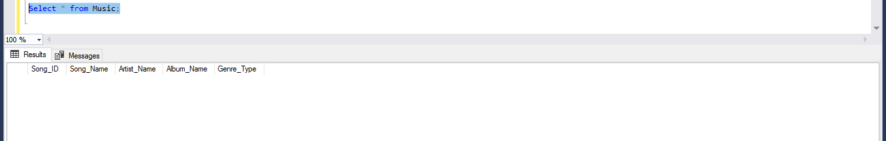Figure 4. *After bulk insert*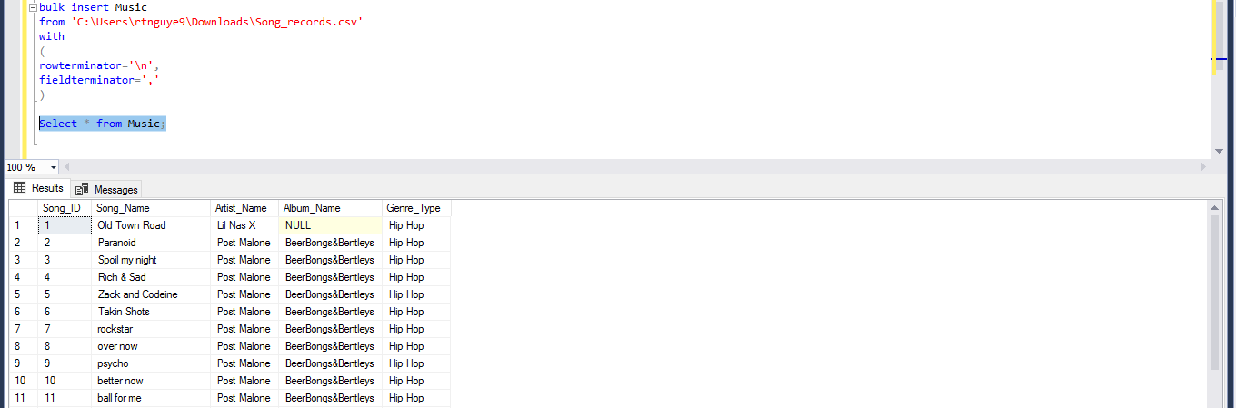

insert into County(County_ID, County_Name)

values(101 ,'Fort Ben');

Figure 1. *Before County insert*



Figure 2. *After County insert*

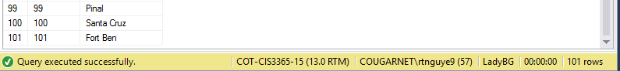

insert into Locations(Location_ID, Street_Address, City, State, Postal, Country)

values(101, '1725 Slough Ave.', 'Scranton', 'PA', '18504', 'United States');

Figure 3. *Before location insert*



Figure 4. *After location insert*

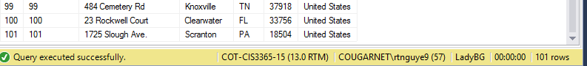

Insert into Event(Event_ID,Client_ID,End_Time,Event_Date,Event_Location,Service_Requested,Start_Time)

Values(‘101’, ‘101’, ‘21:00’, ‘5/8/2019’, ‘Spring Branch’, ‘Karaoke Only’, ‘17:00’);

Figure1. Before Insert

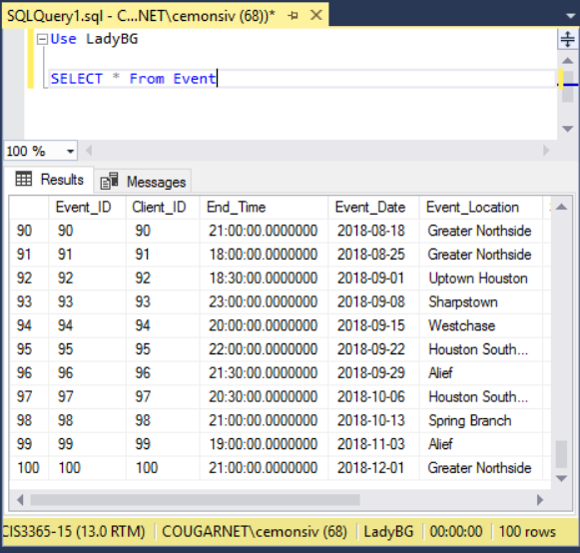

Figure2. After Insert

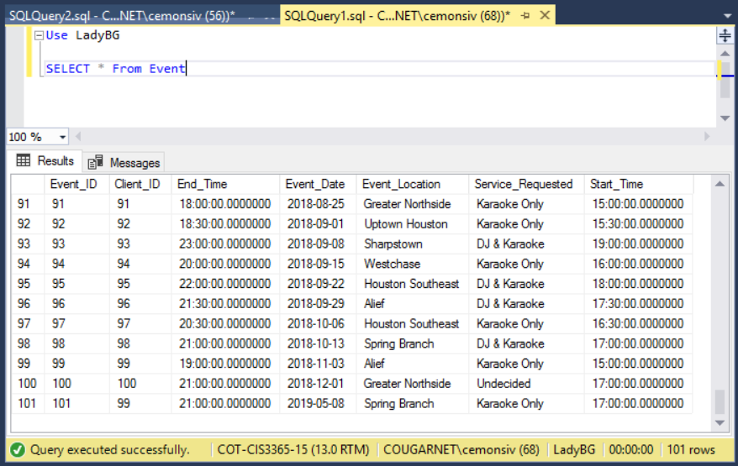

Insert into Event_Type(Event_Type_ID,Event_ID,Event_Type)

Values(‘101’, ‘101’, ‘Private Event’);

Figure1. Before Insert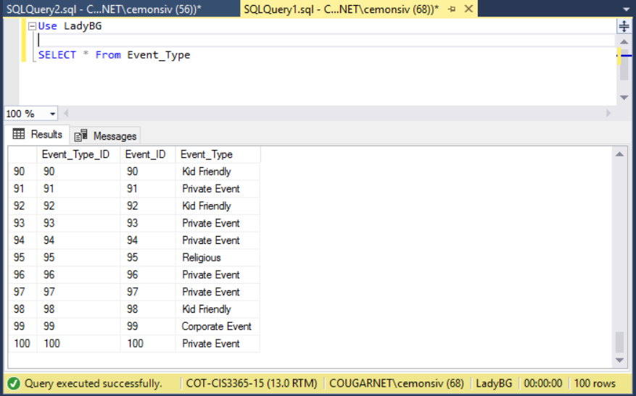

Figure2. After Insert

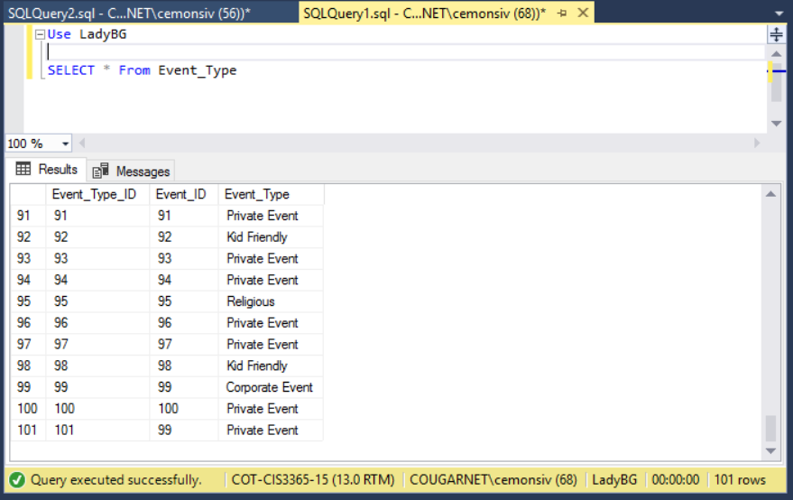

Before (Max 99 rows):

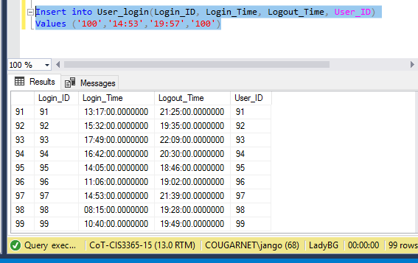

After (Row 100 is added with values):

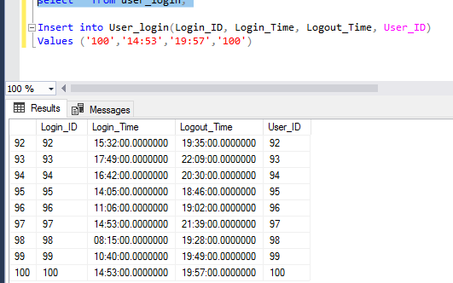

Before (no data):

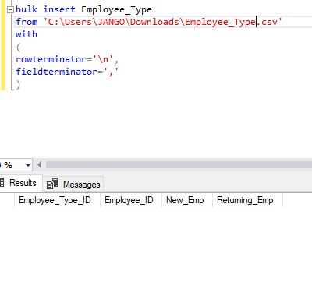

After (data is populated from bulk insert):

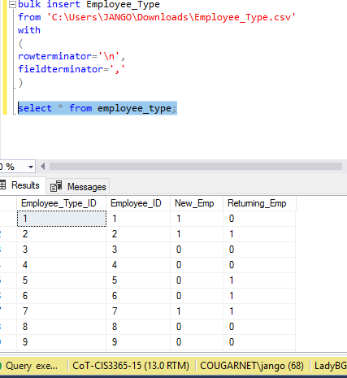

Before and after inserting Catie Mcgawn into Employee Status Table 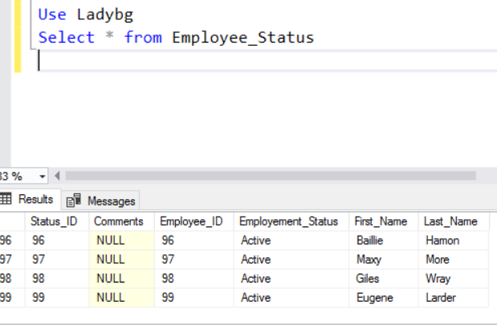

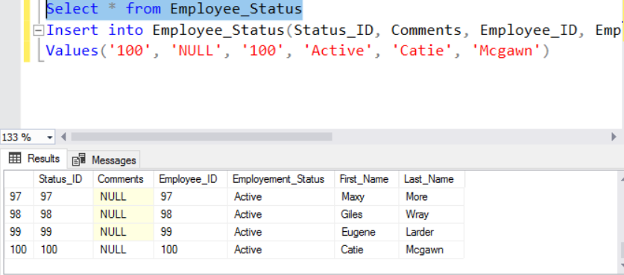

Before and after Inserting Employee ID 100 into Employee Title table

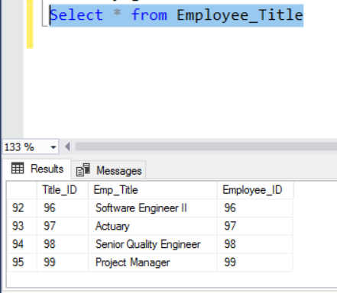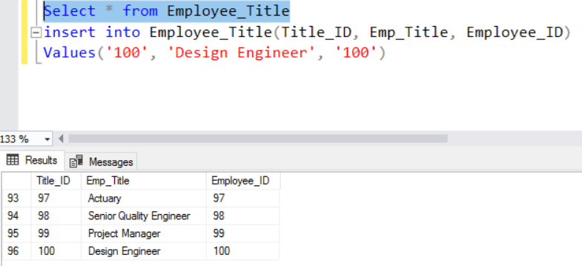

Insert into Payment_Method(Payment_ID, Client_ID, Payment_Amount, Payment_Type)

Values(‘5’,’5’,’890.95’, ‘Chase’);

Figure 1. Before insert

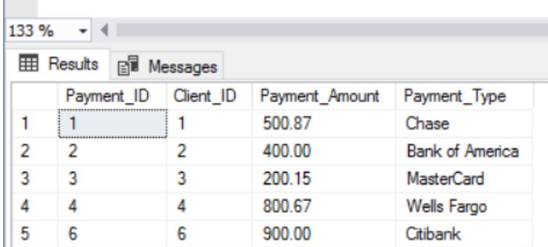

Figure 2. After insert

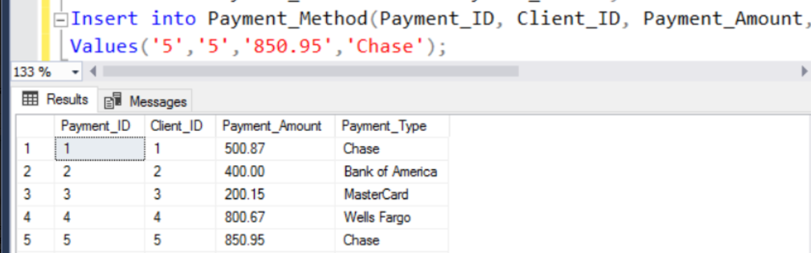

From ‘C:\Users\maabuba2\Desktop\Payment_Method.csv’

With

(

rowterminator=’\n’,

fieldterminator=’,’

)

Figure 3. bulk insert

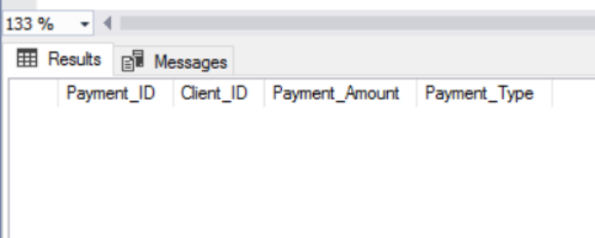

Figure 4. After bulk insert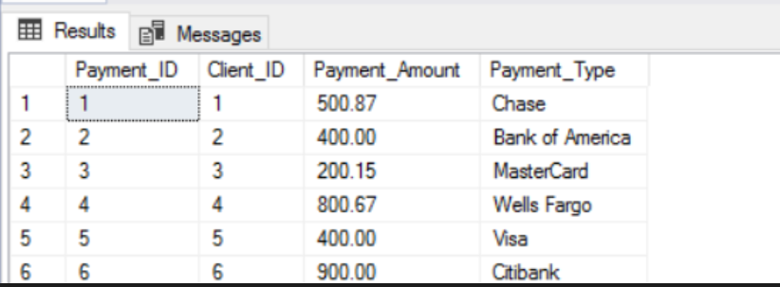

Insert into Payroll(Payroll_ID, Time_In, Time_Out, Timesheet_ID, Wage)

Values (101, '22:00', '1:00', 1 , 20)

Figure 1. Before *Payroll Insert*

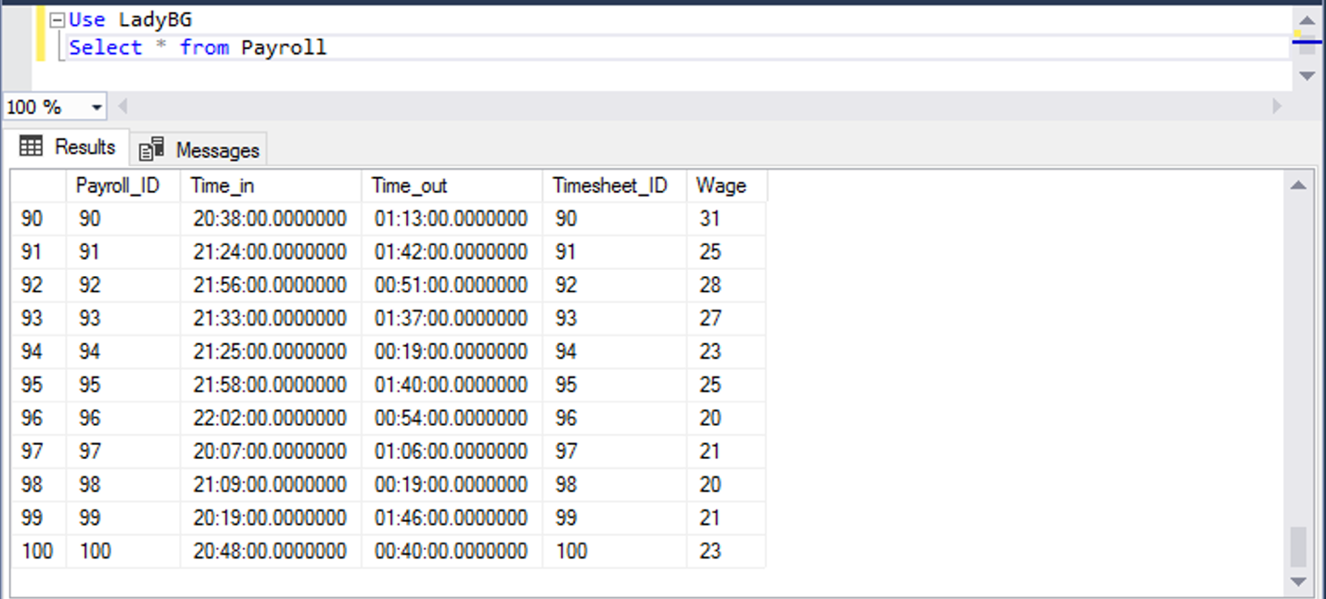

Figure 2. After *Payroll Insert*

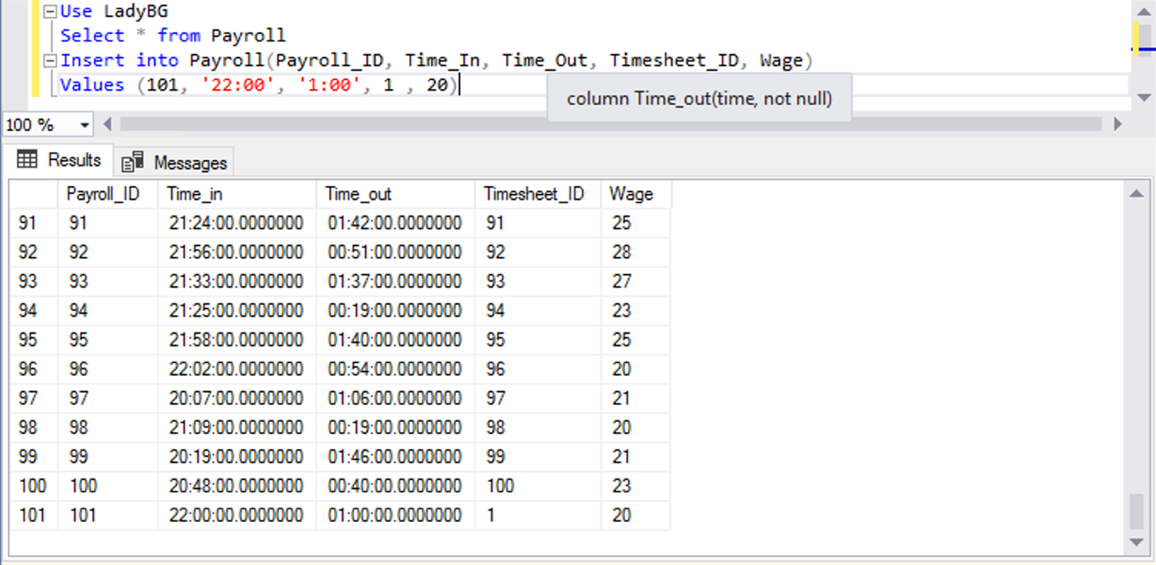

Insert into Timesheet(Timesheet_ID, Employee_ID, Work_Day, Time_In, Time_Out)

Values (101, 55, '2019/08/13', '20:15' , 1:40)

Figure 1. *Before Timesheet Insert*

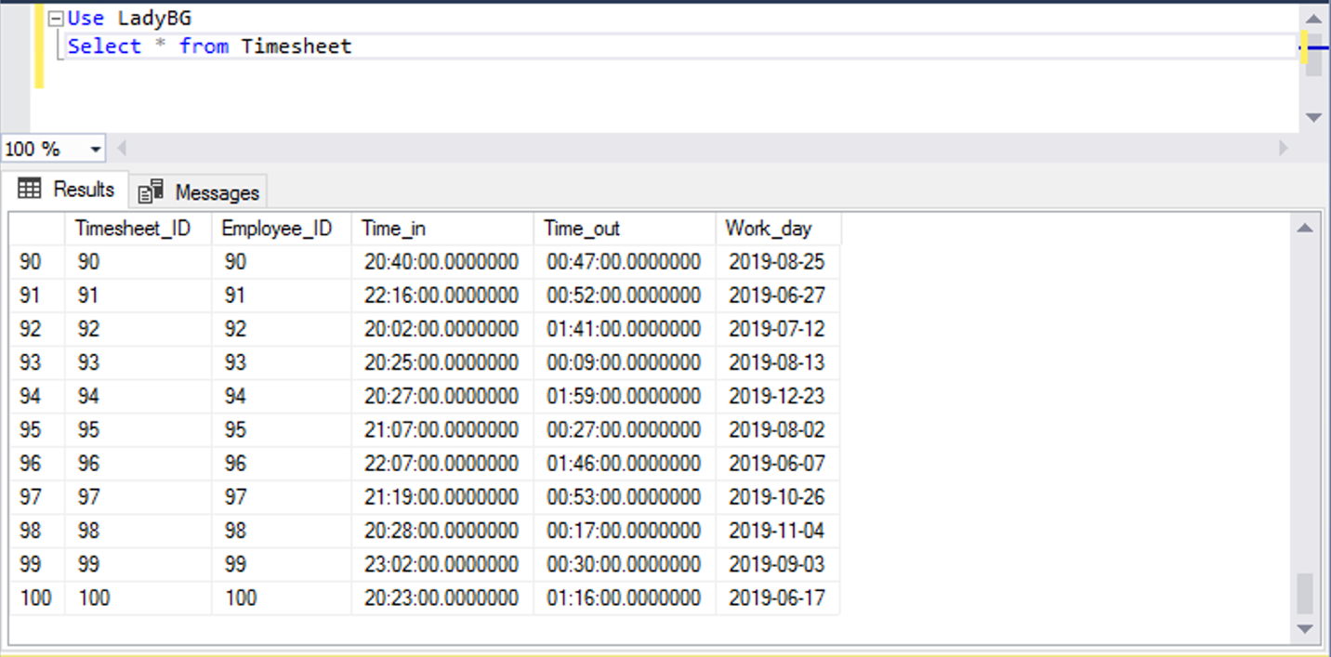

Figure 2. *After Timesheet Insert*

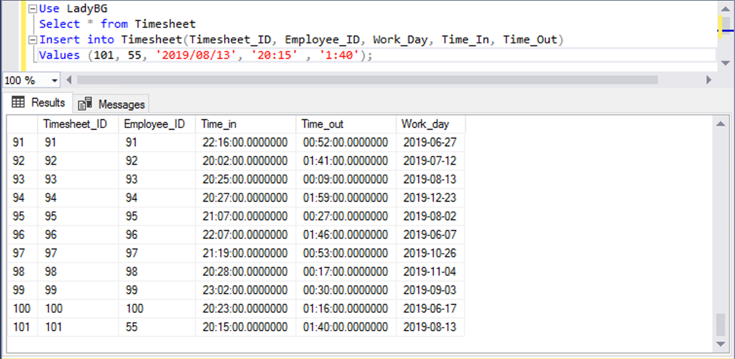

Insert into Server_Requested(Request_ID, Event_ID, Service_Requested)

Values(101, 1, ‘Corporate’)

Before (Service Request with 100 rows):

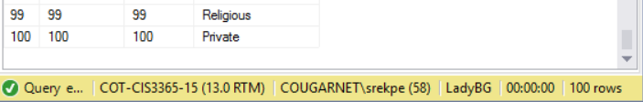

After (Service Request with 101 rows):

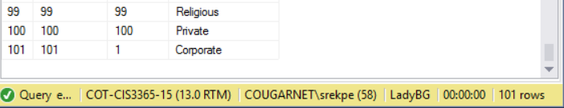

Insert into Vacation_Status(Vacation_StatusID, Comments, Status, Vacation_ID)

Values(101, ‘’, ‘Pending’, 101)

Before (Vacation Status with 100 rows):

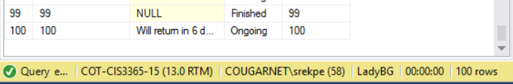

After (Vacation Request with 101 rows):

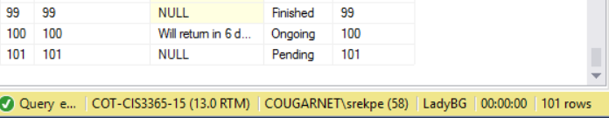

## Update Scripts

Update Music

set Album_Name = ‘Old Town Road’

where Song_ID = 1;

Figure 5. *Before update script 1*

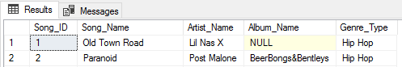

Figure 6. *After update script 1*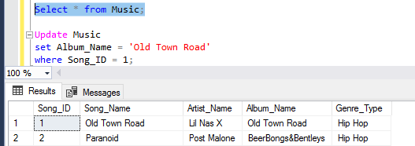

Update Music

set Album_Name = ‘Kamikaze’

where Song_ID = 100;

Figure 7. *Before update script 2*



Figure 8. *After update script 2*



update Locations

set Street_Address = '5831 Southford', Postal = '77033'

where Location_ID = 2;

Figure 5. *Before location update*

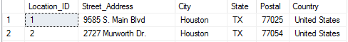

Figure 6. *After location update*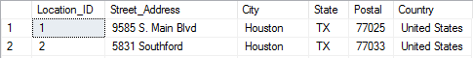

update PostalCode

set PostalCode = '77406', County = 'Fort Bend'

where PostalCode_ID = 2;

Figure 7. *Before Postal Code update*

Figure 8. *After Postal Code update*



Update Event_Type

set Event_Type = ‘Kid Friendly’

where Event_Type_ID = 101

Figure1. Before Update



Figure2.After Update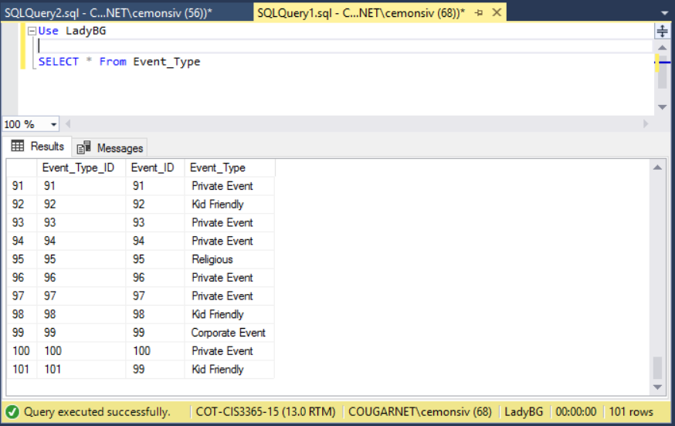

Update Event_Status

set Status = ‘Fulfilled’

where Status_ID =79

Figure1. Before Update

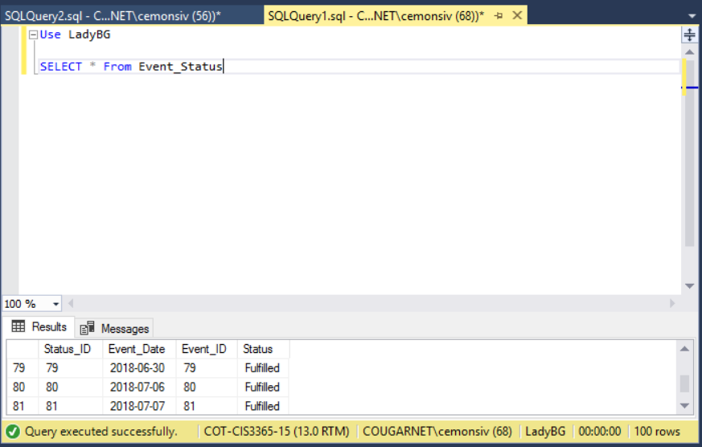

Figure2. After Update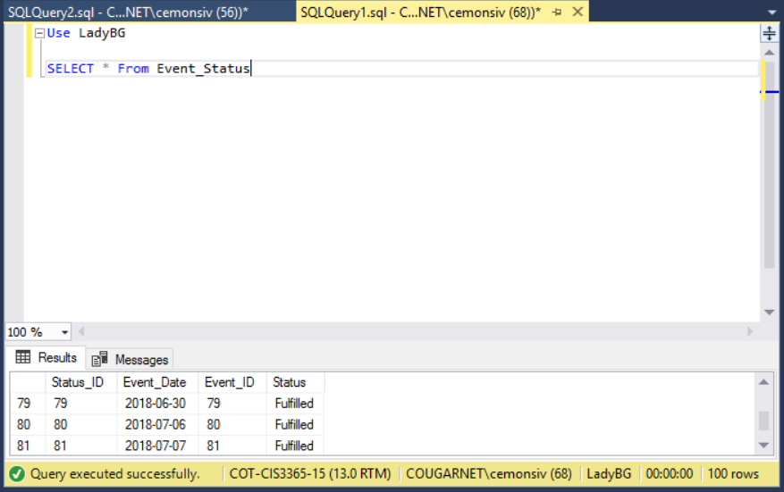

Before (middle name NULL):

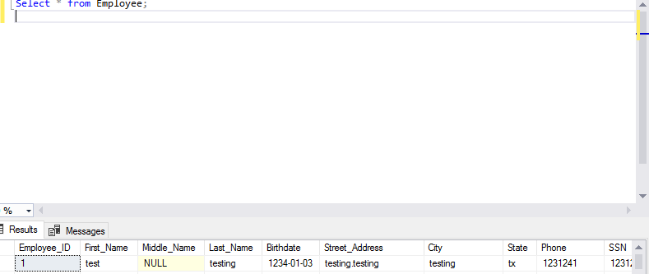

After (middle name has been updated to ‘allan’):

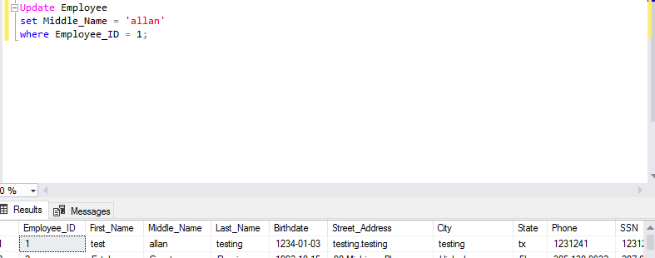

Before:

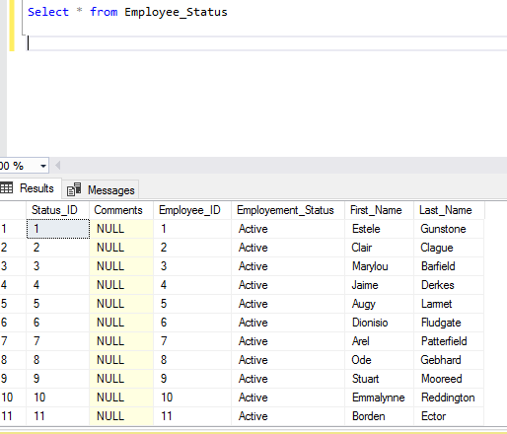

After (employee with the status_ID=’1’ has been ‘let go’):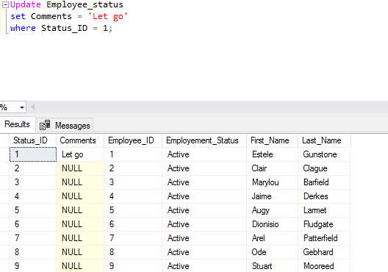

Before and after updating employee ID 27 training status to “Approved” 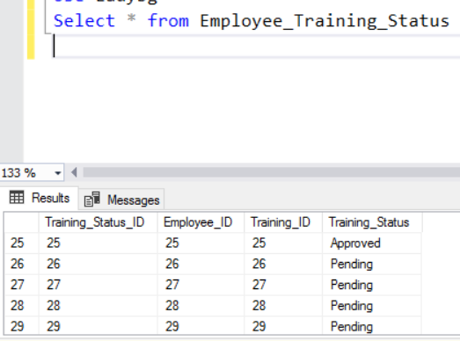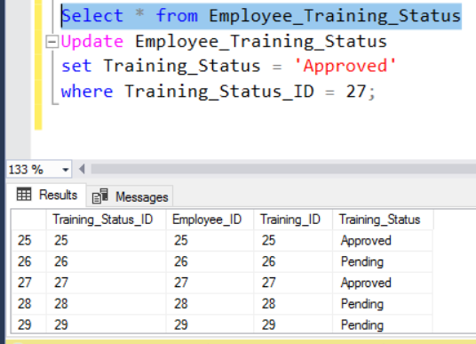

Before and after updating employee ID 100 training status to “Pending” 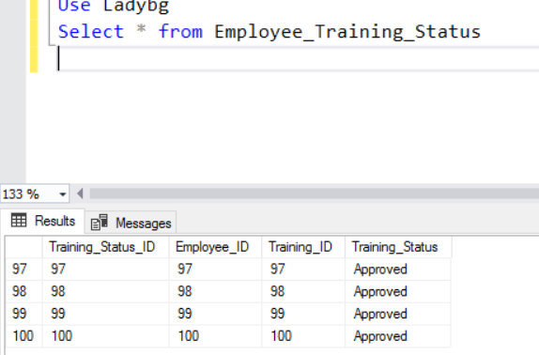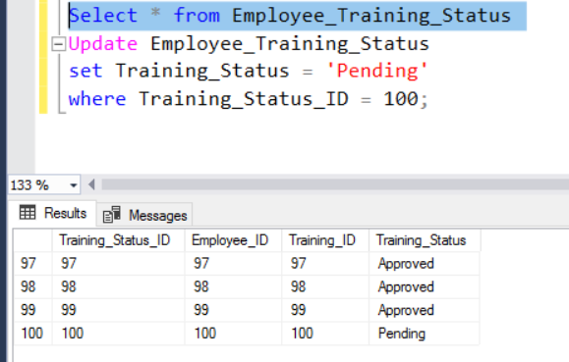

Update Payment_Method set payment_Amount = 1000 where payment_ID = 2;

Figure 5. Before update script 1

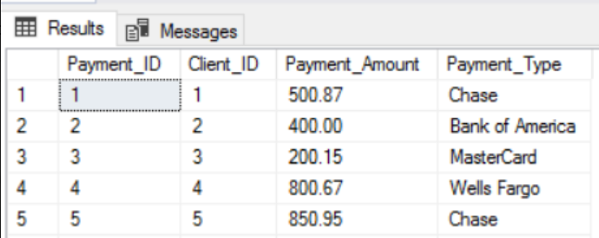

Figure 6. After update script 1

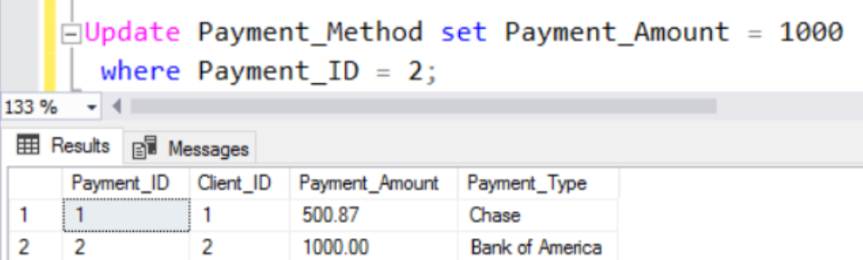

Update Booking_Status set Booking_Status = ‘Confirmed’ where Booking_ID = 1;

Figure 7. Before update script 2

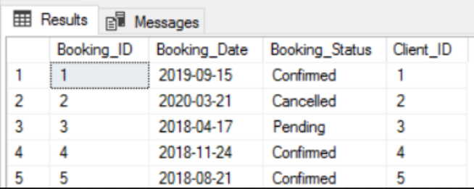

Figure 8. After update script 2

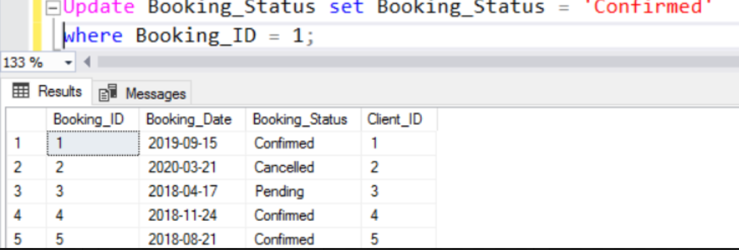

Update Payroll

set Wage = 20

where Payroll_ID = 1;

Figure 1. *Before Payroll Update*

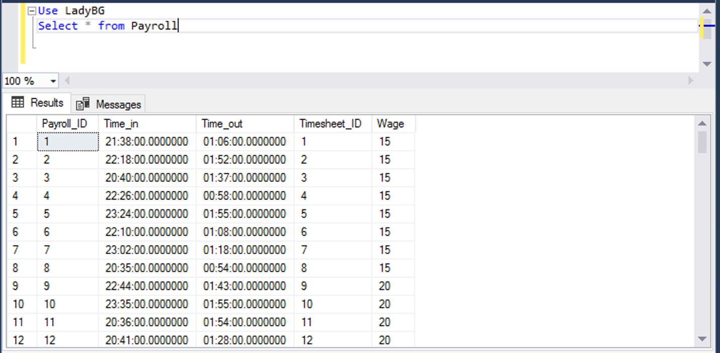

Figure 2. *After Payroll Update*

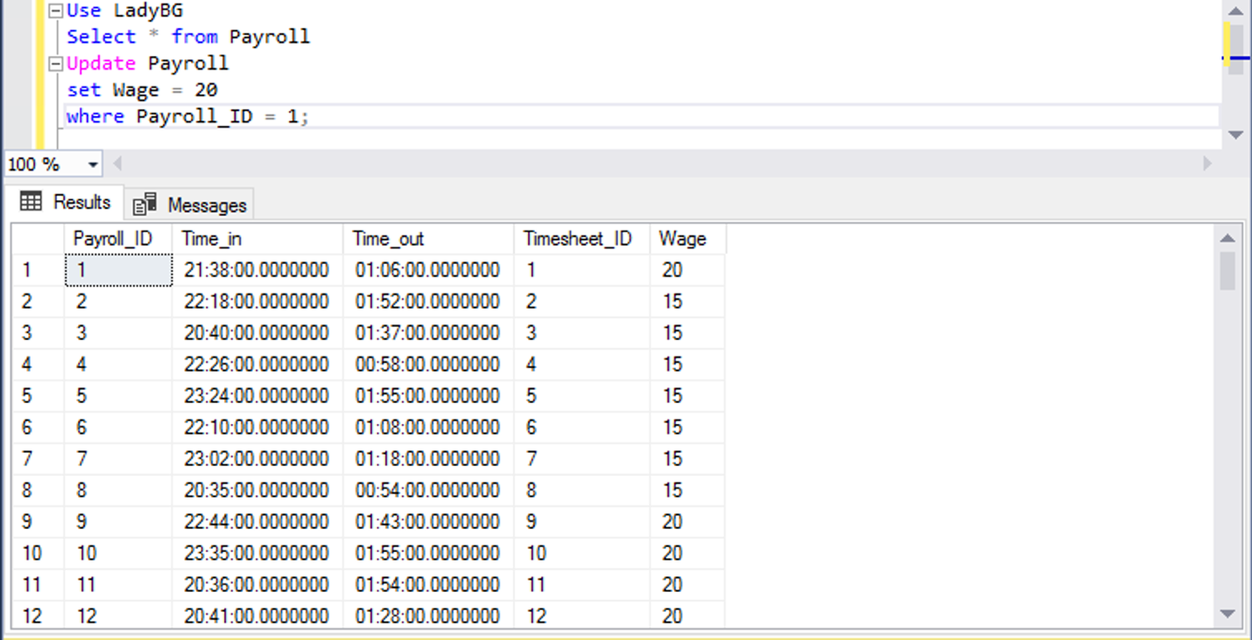

Update Timesheet

set Time_In = 22

where Timesheet_ID = 1;

Figure 1. *Before Timesheet Update*

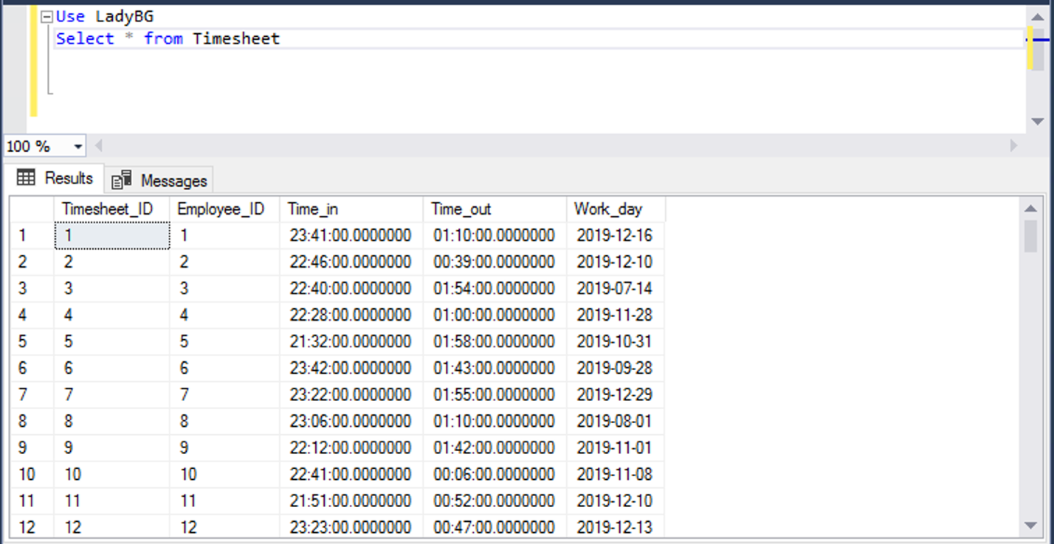

Figure 2. *After Timesheet Update*

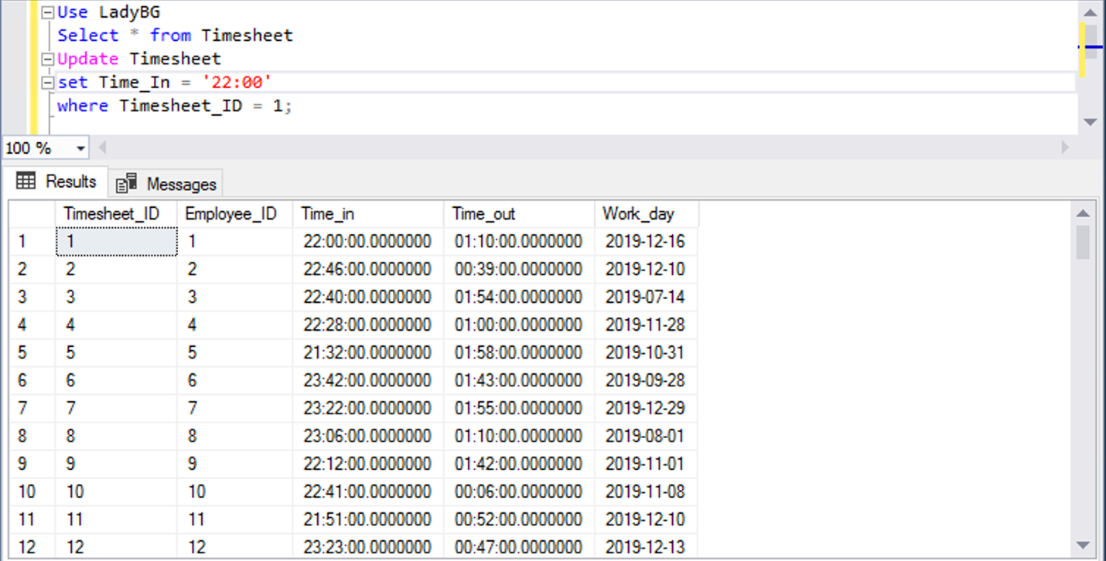

Update Event_Type

set Event_Type = ‘Corporate’

where Event_Type_ID = 101;

Before (Event Type for record 101 is currently Kid Friendly):

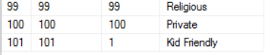

After (Event Type for record 101 is now Corporate):



Update Vacation_Request

set Reason = ‘Sickness’

where Vacation_ID = 201;

Before (Reason for record 101 is currently Leisure):

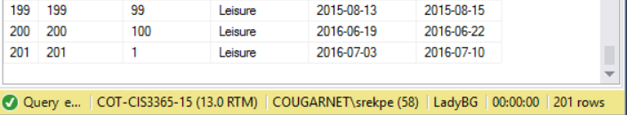

After (Reason for record 101 is now Sickness):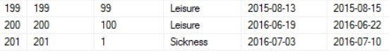

## Delete Scripts

Delete from Music;

Figure 9. *Before delete* 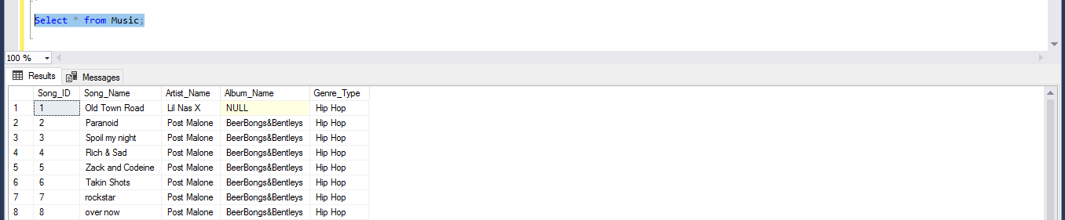

Figure 10. *After delete; all rows deleted because nothing was specified*

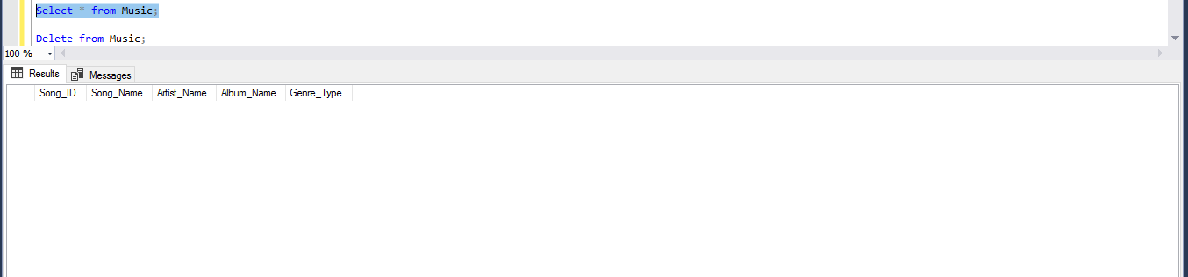

Delete from Music

where Song_ID = 93;

Figure 11. *Before specified delete*

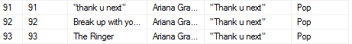

Figure 12. *After delete for Song_ID = 93*

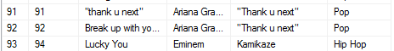

delete from County

where County_ID = 101;

Figure 9. *Before County delete*



Figure 10. *After County delete*



delete from Locations

where Location_ID = 101;

Figure 11. *Before Location delete*



Figure 12. *After Location delete*



Delete from Event

where Event_ID = 101;

Figure1. Before Delete

Figure2. After Delete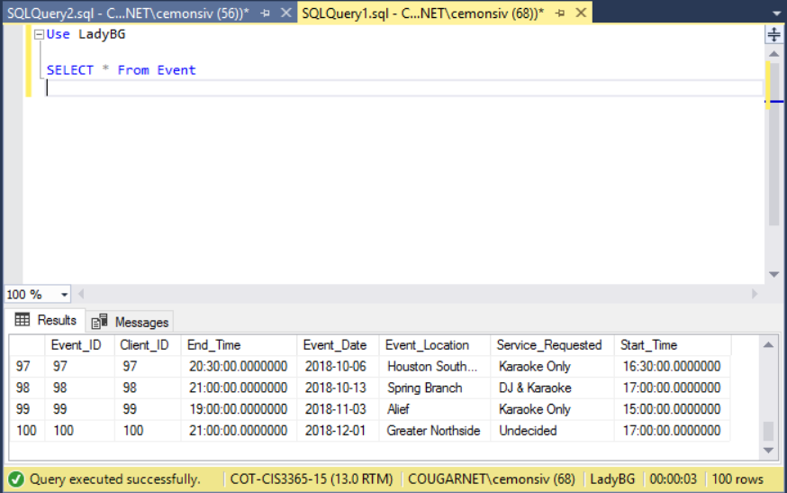

Delete from Event_Type

where Event_Type_ID = 2;

Figure1.Before Delete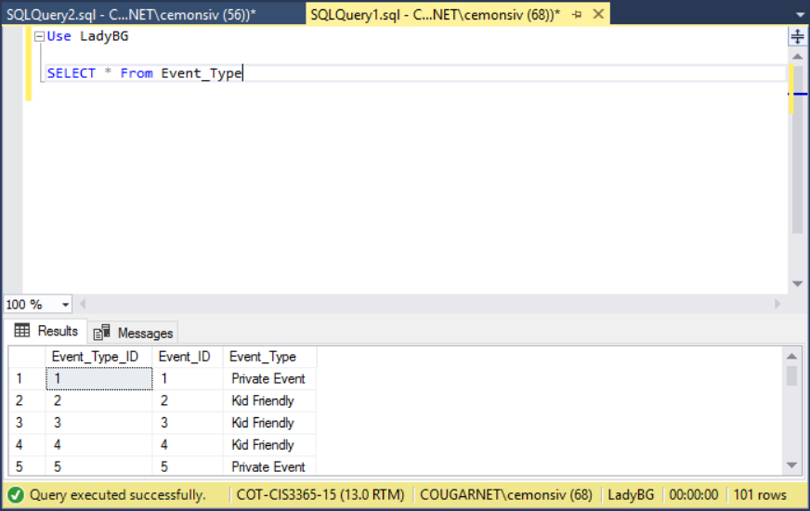

Figure2. After Delete

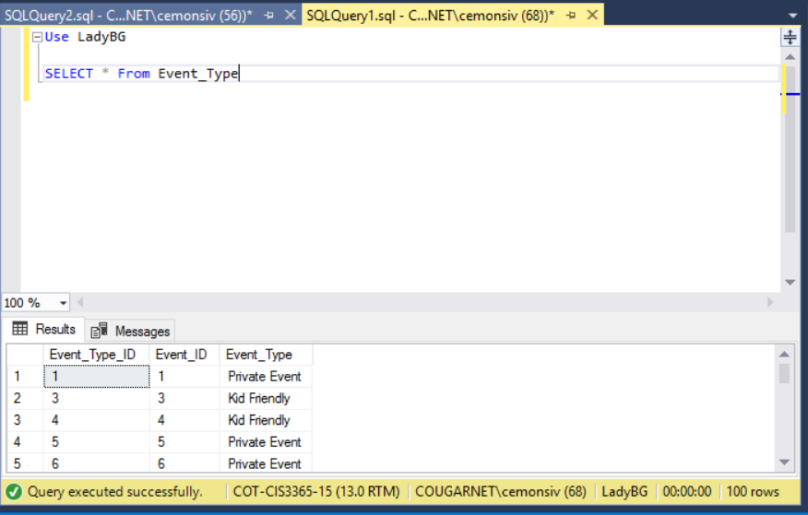

Before (there is up to 150 results):

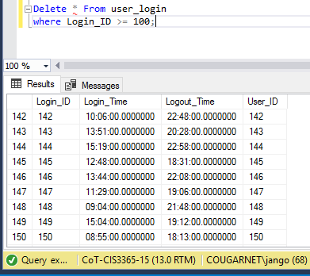

After (Rows after 99 are deleted):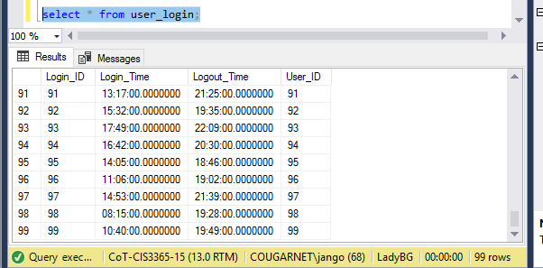

Before (table view of Employee_type shows it is populated):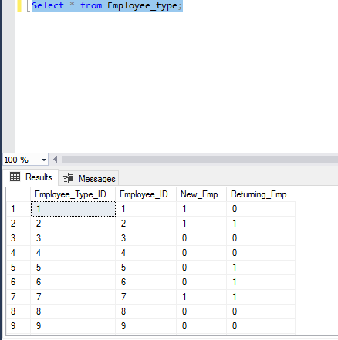

After (the whole employee_type table is deleted because there was no specification):

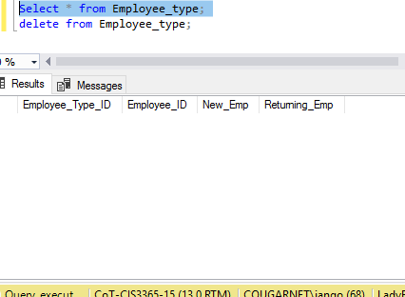

Before and after deleting training status ID 100 from Employee Training Status Table

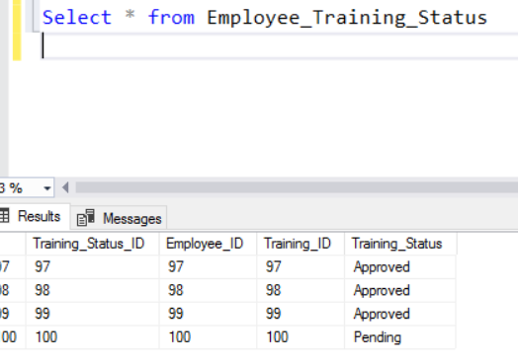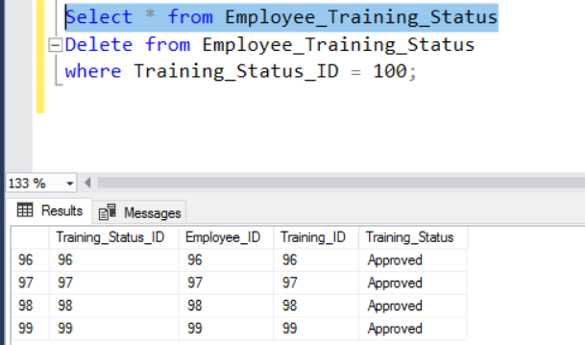

Before and after deleting Training Status ID 101 from Employee Training Status Table 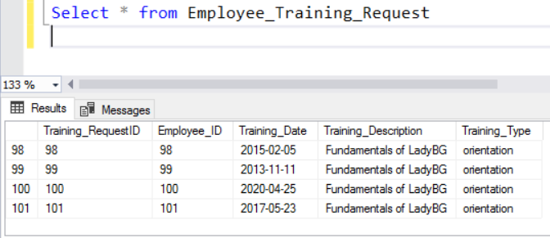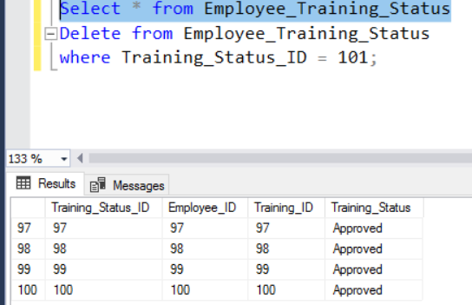

Delete Scripts

Delete Payment_Method;

Figure 9. Before delete script 1

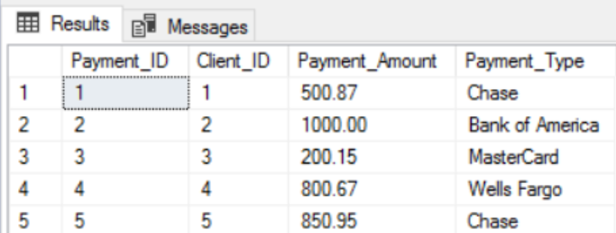

Figure 10. After delete script 1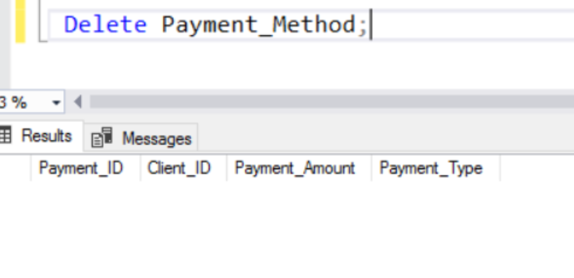

Figure 11. Before delete script 2

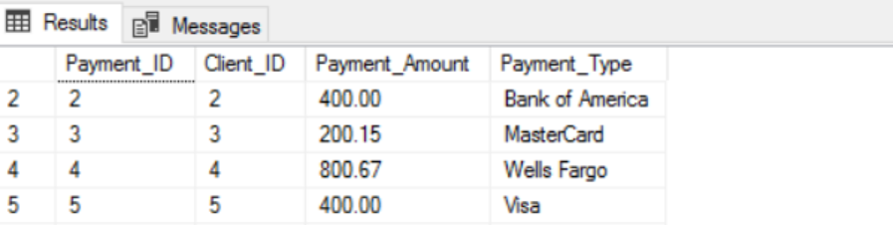

Figure 12. After delete script 2

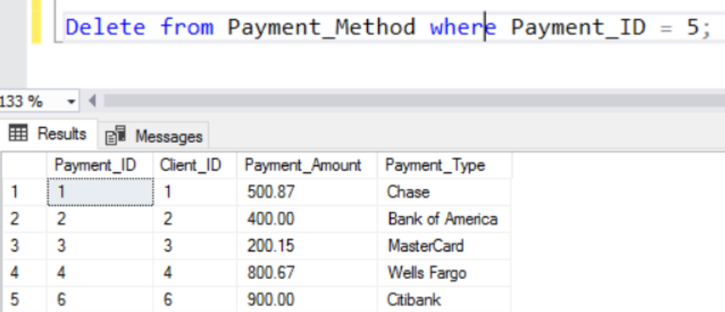

Delete from Payroll;

where Payroll_ID = 101;

Figure 1. *Before Payroll Delete*

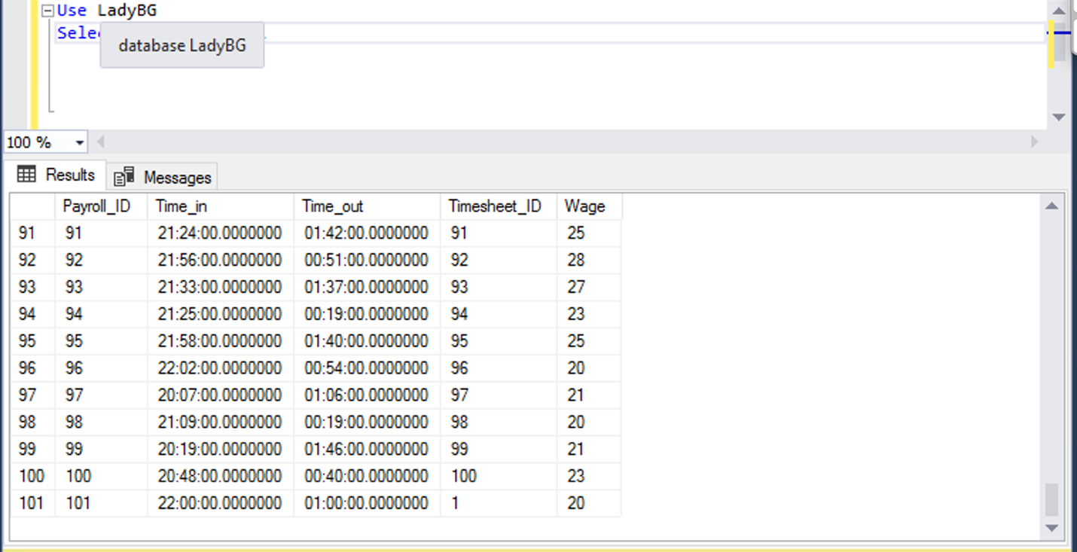

Figure 2. *After Payroll Delete*

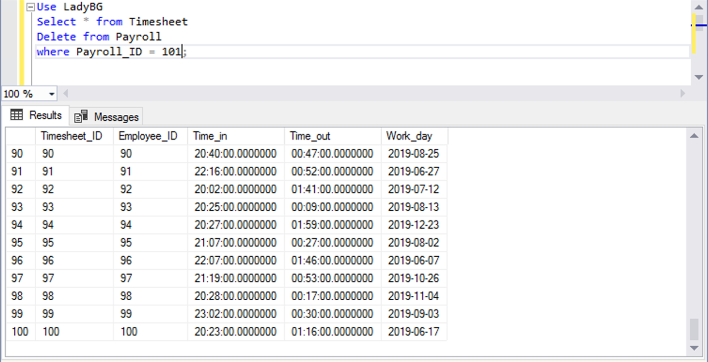

Delete from Timesheet

where Timesheet_ID = 101;

Figure 1. *Before Timesheet Delete*

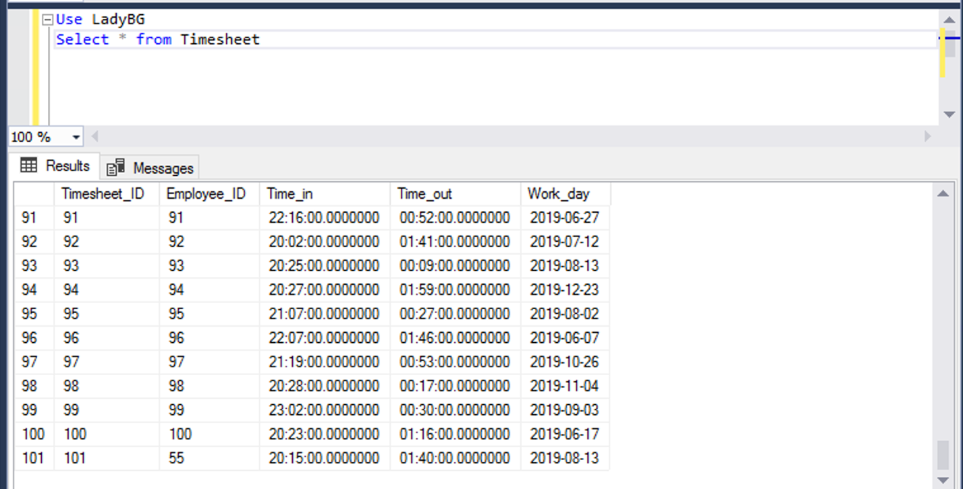

Figure 2. *After Timesheet Delete*

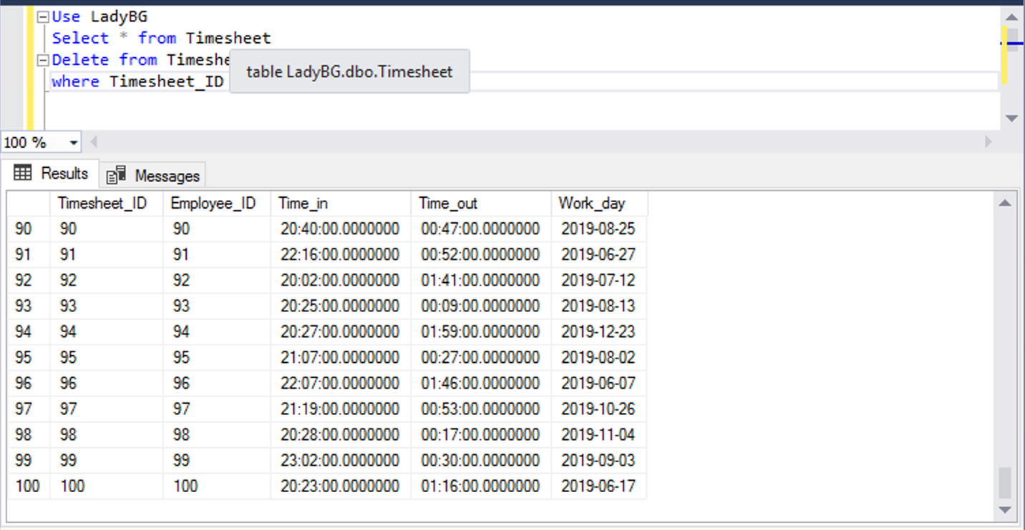

Delete from Vacation_Request

Where Vacation_ID = 201;

Before (Vacation Request row with 201 rows):



After (Vacation Request row with 200 rows):

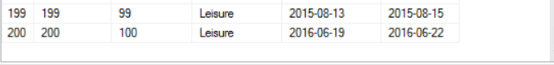

Delete from Vacation_Status

Where Vacation_StatusID = 101;

Before (Vacation Status with 101 rows):



After (Vacation Status with 100 rows):

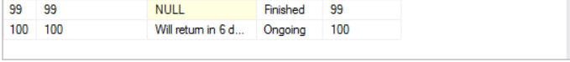

# Join Query Reports

#### Query 1

Select loc.Location_ID, cl.Client_First, cl.Client_Last, ev.Event_ID, ev.Service_Requested, evl.Street_Address, evl.City

from Locations as loc inner join Client as cl

on loc.Location_ID = cl.Location_ID

inner join Event ev

on ev.Client_ID = cl.Client_ID

inner join Event_Location evl

on evl.Event_ID = ev.Event_ID

* This report query combines the following tables:
  + Location
  + Client
  + Event
  + Service Requested
* Using the location table, we find which company location that the client has requested his event from.
* The client table pulls the clients information such as the first and last name.
* The event table allows us to see which event the client requested for and where the event will be at.
* The service requested table will allow us to see what type of service the client requested for their event.

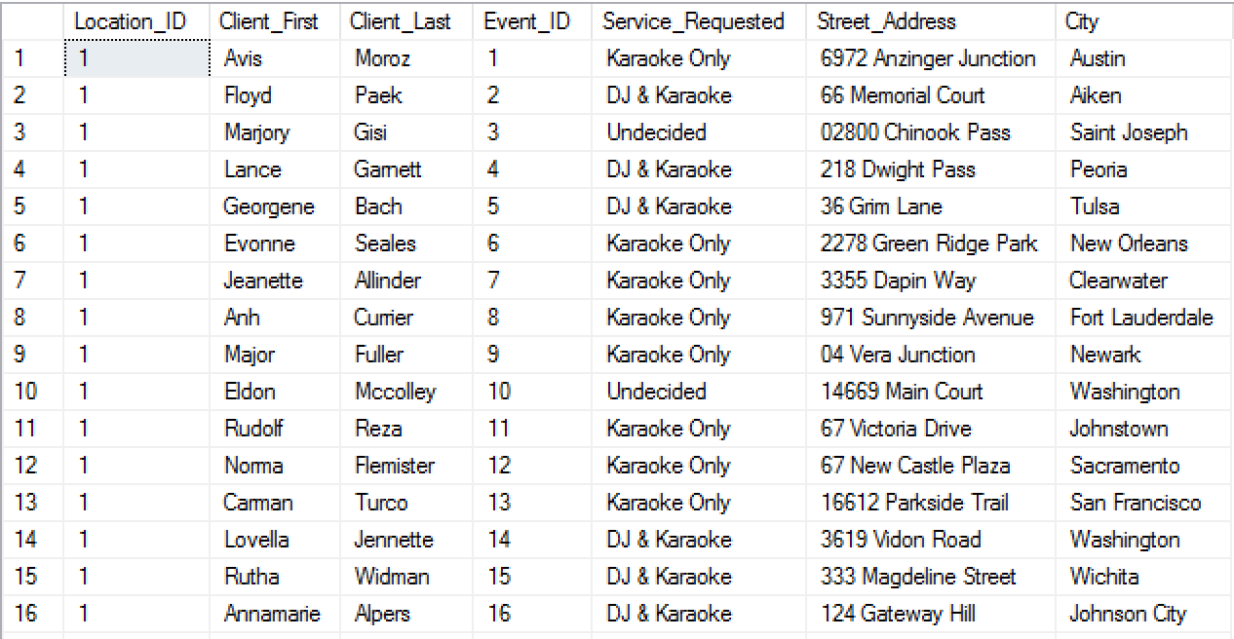

#### Query 2

Select loc.Location_ID, cl.Client_First, cl.Client_Last, ev.Event_ID, evs.Status

from Locations as loc inner join Client as cl

on loc.Location_ID = cl.Location_ID

inner join Event ev

on ev.Client_ID = cl.Client_ID

inner join Event_Status evs

on evs.Event_ID = ev.Event_ID

* This report query combines the following tables:
  + Location
  + Client
  + Event
  + Event Status
* Using the location table, we find which company location that the client has requested his event from.
* The client table pulls the clients information such as the first and last name.
* The event table allows us to see which event the client requested and its ID.
* The status table allows us to see whether or not the request has been completed.

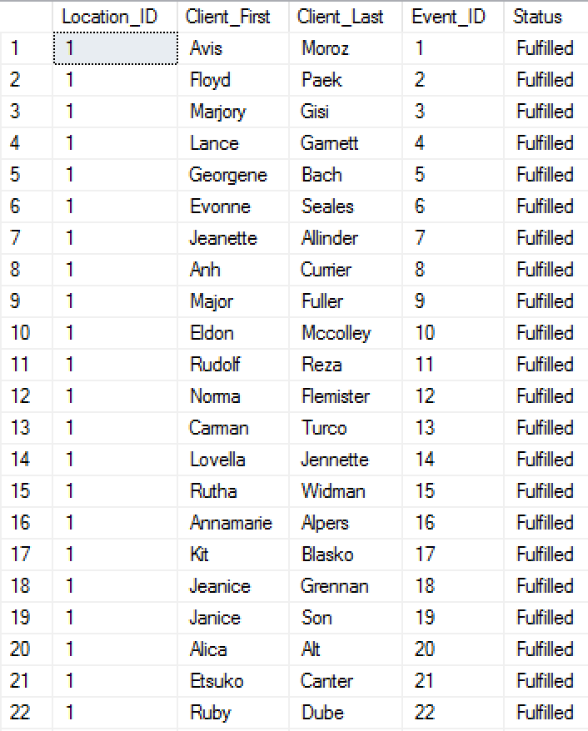

#### Query 3

Select loc.Location_ID, cl.Client_First, cl.Client_Last, ev.Event_ID, serv.Service_Requested

from Locations as loc inner join Client as cl

on loc.Location_ID = cl.Location_ID

inner join Event ev

on ev.Client_ID = cl.Client_ID

inner join Service_Request serv

on serv.Event_ID = ev.Event_ID

* This report query combines the following tables:
  + Location
  + Client
  + Event
  + Service Requested
* Using the location table, we find which company location that the client has requested his event from.
* The client table pulls the clients information such as the first and last name.
* The event table allows us to see which event the client requested and its ID.
* The service requested table allows us to see what service the client wanted.

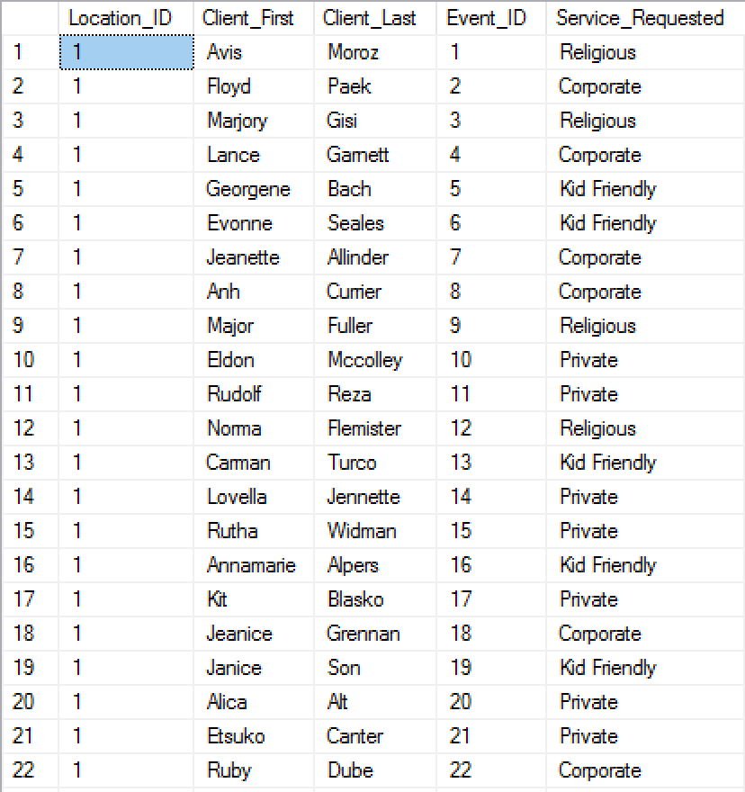

#### Query 4

Select loc.Location_ID, cl.Client_First, cl.Client_Last, ev.Event_ID, ev.Service_Requested, evd.Event_Date

from Locations as loc inner join Client as cl

on loc.Location_ID = cl.Location_ID

inner join Event ev

on ev.Client_ID = cl.Client_ID

inner join Event_Date evd

on evd.Event_ID = ev.Event_ID

* This report query combines the following tables:
  + Location
  + Client
  + Event
  + Event_Date
* Using the location table, we find which company location that the client has requested his event from.
* The client table pulls the clients information such as the first and last name.
* The event table allows us to see which event the client requested and its information.
* The event date table allows us to see what day the event will begin.

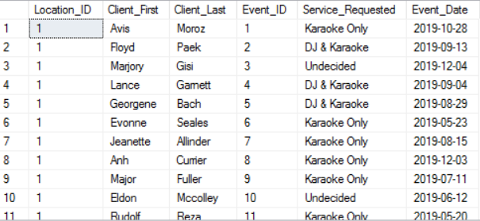

#### Query 5

Select loc.Location_ID, cl.Client_First, cl.Client_Last, ev.Event_ID, ev.Service_Requested, evd.Event_Date, evd.Event_Start, evd.Event_End

from Locations as loc inner join Client as cl

on loc.Location_ID = cl.Location_ID

inner join Event ev

on ev.Client_ID = cl.Client_ID

inner join Event_Date evd

on evd.Event_ID = ev.Event_ID

* This report query combines the following tables:
  + Location
  + Client
  + Event
  + Event_Date
* Using the location table, we find which company location that the client has requested his event from.
* The client table pulls the clients information such as the first and last name.
* The event table allows us to see which event the client requested and its information.
* The event date table allows us to see what day the event will begin and the time the event ends and begins.

#### Query 6

Select loc.Location_ID, cli.Client_First, cli.Client_Last, ctype.New_Client, ctype.Returning_Client, pay.Payment_Type, pay.Payment_Amount

from Locations as loc inner join Client as cli

on loc.Location_ID = cli.Client_ID

inner join Client_Type ctype

on ctype.Client_ID = cli.Client_ID

inner join Payment_Method pay

on pay.Client_ID = cli.Client_ID

* This report query combines the following tables:
  + Location
  + Client
  + Client Type
  + Payment Method
* Using the location table, we find which company location that the client has requested his event from.
* The client table pulls the clients information such as the first and last name.
* The client type table allows us to see if the clients are returning or new. The owner can base off their prices and discounts on this.
* The payment method allows us to see how they paid for it and the amount paid.

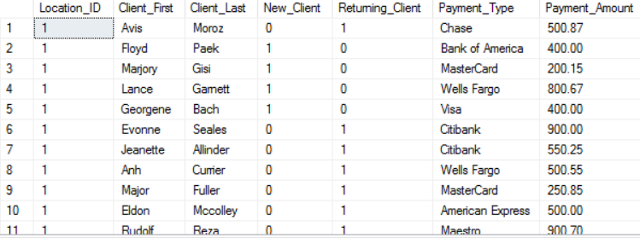

#### Query 7

Select loc.Location_ID, cli.Client_First, cli.Client_Last, ev.Event_ID, bs.Booking_Status

from Locations as loc inner join Client as cli

on loc.Location_ID = cli.Location_ID

inner join Event ev

on ev.Client_ID = cli.Client_ID

inner join Booking_Status bs

on bs.Client_ID = cli.Client_ID

* This report query combines the following tables:
  + Location
  + Client
  + Event
  + Booking_Status
* Using the location table, we find which company location that the client has requested his event from.
* The client table pulls the clients information such as the first and last name.
* The event table lets us find the event ID and connect it to our booking status.
* The booking status lets us determine whether or not it has been fulfilled.

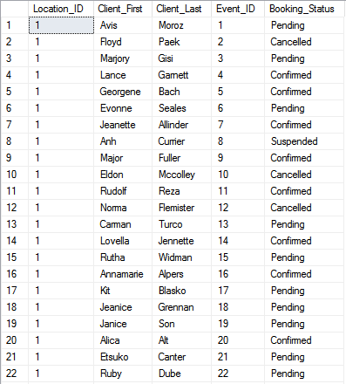

#### Query 8

Select loc.Location_ID, emp.First_Name, emp.Last_Name, vr.Reason, vr.Date_Requested, vr.Date_Return, vs.Status

from Locations as loc inner join Employee as emp

on loc.Location_ID = emp.Location_ID

inner join Vacation_Request vr

on vr.Employee_ID = emp.Employee_ID

inner join Vacation_Status vs

on vs.Vacation_ID = vr.Vacation_ID

* This report query combines the following tables:
  + Location
  + Employee
  + Vacation_Request
  + Vacation_Status
* Using the location table, we find which company location that the client has requested his event from.
* The employee table allows us to find information about the employee, such as the first and last name.
* The vacation request table allows us to find the requests for vacation made by employees.
* The vacation status table lets us know whether or not the request has been approved.

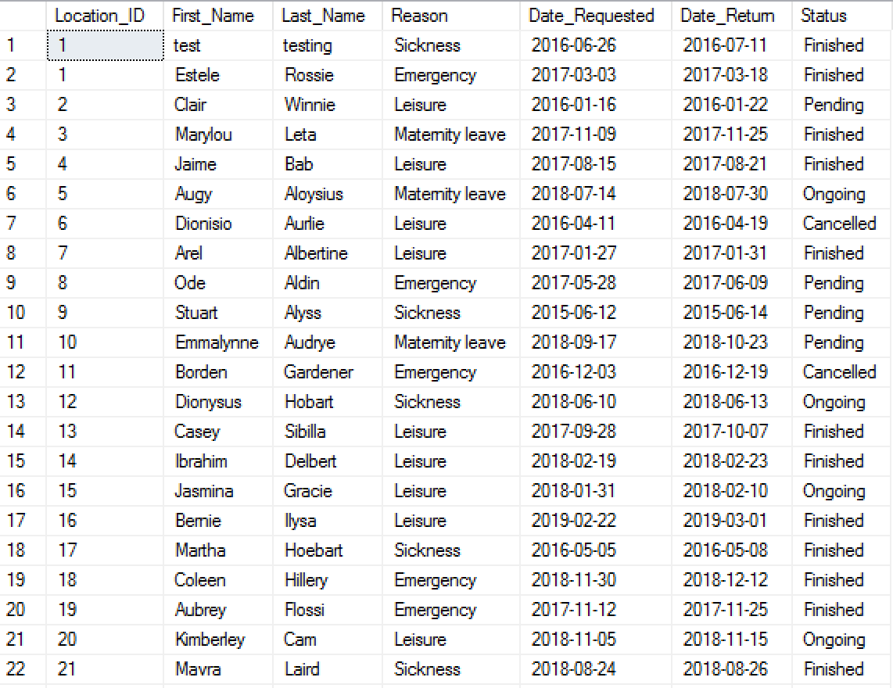

#### Query 9

Select loc.Location_ID, emp.First_Name, emp.Last_Name, et.Emp_Title, es.Employement_Status

from Locations as loc inner join Employee as emp

on loc.Location_ID = emp.Location_ID

inner join Employee_Title et

on et.Employee_ID = emp.Employee_ID

inner join Employee_Status es

on es.Employee_ID = emp.Employee_ID

* This report query combines the following tables:
  + Location
  + Employee
  + Employee_Title
  + Employee_Status
* Using the location table, we find which company location that the client has requested his event from.
* The employee table allows us to find information about the employee, such as the first and last name.
* The employee title table gives us information about the employee and their position in the company.
* The employee status lets us know whether or not the employee is active within the company.

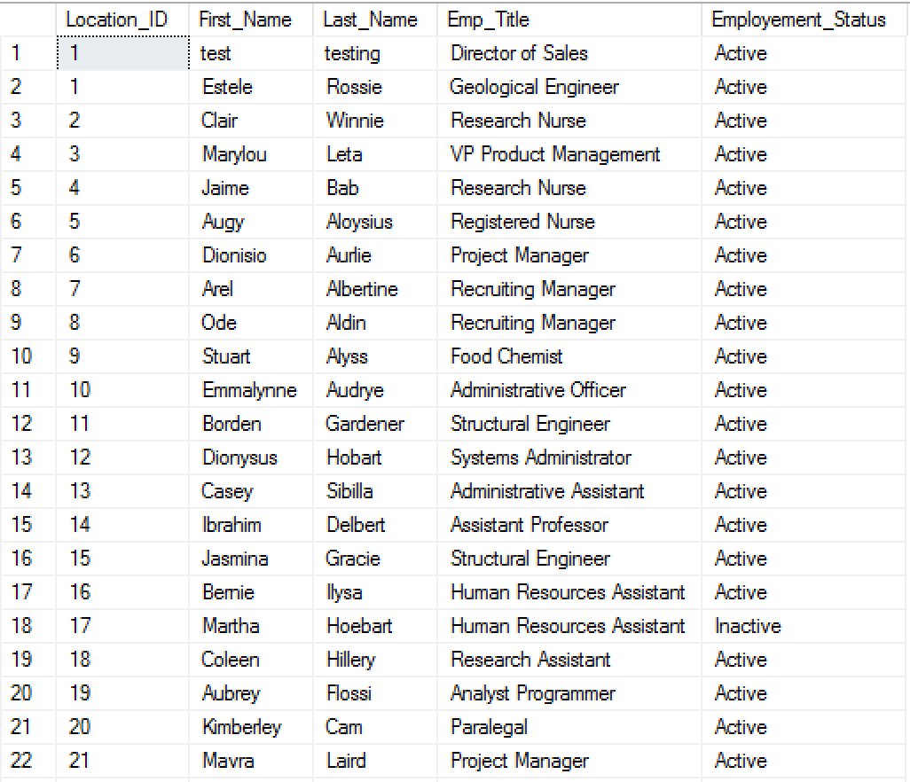

#### Query 10

Select loc.Location_ID, emp.First_Name, emp.Last_Name, ts.Work_day, ts.Time_in, ts.Time_out, tss.Status

from Locations as loc inner join Employee as emp

on loc.Location_ID = emp.Location_ID

inner join Timesheet ts

on ts.Employee_ID = emp.Employee_ID

inner join Timesheet_Status tss

on tss.Timesheet_ID = ts.Timesheet_ID

* This report query combines the following tables:
  + Location
  + Employee
  + Timesheet
  + Timesheet_Status
* Using the location table, we find which company location that the client has requested his event from.
* The employee table allows us to find information about the employee, such as the first and last name.
* The timesheet table lets us see the clock in and clock out time for each employee.
* The timesheet status allows us to see whether or not the timesheets submitted are approved or not.

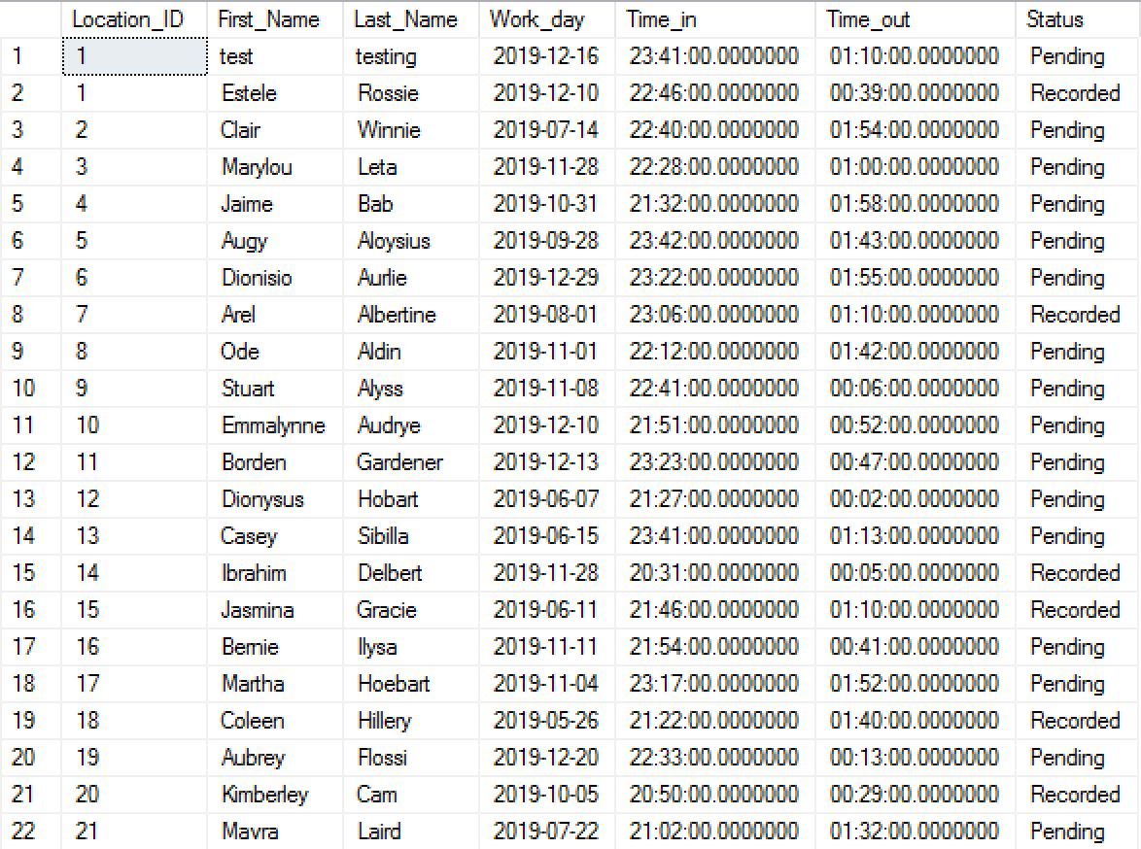

#### Query 11

SELECT dbo.Locations.Location_ID, dbo.Employee.First_Name, dbo.Employee.Last_Name, dbo.User_Info.User_ID, dbo.User_Login.Login_Time, dbo.User_Login.Logout_Time, dbo.Locations.City

FROM dbo.Locations INNER JOIN

dbo.Employee ON dbo.Locations.Location_ID = dbo.Employee.Location_ID INNER JOIN

dbo.User_Info ON dbo.Employee.Employee_ID = dbo.User_Info.Employee_ID INNER JOIN

dbo.User_Login ON dbo.User_Info.User_ID = dbo.User_Login.User_ID

WHERE (dbo.Locations.City = 'houston')

* This report query combines the following tables:
  + Location
  + Employee
  + User Info
  + User Login
* Using the location table, we find which company location that the client has requested his event from
* The Employee table pulls the Employee information such as the first and last name
* The User info table can check which employee is logged in at the time
* The User login table allows us to track work activity and productivity of any employee

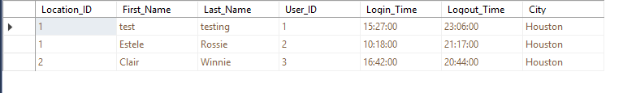

#### Query 12

SELECT dbo.Locations.Location_ID, dbo.Employee.First_Name, dbo.Employee.Last_Name, dbo.Employee_Training_Request.Training_RequestID, dbo.Employee_Training_Status.Training_Status

FROM dbo.Locations INNER JOIN

dbo.Employee ON dbo.Locations.Location_ID = dbo.Employee.Location_ID INNER JOIN

dbo.Employee_Training_Request ON dbo.Employee.Employee_ID = dbo.Employee_Training_Request.Employee_ID INNER JOIN

dbo.Employee_Training_Status ON dbo.Employee.Employee_ID = dbo.Employee_Training_Status.Employee_ID AND

dbo.Employee_Training_Request.Training_RequestID = dbo.Employee_Training_Status.Training_ID

* This report query combines the following tables:
  + Location
  + Employee
  + Employee Training Request
  + Employee Training Status
* Using the location table, we find which company location that the client has requested his event from
* The Employee table pulls the Employee information such as the first and last name
* The Employee Training Request table can check which employee is asking for what type of training
* The Employee Training Status table allows us to see if the Training Request was approved or pending

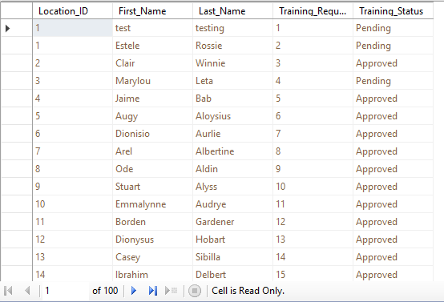

#### Query 13

SELECT dbo.Locations.Location_ID, dbo.Client.Client_First, dbo.Client.Client_Last, dbo.Booking_Status.Booking_ID, dbo.Event_Expenses.Service_Cost

FROM dbo.Locations INNER JOIN

dbo.Client ON dbo.Locations.Location_ID = dbo.Client.Location_ID INNER JOIN

dbo.Booking_Status ON dbo.Client.Client_ID = dbo.Booking_Status.Client_ID CROSS JOIN

dbo.Event_Expenses

* This report query combines the following tables:
  + Location
  + Client
  + Booking Status
  + Event Expenses
* Using the location table, we find which company location that the client has requested his event from
* The Client table pulls the Client information such as the first and last name
* The Booking Status table can check which event the client is asking about
* The Event Expenses table allows us to see how much the event will cost if the client asks or if there’s a verbal discrepancies



#### Query 14

SELECT dbo.Client.Client_First, dbo.Client.Client_Last, dbo.Locations.Location_ID, dbo.Booking_Status.Booking_ID, dbo.Event_Status.Status

FROM dbo.Client INNER JOIN

dbo.Locations ON dbo.Client.Location_ID = dbo.Locations.Location_ID INNER JOIN

dbo.Booking_Status ON dbo.Client.Client_ID = dbo.Booking_Status.Client_ID CROSS JOIN

dbo.Event_Status

* This report query combines the following tables:
  + Location
  + Client
  + Booking Status
  + Event Status
* Using the location table, we find which company location that the client has requested his event from
* The Client table pulls the Client information such as the first and last name
* The Booking Status table can check which event the client is asking about
* The Event Status table allows us to see if the event has been fulfilled, missed, or overlooked if a client has a dispute

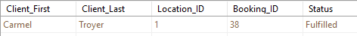

#### Query 15

SELECT dbo.Employee.First_Name, dbo.Employee.Last_Name, dbo.Timesheet.Work_day, dbo.Employee_Type.Employee_Type_ID, dbo.Payroll.Wage

FROM dbo.Employee INNER JOIN

dbo.Timesheet ON dbo.Employee.Employee_ID = dbo.Timesheet.Employee_ID INNER JOIN

dbo.Employee_Type ON dbo.Employee.Employee_ID = dbo.Employee_Type.Employee_ID INNER JOIN

dbo.Payroll ON dbo.Timesheet.Timesheet_ID = dbo.Payroll.Timesheet_ID

* This report query combines the following tables:
  + Employee
  + Timesheet
  + Employee Type
  + Payroll
* Using the Employee Type table, we can find out what type of employee they are to see if the wage makes sense/matches up
* The Employee table pulls the Employee information such as the first and last name
* The Timesheet table can check any employee’s working productivity
* The Payroll table allows us to see how much that certain employee is getting paid
* All this information together is useful to see if certain employees are being paid fairly based on performance and type of employee they are

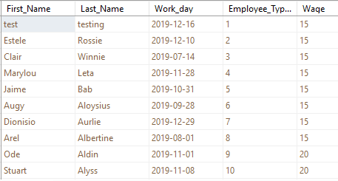

#### Query 16

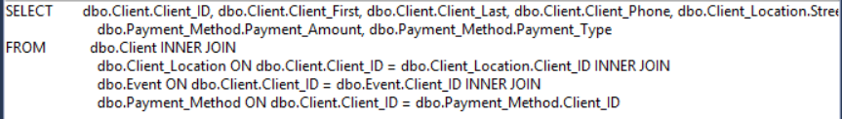

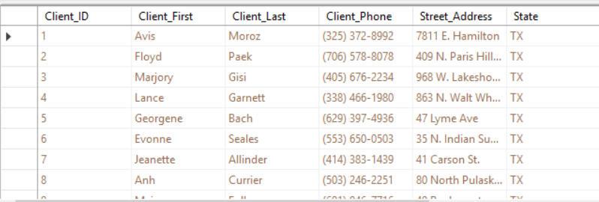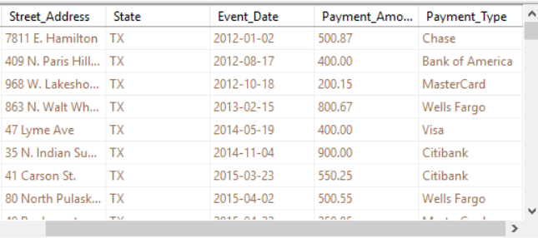

This Report Combines the tables:

* Client
* Client Location
* Event
* Payment Method

The Client table displays the client ID, first name, last name, and phone number to search for a specific individual

The Client Location table shows the address of each client

The Event table shows the event of which each client attended

The Payment Method table shows the payment method and amount of each event for a specific individual

#### Query 17

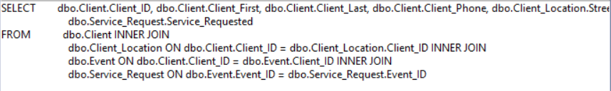

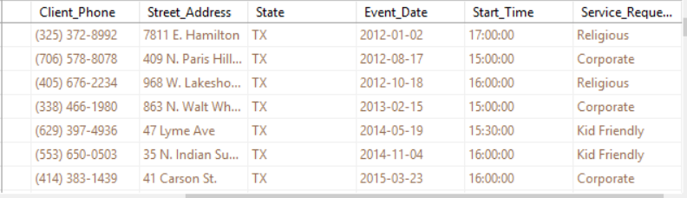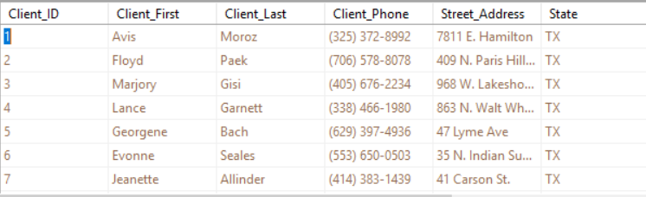

This Report combines the tables:

* Client
* Client Location
* Event
* Service Requested

The Client Table shows the Client ID, first name, last name and phone number associated with an individual if a search is required

The Client Location table shows the client’s address

The Event Table shows the event of which each client attended

The Service Requested table shows kind of service a client requested and can be associated with which event

#### Query 18

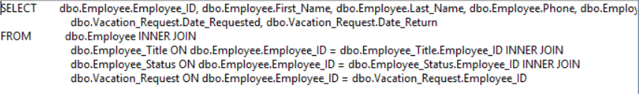

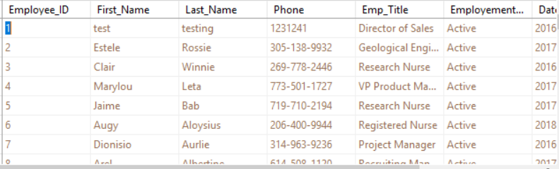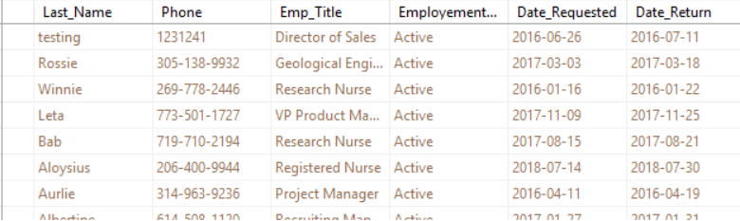

This report combines the tables:

* Employee
* Employee Title
* Employee Status
* Vacation Request

The employee table shows the Employee ID, first name, last name, and phone number associated with an individual

The Employee Title table shows the position or title of a specific employee

The Employee Status table shows if an employee is currently active or inactive within the company

The Vacation Request table shows the date requested for a vacation and the date returned for a vacation for each employee

#### Query 19

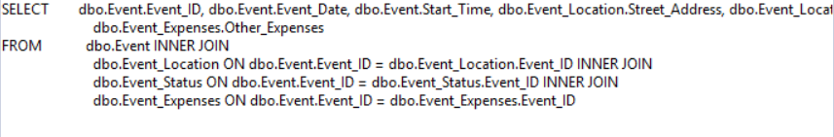

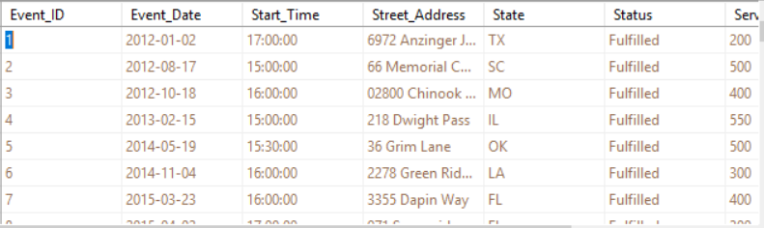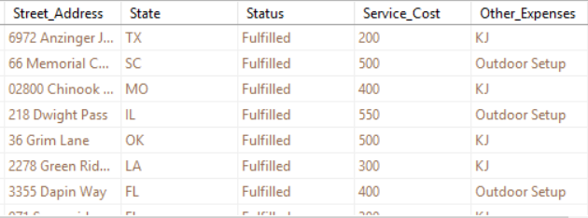

This Report combines the tables:

* Event
* Event Location
* Event Status
* Event Expenses

The Event table associates each event with an Event ID for efficient searching as well as the start time of each event

The Event Location table shows the street address and state of each event held

The Event Status table shows if an event is fulfilled, meaning it was booked and complete

The Event Expenses table shows the service cost and any other expenses that may have been associated with an event

#### Query 20

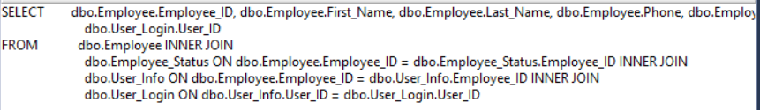

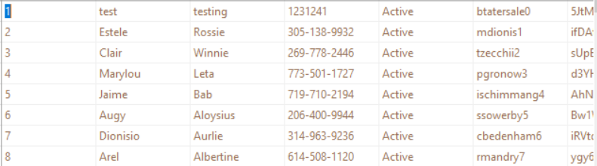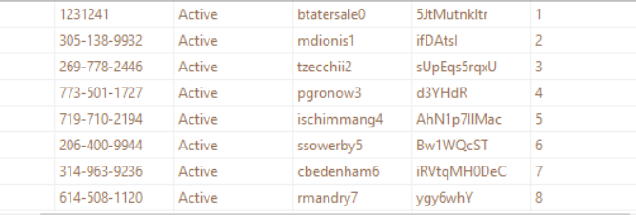

This report combines the tables:

* Employee
* Employee Status
* User Info
* User Login

The employee table shows the Employee ID, first name, last name, and phone number associated with an individual

The Employee Status table shows the current status of an specific employee, whether or not they are active within the company

The User Info table shows the assigned login and password for each individual in case an employee forgets. This information would require specific authorization

The User Login table associates a login ID with each individual’s Employee ID

#### Query 21

SELECT dbo.Client.Client_First, dbo.Client.Client_Last, dbo.Event.Event_ID, dbo.Event_Type.Event_Type, dbo.Event_Date.Event_Date

FROM dbo.Client INNER JOIN

dbo.Event ON dbo.Client.Client_ID = dbo.Event.Client_ID INNER JOIN

dbo.Event_Type ON dbo.Event.Event_ID = dbo.Event_Type.Evnt_ID INNER JOIN

dbo.Event_Date ON dbo.Event_ID = dbo.Event_Date.Event_ID

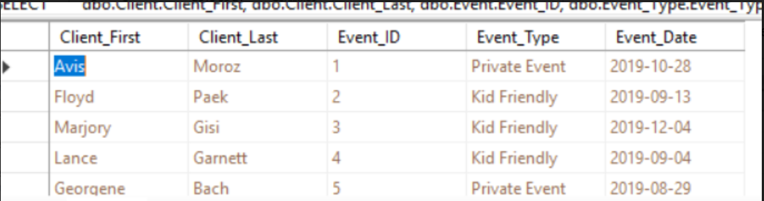

This report would be able to show the Client information, what type of event and the date of the event.

#### Query 22

SELECT dbo.Client.Client_First, dbo.Client.Client_Last, dbo.Event.Event_ID, dbo.Event_Type.Event_Type, dbo.Event_Date.Event_Date, dbo.Event.End_Time, dbo.Event.Start_Time, dbo.Service_Request.Service_Requested

Form dbo.Client INNER JOIN dbo.Event ON dbo.Client.Client_ID = dbo.Event.Client_ID INNER JOIN dbo.Event_Date ON dbo.Event.Event_ID = dbo.Event_Date.Event_ID INNER JOIN dbo.Service_Request ON dbo.Event.Event_ID = dbo.Service_Request.Event_ID

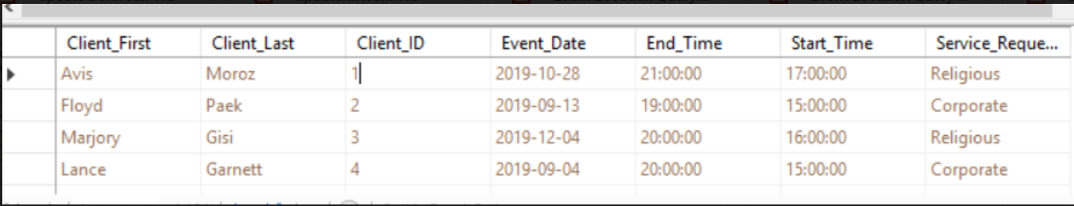

This report would show the Client names, the event start and end time and the type of service requested.

#### Query 23

SELECT dbo.Client.Client_ID, dbo.Client.Client_First, dbo.Client.Client_Last, dbo.Client_Location.City, dbo.Client_Type.New_Client, dbo.Client_Type.Returning_Client, dbo.Payment_Method.Payment_Amount, dbo.Payment_Method.Payemnt_Type

FORM dbo.Client INNER JOIN dbo.Cleint_Location ON dbo.Client.Client_ID = dbo.Client_Locaiton.Client_ID INNER JOIN dbo.Client_Type ON dbo.Client.Client_ID = dbo.Client_Type.Client_ID INNER JOIN dbo.Payment_Method ON dbo.Client.Client_ID = dbo.Payment_Method.Client_ID

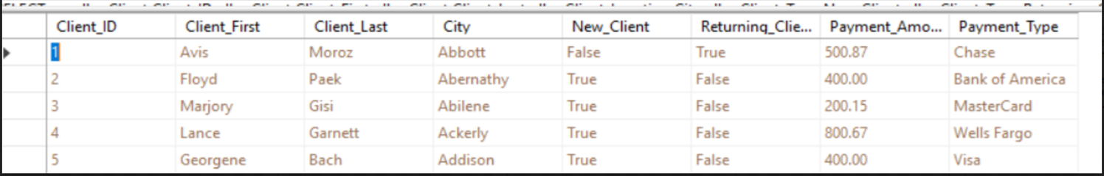

This report would show both types of client. It could be used to compared both types of client.

#### Query 24

SELECT dbo.Employee.First_Name, dbo.Employee.Last_Name, dbo.Employee.Employee_ID, dbo.Employee_Training_Status.Training_Status, dbo.Employee_Title.Emp_Title, dbo.Employee_Training_Request.Training_Date

FORM dbo.Employee INNER JOIN

Dbo.Employee.Training_Request ON dbo.Employee.Employee_ID = dbo.Employee_Training_Request.Employee_ID INNER JOIN

Dbo.Employee_Training_Request.Training_RequestID = dbo.Employee_Training_Status.Training_ID INNER JOIN

dbo.Employee_Tilte ON dbo.Employee.Employee_ID = dbo.Employee_Title.Employee_ID

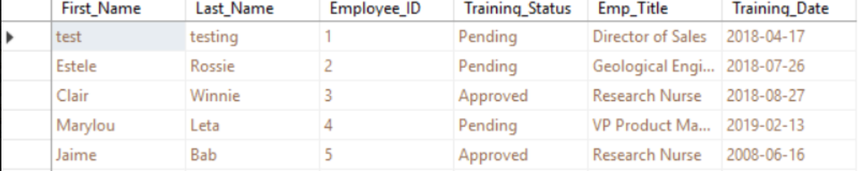

This report would show which employee has completed training, training status and what are their titles.

#### Query 25

SELECT dbo.Locations.Loaction_ID, dbo.Locations.City, dbo.Event.Event_ID

dbo.Event_Date.Event_Date, dbo.Event_Expenses.Service_Ceost, dbo.Event_Expenses.Services, dbo.Locations.State

FORM dbo.Event_Date INNER JOIN

dbo.Event On dbo.Event_Date.Event_ID = dbo.Event.Event_ID INNER JOIN

DBO.Event_Express ON dbo.Event.Event_ID = dbo.Event_Expenses.Event_ID CROSS JOIN

Dbo.Locations

WHERE (dbo.Locations.State=’TX’) AND (dbo.Location.City = ‘Houston’)

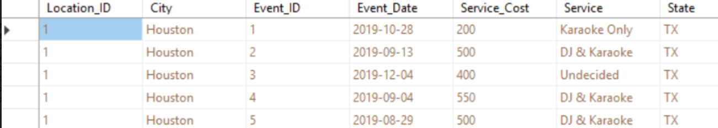

This report would compare expenses in Houston to other city.

#### Query 26

SELECT dbo.Event.Event_Date, dbo.Service_Request.Service_Requested, dbo.Event_Date.Event_Start, dbo.Event_Date.Event_End, dbo.Event_Status.Status

FROM dbo.Event

INNER JOIN dbo.Event_Date

ON dbo.Event.Event_ID = dbo.Event_Date.Event_ID

INNER JOIN dbo.Event_Status

ON dbo.Event.Event_ID = dbo.Event_Status.Event_ID

INNER JOIN dbo.Service_Request

ON dbo.Event.Event_ID = dbo.Service_Request.Event_ID

* This report query combines the following tables:
  + Event
  + Service_Request
  + Event_Date
  + Event_Status
* Using the Event table, we find out which day the event falls under.
* The Service_Request table shows which type of service was requested for the Event.
* The Event_Date table pulls out information regarding the start and end times for the event.
* The Event_Status table will allow us to see what type of service the client requested for their event.

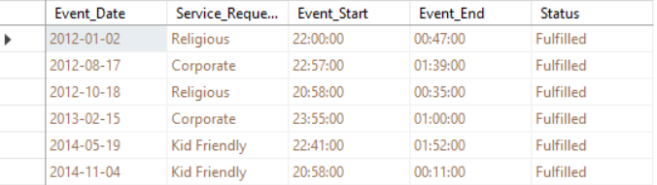

#### Query 27

SELECT dbo.Event.Event_Date, dbo.Service_Request.Service_Requested

AS Expr1, dbo.Event_Expenses.Other_Expenses, dbo.Event_Type.Event_Type

FROM dbo.Event

INNER JOIN dbo.Event_Expenses

ON dbo.Event.Event_ID = dbo.Event_Expenses.Event_ID

INNER JOIN dbo.Event_Type

ON dbo.Event.Event_ID = dbo.Event_Type.Event_ID

INNER JOIN dbo.Service_Request

ON dbo.Event.Event_ID = dbo.Service_Request.Event_ID

* This report query combines the following tables:
  + Event
  + Service_Request
  + Event_Expenses
  + Event_Type
* Using the Event table, we find out the date on which the event is held.
* The Service_Request table displays which kind of service was requested for the Event.
* The Event_Expenses table shows the information regarding what kind of other services where charged for the event.
* The Event_Type table will lastly display the type of event with these known it will inform which equipment is needed for a certain day.

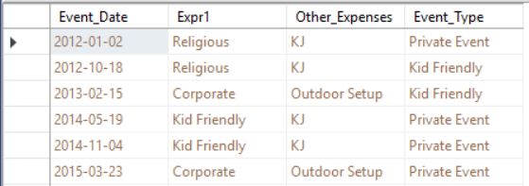

#### Query 28

SELECT dbo.Client.Client_First, dbo.Client.Client_Email, dbo.Client_Type.New_Client, dbo.Event.Client_ID, dbo.Event_Expenses.Other_Cost, dbo.Payment_Method.Payment_Amount

FROM dbo.Client

INNER JOIN dbo.Client_Type

ON dbo.Client.Client_ID = dbo.Client_Type.Client_ID

INNER JOIN dbo.Event

ON dbo.Client.Client_ID = dbo.Event.Client_ID

INNER JOIN dbo.Event_Expenses

ON dbo.Event.Event_ID = dbo.Event_Expenses.Event_ID

INNER JOIN dbo.Payment_Method

ON dbo.Client.Client_ID = dbo.Payment_Method.Client_ID

* This report query combines the following tables:
  + Client
  + Client_Type
  + Event
  + Event_Expenses
  + Payment_Method
* Using the Event table, we can personalize informing a client by email when using their first name.
* The Client _Type table informs if the Client is a new customer or not.
* The Event_Expenses table allows the connection of a client to an event thus using their ID.
* The Payment_Method table will show the current payment amount we can deduct a discount for being a new client and inform the client of this change through email.

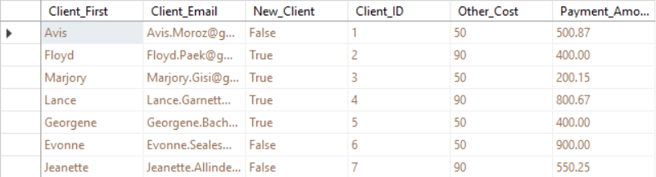

#### Query 29

SELECT dbo.Client.Client_First, dbo.Client.Client_Last, dbo.Event.Client_ID, dbo.Event_Date.Event_Date, dbo.Event_Status.Status

FROM dbo.Client

INNER JOIN dbo.Event

ON dbo.Client.Client_ID = dbo.Event.Client_ID

INNER JOIN dbo.Event_Status

ON dbo.Event.Event_ID = dbo.Event_Status.Event_ID

INNER JOIN dbo.Event_Date

ON dbo.Event.Event_ID = dbo.Event_Date.Event_ID

* This report query combines the following tables:
  + Client
  + Event
  + Event_Date
  + Event_Status
* Using the Client table, we can see the first and last name of the Client.
* The Event table allows the connection between the client and the event thus using the client’s ID.
* The Event_Date table displays what day the event is scheduled for.
* The Event_Status table will show if the status of the event informing if an event is currently upcoming.

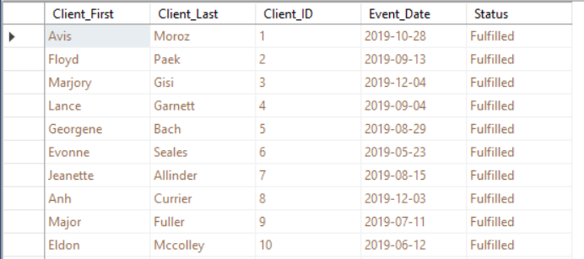

#### Query 30

#### Query 31

SELECT        dbo.Locations.Location_ID, dbo.Client.Client_ID, dbo.Event.Event_ID, dbo.Event_Type.Event_Type

FROM            dbo.Client INNER JOIN

                        dbo.Locations ON dbo.Client.Location_ID = dbo.Locations.Location_ID INNER JOIN

                        dbo.Event ON dbo.Client.Client_ID = dbo.Event.Client_ID INNER JOIN

                        dbo.Event_Type ON dbo.Event.Event_ID = dbo.Event_Type.Event_ID

* This report query combines the following tables:
  + Location
  + Client
  + Event
  + Event Type
* The Location table shows which location the client requests their event from
* The Client table displays the information concerning the client
* The Event table allows us to see which event the client requested for and where the event will be at
* The Event Type table lets us know what kind of event the customer requested

#### Query 32

SELECT        dbo.Locations.Location_ID, dbo.Client.Client_ID, dbo.Event.Event_ID, dbo.Event_Date.Event_Start

FROM            dbo.Locations INNER JOIN

                        dbo.Client ON dbo.Locations.Location_ID = dbo.Client.Location_ID INNER JOIN

                        dbo.Event ON dbo.Client.Client_ID = dbo.Event.Client_ID INNER JOIN

                        dbo.Event_Date ON dbo.Event.Event_ID = dbo.Event_Date.Event_ID

* This report query combines the following tables:
  + Location
  + Client
  + Event
  + Event Date
* The Location table shows which location the client requests their event from
* The Client table displays the information concerning the client
* The Event table allows us to see which event the client requested for and where the event will be at
* The Event date table displays the day that the event will take place

#### Query 33

SELECT        dbo.Employee.Employee_ID, dbo.User_Info.User_ID, dbo.User_Login.Login_ID, dbo.Locations.Location_ID

FROM            dbo.Employee INNER JOIN

                        dbo.User_Info ON dbo.Employee.Employee_ID = dbo.User_Info.Employee_ID INNER JOIN

                        dbo.User_Login ON dbo.User_Info.User_ID = dbo.User_Login.User_ID INNER JOIN

                        dbo.Locations ON dbo.Employee.Location_ID = dbo.Locations.Location_ID INNER JOIN

                        dbo.Employee_Type ON dbo.Employee.Employee_ID = dbo.Employee_Type.Employee_ID

* This report query combines the following tables:
  + Employee
  + User Info
  + User Login
  + Location
* The Employee table pulls the Employee information such as the first and last name
* The User info table can check which employee is logged in at the time
* The User login table allows us to track work activity and productivity of any employee
* The Location table shows which location the client requests their event from

#### Query 34

SELECT        dbo.Employee.Employee_ID, dbo.Employee_Type.Employee_Type_ID, dbo.User_Info.User_ID, dbo.User_Login.Login_ID

FROM            dbo.Employee INNER JOIN

                        dbo.Employee_Type ON dbo.Employee.Employee_ID = dbo.Employee_Type.Employee_ID INNER JOIN

                        dbo.User_Info ON dbo.Employee.Employee_ID = dbo.User_Info.Employee_ID INNER JOIN

                        dbo.User_Login ON dbo.User_Info.User_ID = dbo.User_Login.User_ID

* This report query combines the following tables:
  + Employee
  + Employee Type
  + User Info
  + User Login
* The Employee table pulls the Employee information such as the first and last name
* The Employee Type table helps us find out what type of employee they are to see if the wage makes sense/matches up
* The User info table can check which employee is logged in at the time
* The User login table allows us to track work activity and productivity of any employee



#### Query 35

SELECT        dbo.Client.Client_ID, dbo.Event.Event_ID, dbo.Event_Status.Status_ID, dbo.Event_Date.Event_Date, dbo.Event_Expenses.Expense_ID

FROM            dbo.Client INNER JOIN

                        dbo.Event ON dbo.Client.Client_ID = dbo.Event.Client_ID INNER JOIN

                        dbo.Event_Status ON dbo.Event.Event_ID = dbo.Event_Status.Event_ID INNER JOIN

                        dbo.Event_Date ON dbo.Event.Event_ID = dbo.Event_Date.Event_ID INNER JOIN

                        dbo.Event_Expenses ON dbo.Event.Event_ID = dbo.Event_Expenses.Event_ID

* This report query combines the following tables:
  + Client
  + Event
  + Event Status
  + Event Date
  + Event Expenses
* The Client table displays the information concerning the client
* The Event table allows us to see which event the client requested for and where the event will be at
* The Event Status shows if the event is yet to occur, is currently taking place, has started, or ended
* The Event date table displays the day that the event will take place

The Event Expenses table lets us know how much a specific event will cost

#### Query 36

SELECT dbo.Client.Client_ID, dbo.Event.Event_ID, dbo.Event.Client_ID AS Expr1, dbo.Event_Expenses.Event_ID AS Expr2, dbo.Event_Status.Status_ID, dbo.Client.Client_First, dbo.Client.Client_Last,

dbo.Client.Client_Comments

FROM dbo.Client INNER JOIN

dbo.Event ON dbo.Client.Client_ID = dbo.Event.Client_ID INNER JOIN

dbo.Event_Expenses ON dbo.Event.Event_ID = dbo.Event_Expenses.Event_ID INNER JOIN

dbo.Event_Status ON dbo.Event.Event_ID = dbo.Event_Status.Event_ID

**This query combines the tables Client, Event, Event_Expenses, Event_Status**

**It extracts from Client the Client_ID, Client_First, Client_Last , Event, Event_Expenses, and Status_ID**

**It is useful to charge the client a cancelling fee if the event status turns to canceled**

#### Query 37

SELECT dbo.Client.Client_ID, dbo.Payment_Method.Client_ID AS Expr1, dbo.Booking_Status.Client_ID AS Expr2, dbo.Client_Type.Client_ID AS Expr3, dbo.Client.Client_First, dbo.Client.Client_Last

FROM dbo.Client INNER JOIN

dbo.Payment_Method ON dbo.Client.Client_ID = dbo.Payment_Method.Client_ID INNER JOIN

dbo.Client_Type ON dbo.Client.Client_ID = dbo.Client_Type.Client_ID INNER JOIN

dbo.Booking_Status ON dbo.Client.Client_ID = dbo.Booking_Status.Client_ID

**This query combines the tables Client, Client_Type, Payment_Method, and Booking Status**

**It extracts from Client the Client_ID, Client_First, Client_Last**

**This is useful to determine the type of client (such as a returning customer) and gives the booking status**

#### Query 38

SELECT dbo.Client.Client_ID, dbo.Client.Client_First, dbo.Client.Client_Last, dbo.Payment_Method.Client_ID AS Expr1, dbo.Client_Location.Client_ID AS Expr2, dbo.Event.Client_ID AS Expr3

FROM dbo.Client INNER JOIN

dbo.Payment_Method ON dbo.Client.Client_ID = dbo.Payment_Method.Client_ID INNER JOIN

dbo.Client_Location ON dbo.Client.Client_ID = dbo.Client_Location.Client_ID INNER JOIN

dbo.Event ON dbo.Client.Client_ID = dbo.Event.Client_ID

**This query combines the tables, Client, Payment_Method, Client_Location, Event**

**It extracts from Client the Client_ID, Client_First, Client_Last**

**It is useful to generate a mini report that could be referenced on sight at an event to verify important details**

#### Query 39

SELECT dbo.Employee.First_Name, dbo.Employee.Employee_ID, dbo.Employee.Middle_Name, dbo.User_Info.Employee_ID AS Expr1, dbo.Employee_Type.Employee_ID AS Expr2,

dbo.Employee_Title.Employee_ID AS Expr3

FROM dbo.Employee INNER JOIN

dbo.User_Info ON dbo.Employee.Employee_ID = dbo.User_Info.Employee_ID INNER JOIN

dbo.Employee_Title ON dbo.Employee.Employee_ID = dbo.Employee_Title.Employee_ID INNER JOIN

dbo.Employee_Type ON dbo.Employee.Employee_ID = dbo.Employee_Type.Employee_ID

**This query combines from tables Employee, User_Info, Employee_Type, Empoyee_Title**

**It extracts from Employee the Employee_ID, First_Name, Middle_Name**

**It is useful to identify the type of Employee and their Title**

#### Query 40

SELECT dbo.Employee.Employee_ID, dbo.Timesheet.Employee_ID AS Expr1, dbo.Vacation_Request.Employee_ID AS Expr2, dbo.Employee_Status.Employee_ID AS Expr3, dbo.Employee.First_Name,

dbo.Employee.Last_Name, dbo.Employee.Middle_Name

FROM dbo.Employee INNER JOIN

dbo.Timesheet ON dbo.Employee.Employee_ID = dbo.Timesheet.Employee_ID INNER JOIN

dbo.Vacation_Request ON dbo.Employee.Employee_ID = dbo.Vacation_Request.Employee_ID INNER JOIN

dbo.Employee_Status ON dbo.Employee.Employee_ID = dbo.Employee_Status.Employee_ID

**This query combines the tables Employee, Timesheet, Vacation_Request, Employee Status**

**It extracts from Employee Employee_ID, First_Name, Middle_Name, Last_Name**

**It is useful to verify the vacation status of an employee and cross reference with the timesheet**

# GUI Forms/Screens

## Login Menu

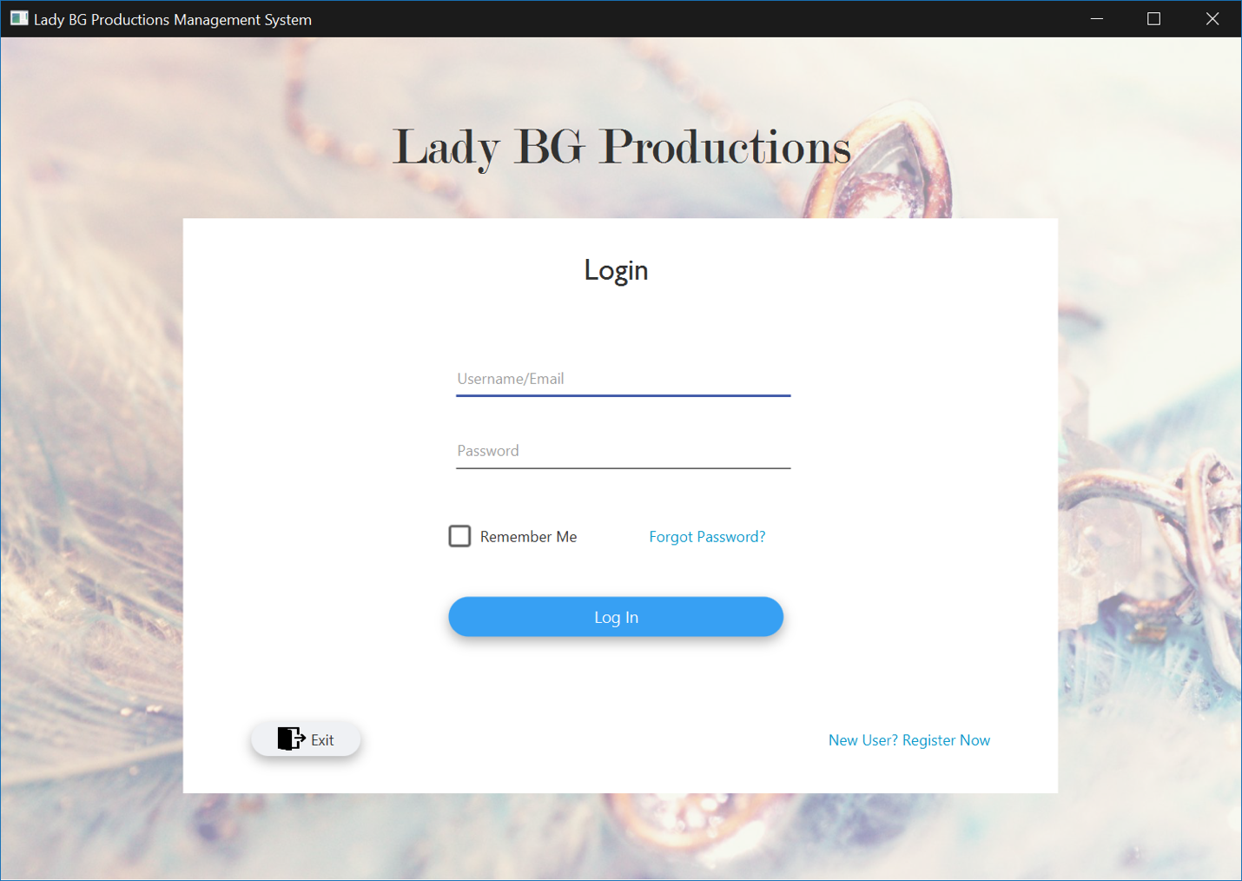

## Main Menu

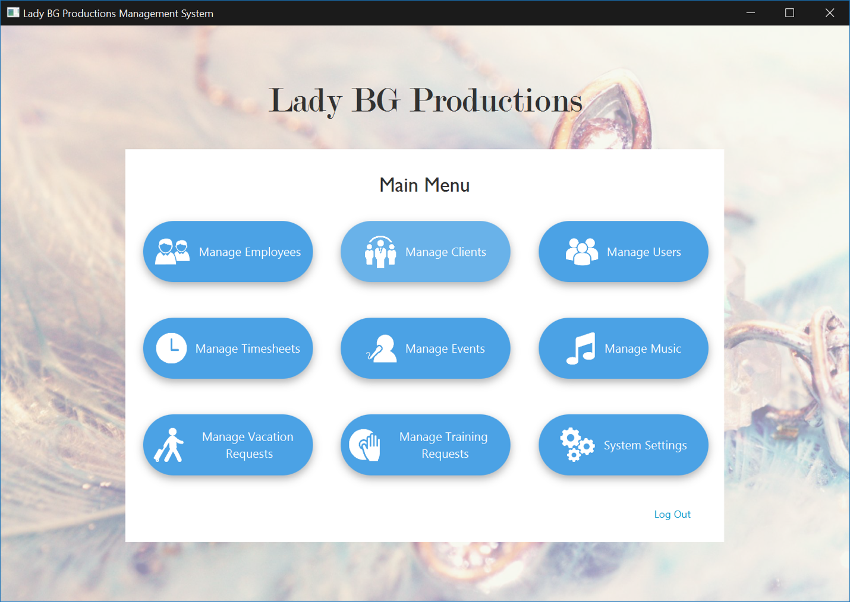

## Client Menu

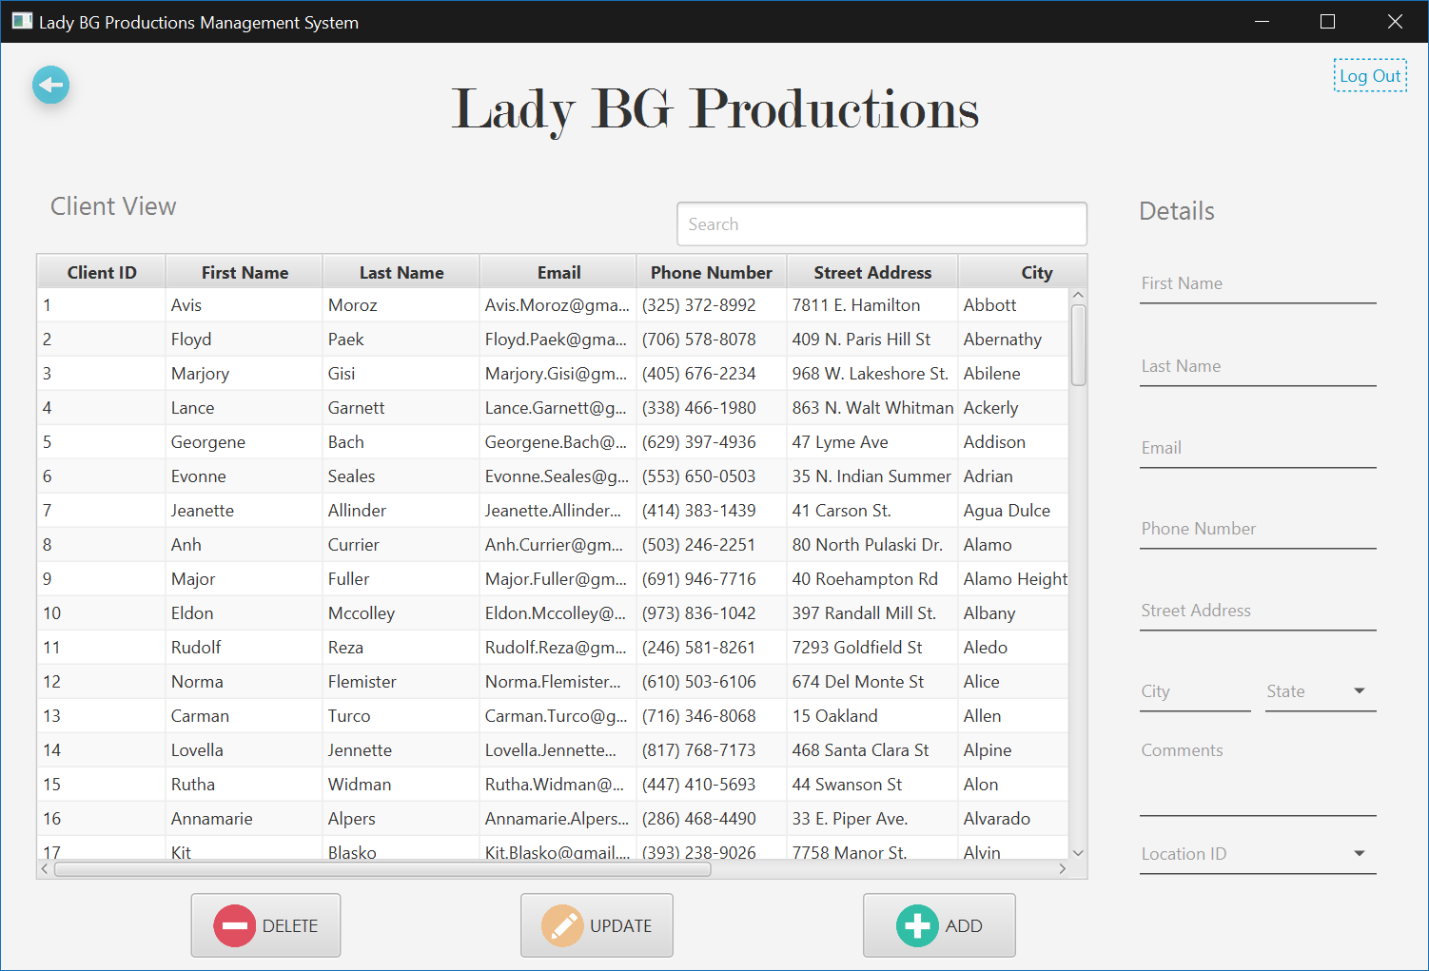

## Employee Menu

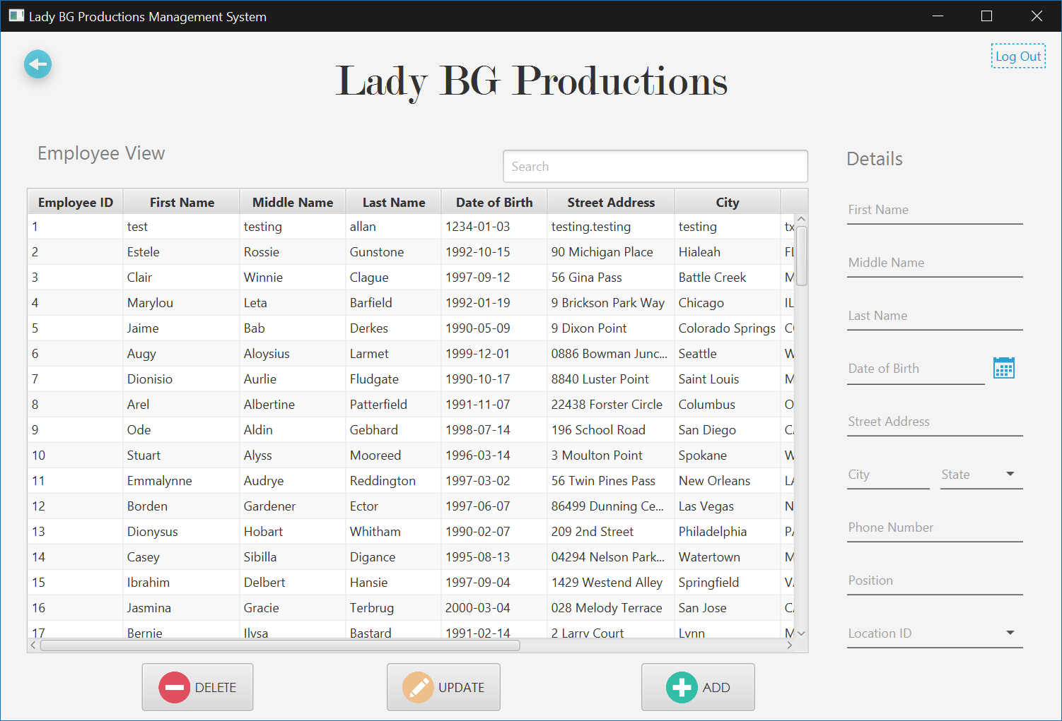

## Event Menu

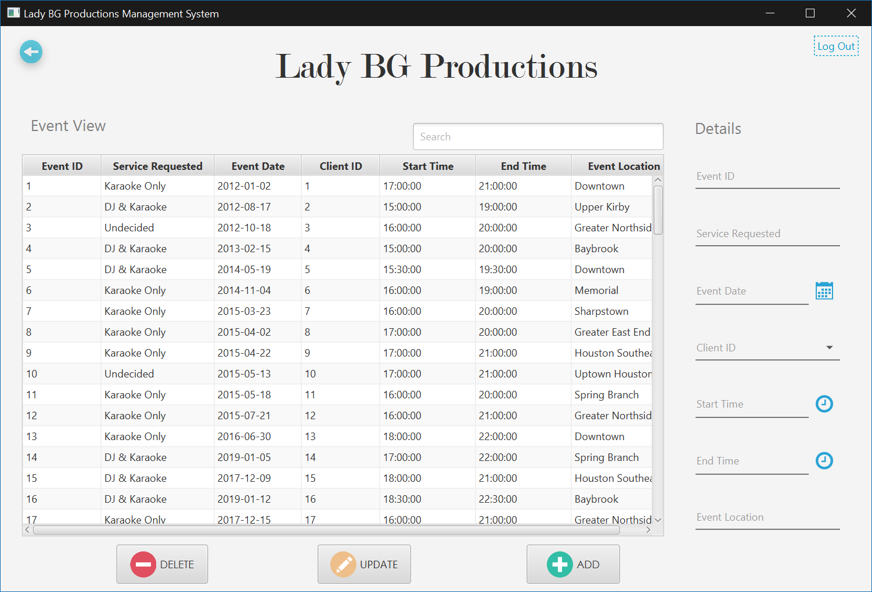

## Music Menu

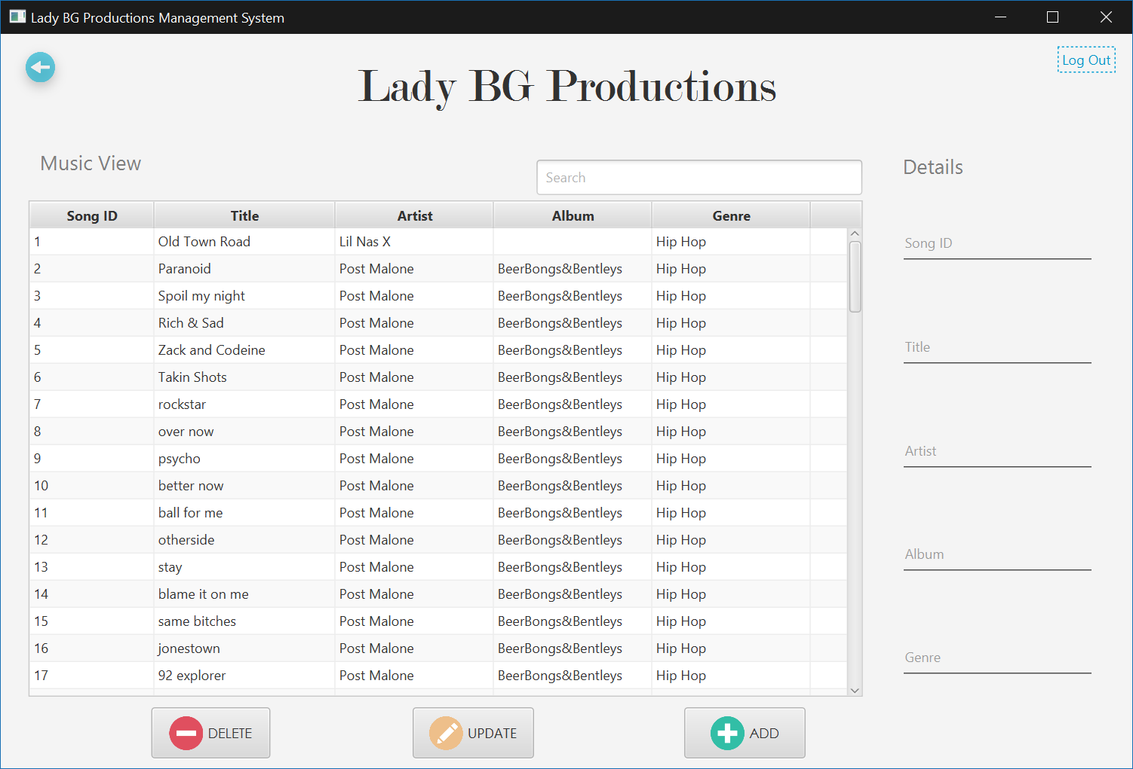

## Timesheet Menu

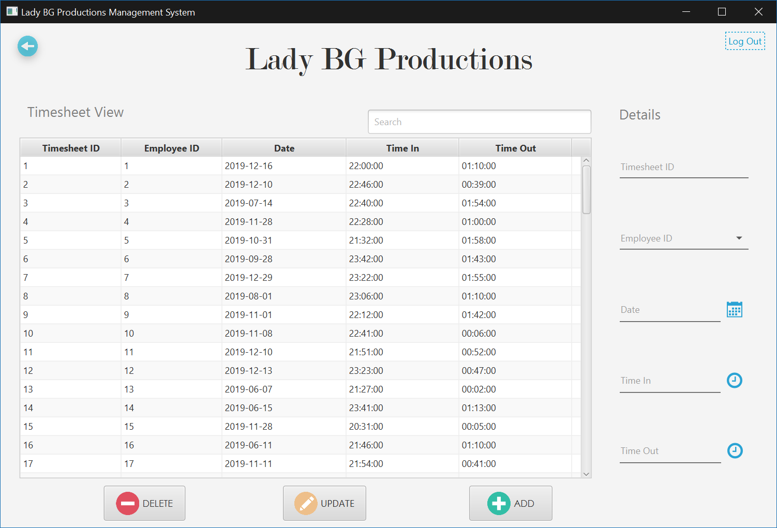

## Training Request Menu

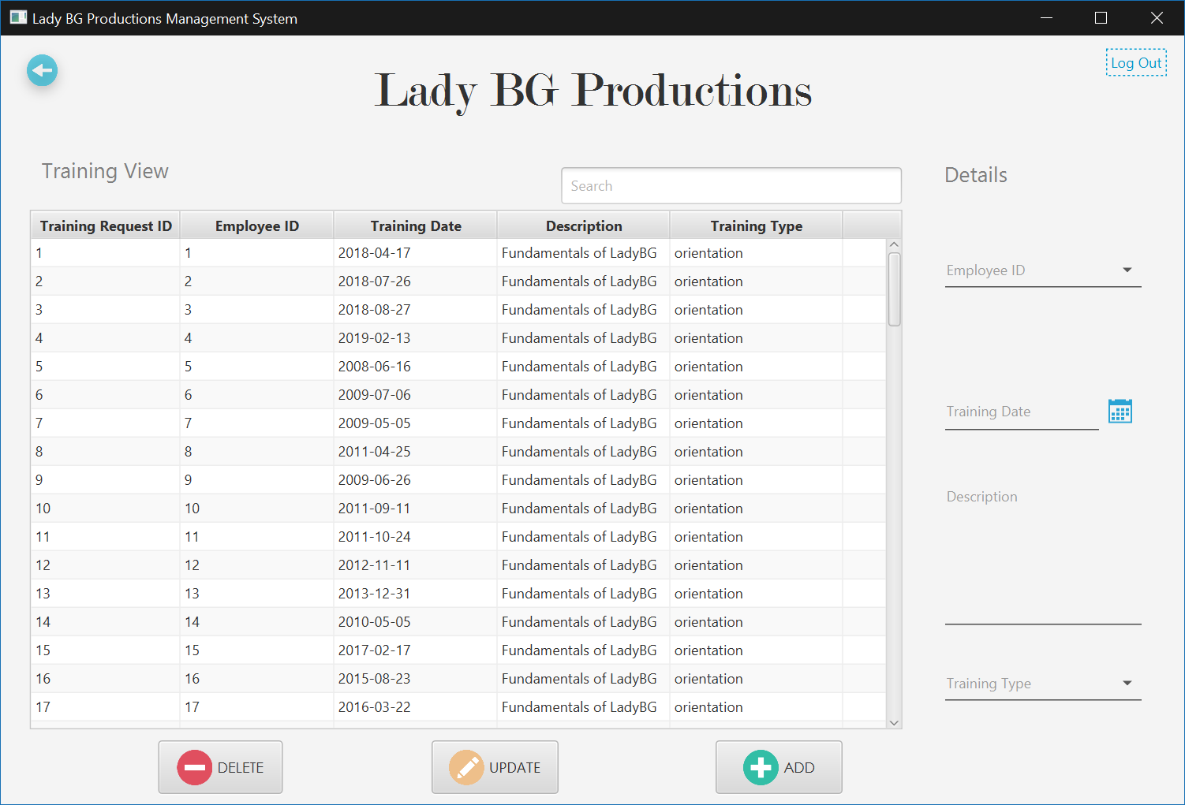

## User Menu

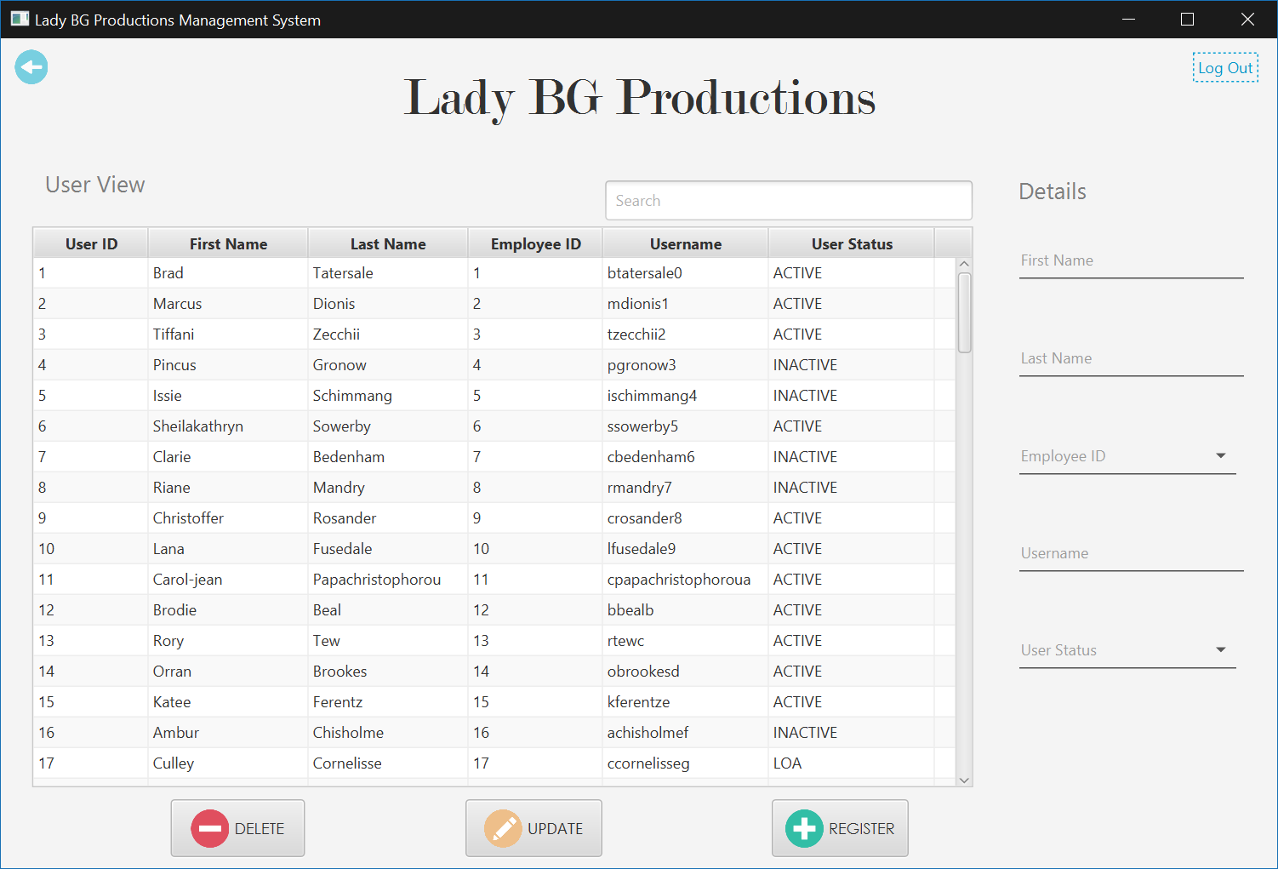

## User Registration

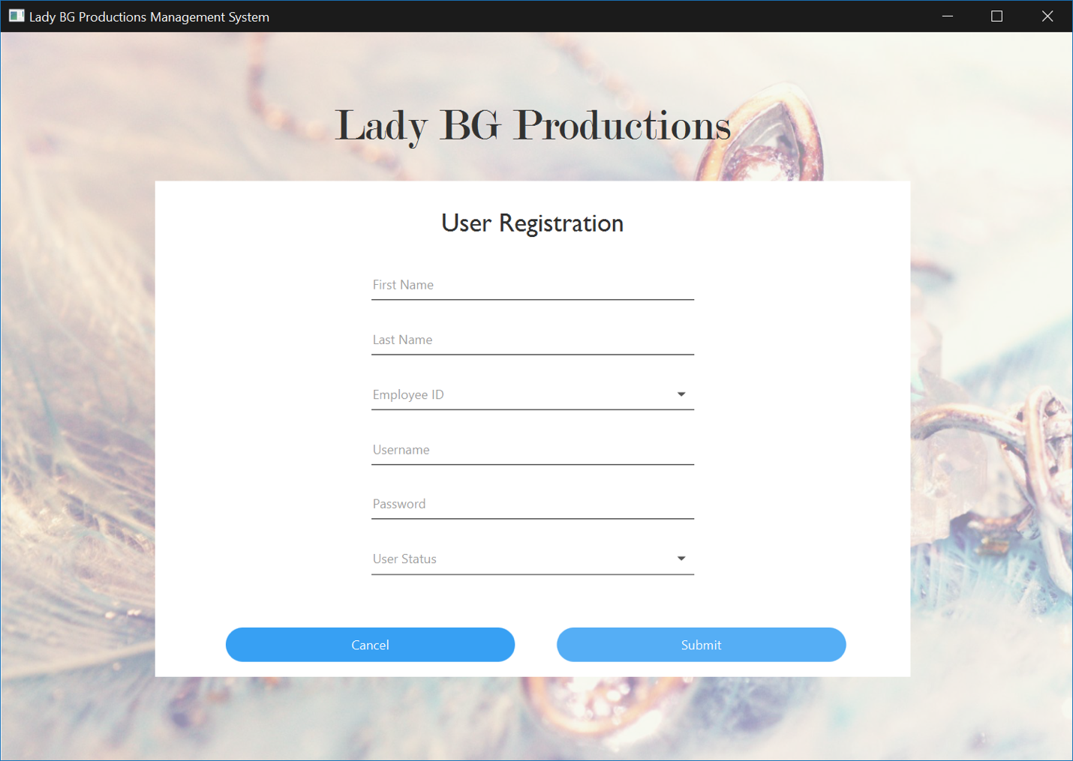

## Vacation Requests Menu

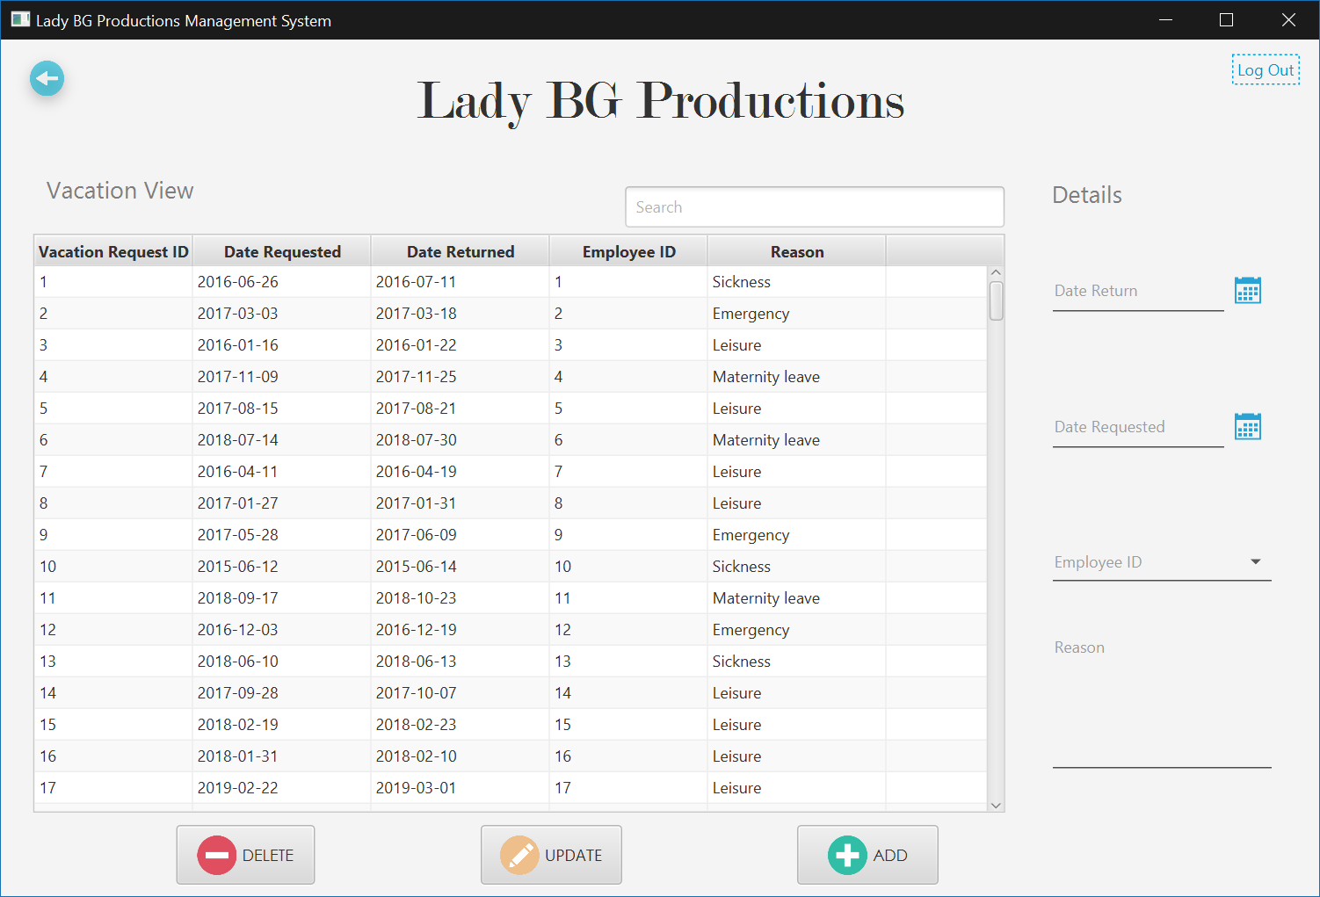

# Updated Problems and Requirements List

|  |  |  |  |  |
| --- | --- | --- | --- | --- |
| **Problem Number** | **Category** | **Rank of Importance** | **Description** | **Measure of effectiveness** |
| PN1 | Clients | 8 | There is no way to track customer bookings or purchases. | Create a query based upon client bookings or purchases. |
| PN2 | Clients | 8 | Owner can't reach out to customer who haven't booked an event with her in long period of time. | Allow owner to run report of customer who haven't booked in the last year. |
| PN3 | Clients | 9 | Owner is not able to market directly to her previous clients. | Create customer database that can pull customer email address for marketing purposes. |
| PN4 | Reports | 7 | Reports must be created manually. | Create reports that can run with one click. |
| PN5 | Reports | 9 | There are no built-in reporting options. | Create a report builder. |
| PN6 | Reports | 6 | Number of monthly bookings must be tracked manually. | Allow preview of monthly bookings. |
| PN7 | Reports | 5 | The owner is unable to sort clients by email address or other information. | Create a custom report with client's contact information. |
| PN8 | Reports | 5 | Unable to print a list of events assigned to each employee. | Create a customer list of events assigned to each employee. |
| PN9 | Bookings | 9 | There is no automatic way to filter booking request. | Bookings should be entered into a searchable database. |
| PN10 | Bookings | 5 | Sending the booking form is done manually. | Automate booking form emails. |
| PN11 | Bookings | 9 | It takes several hours to send booking forms to clients. | Automate booking form emails. |
| PN12 | Bookings | 9 | There is no follow-up email after events. | Create a follow up email or survey. |
| PN13 | Bookings | 5 | Employees are not able to see their scheduled shows per month. | Create a list of employees assigned to each event monthly. |
| PN14 | Bookings | 5 | Unable to sort an event by length. | Allow booking report option to sort by length. |
| PN15 | DVDs | 6 | Unable to create track list of DVD selection. | Allow customer to save list created from her current songbooks. |
| PN16 | DVDs | 7 | Unable to track who has purchased custom DVDs. | Create reports on customers purchasing DVDs. |
| PN17 | Song list | 8 | Unable to sort music by clean/explicit for kid friendly or church events. | Create a searchable database of song selection. |
| PN19 | Song list | 8 | Unable to sort music selection by genre. | Create a searchable database of song selection. |
| PN20 | Song list | 7 | Unable to sort music selection by year. | Create a searchable database of song selection. |
|  |  |  |  |  |

# Status Report

|  |  |
| --- | --- |
| Team Status Report  Group Name: Houston Vertical Systems  Project Manager: Randy Nguyen Date: April 18, 2019 |  |

This week the Houston Vertical Systems team has been working on the following deliverables listed below.

|  |  |  |  |  |
| --- | --- | --- | --- | --- |
| Team Houston Vertical Systems | Deliverable Description | Start Date/Time | Hours Worked | Est. Hours Remaining |
| Randy Nguyen |  |  |  |  |
|  | Java General Programming | 1/17/2019 11:30 | 3 | 0 |
|  | Java GUI | 2/10/2019 14:30 | 4 | 0 |
|  | Create Table | 3/14/2019 22:00 | 2 | 0 |
|  | Bulk Insert | 3/21/2019 13:00 | 4 | 0 |
|  | SQL Scripts & Queries | 4/1/2019 15:15 | 10 | 0 |
|  |  |  | 23 | 0 |
| Brady Acevedo |  |  |  |  |
|  | Create Table | 2/21/2014 0:03 | 2 | 0 |
|  | Bulk Insert | 3/15/2014 3:33 | 4 | 0 |
|  | Java GUI | 3/26/2014 2:33 | 6 | 0 |
|  | CSV Files | 4/7/2014 0:00 | 2 | 0 |
|  | SQL Scripts & Queries | 4/13/2014 20:02 | 5 | 0 |
|  |  |  | 19 | 0 |
|  |  |  |  |  |
| Brandon Nguyen |  |  |  |  |
|  | Create Table | 04/28/2019 14:23 | 3 | 0 |
|  | Bulk Insert | 04/01/2019 18:32 | 2 | 0 |
|  | Java GUI | 04/02/2019 19:33 | 5 | 0 |
|  | CSV Files | 04/14/2019 13:00 | 3 | 0 |
|  | SQL Scripts & Queries | 04/14/2019 14:20 | 3 | 0 |
|  |  |  | 16 | 0 |
| Celesta Monsivaiz |  |  |  |  |
|  | Create Table | 03/2/2019 14:00 | 3 | 0 |
|  | Bulk Insert | 03/18/2019 19:00 | 2 | 0 |
|  | Java GUI | 04/01/2019 18:05 | 5 | 0 |
|  | CSV Files | 04/11/2019 12:45 | 4 | 0 |
|  | SQL Scripts & Queries | 04/14/2019 17:20 | 3 | 0 |
|  |  |  | 17 | 0 |
| Jason Ngo |  |  |  |  |
|  | Programming | 3/3/2019 18:00 | 2 | 0 |
|  | Create Table | 3/14/2019 12:30 | 5 | 0 |
|  | Bulk Insert | 3/28/2019 12:30 | 5 | 0 |
|  | Java GUI | 4/5/2019 18:30 | 6 | 0 |
|  | SQL Scripts & Queries | 4/9/2019 18:30 | 3 | 0 |
|  |  |  | 21 | 0 |
| Kristy Hoang |  |  |  |  |
|  | Programming | 2/21/2019 0:03 | 6 | 0 |
|  | Java GUI | 3/20/2019 3:33 | 6 | 0 |
|  | Bulk Insert | 3/26/2019 2:33 | 3 | 0 |
|  | SQL Scripts & Queries | 4/2/2019 0:00 | 2 | 0 |
|  | Java Forms | 4/10/2019 20:02 | 6 | 0 |
|  |  |  | 23 | 0 |
| Muktar Abubakar |  |  |  |  |
|  | Create Table | 2/24/2019 0:03 | 3 | 0 |
|  | Bulk Insert | 3/4/2019 3:33 | 4 | 0 |
|  | SQL Scripts | 3/25/2019 2:33 | 6 | 0 |
|  | Report Queries | 4/10/2019 0:00 | 2 | 0 |
|  | Java GUI | 4/16/2019 20:02 | 3 | 0 |
|  |  |  | 18 | 0 |
| Samuel Ekpe |  |  |  |  |
|  | Create Table | 3/28/2019 0:03 | 4 | 0 |
|  | Bulk Insert | 4/4/2019 3:33 | 4 | 0 |
|  | SQL Scripts | 4/9/2019 2:33 | 5 | 0 |
|  | Report Queries | 4/11/2019 0:00 | 2 | 0 |
|  | Java GUI | 4/14/2019 20:02 | 3 | 0 |
|  |  |  | 18 | 0 |